30 MINUTE YEAST FREE CHEESY BREAD
Caroline’s Easy Baking Lessons Savoury Lesson No.1
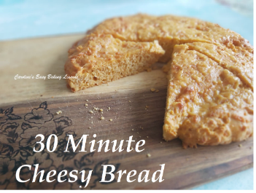
This quick & yeast free recipe was an ideal bake during the food shortages in 2020. Now the recipe originally calls for Mustard Powder & that believe me is great in cheese bakes, but my son had knocked my box of it over & I have to go to the bigger supermarkets for it, so I decided to replace with smoked paprika & a little garlic powder. This gave the bake a nice orange colour & smelt really good even before baked.

Just be warned though it doesn't have the same texture than regular bread because there is no yeast, but would be ideal as a speedy bread accompaniment to a meal or even a nice breakfast. Can be made in about half an hour, so what's not to like?

INGREDIENTS Makes 8 decent slices

• 250g Self-raising or Plain Flour (8 & 3/4 oz)
* (OR 2 cups A.P. or Plain flour plus 2 1/2 tsp Baking Powder)
• 1 tsp Salt
• 1 1/2 tsp Smoked Paprika
• 1/2 tsp Garlic Powder
** (Alternatively to these 2 spices, use 1& 1/2 tsp Mustard Powder)
• 150ml Milk (5 fl. oz or 2/3 cup)
• 1 Medium - Large Egg
• 25g Butter, melted (3/4 oz, 2 level tbsp or 1/5 stick of butter)
• 100g Grated Extra Mature Cheddar Cheese (3.5 oz, 1 cup shredded, extra sharp cheddar)
• For greasing - Lining Paste, butter or cake release spray (see note below)

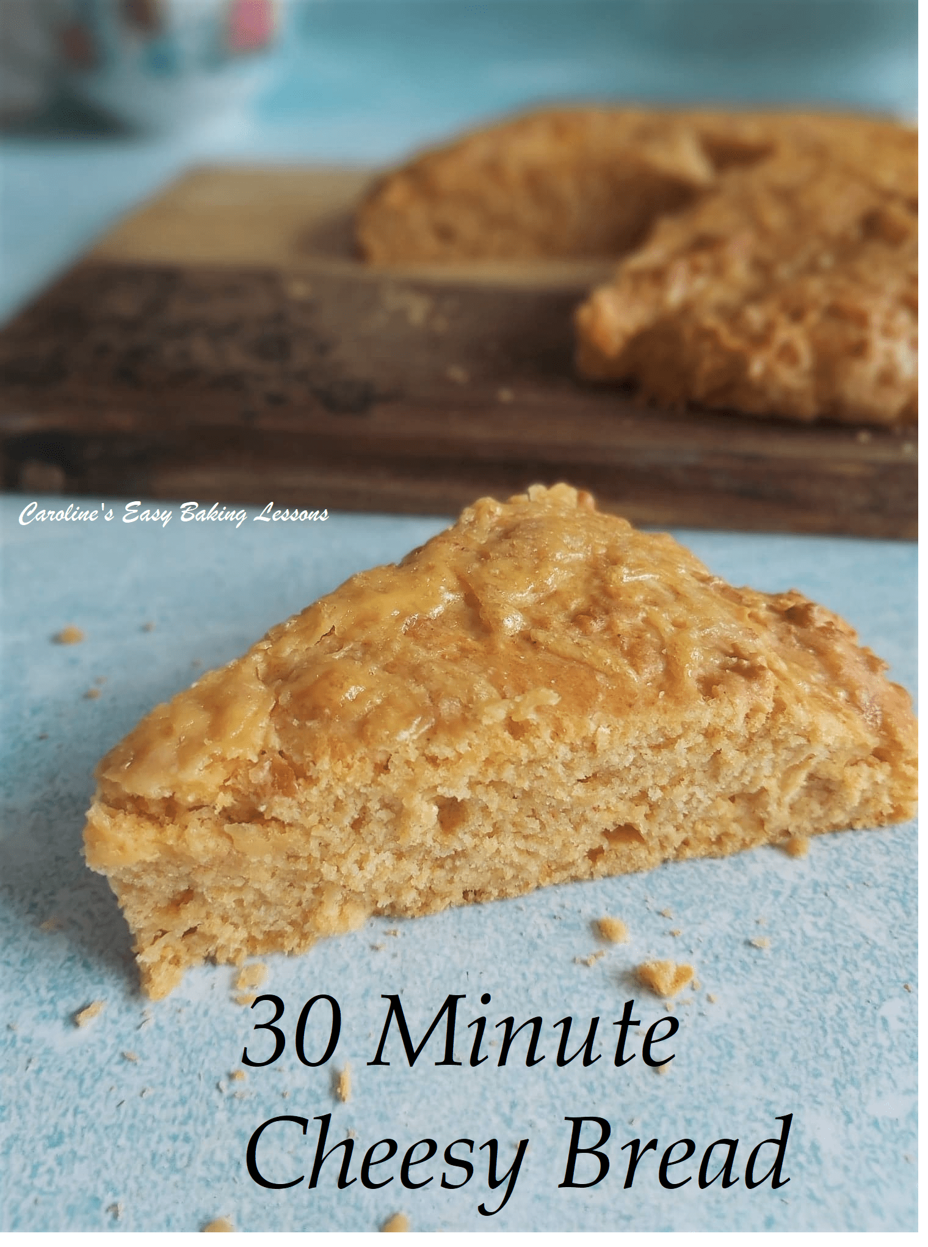
EQUIPMENT

• Large mixing bowl
• Sieve
• Digital scales or Measuring Cups
• Measuring spoons
• Large spoon or spatula
• Grater/shredder
• Small jug
• Small microwave safe bowl for butter
• Cake tin or dish – round 23cm/9.5"
• Brush for greasing tin (optional)
• Timer or mobile phone timer
• Cooling rack

INSTRUCTIONS
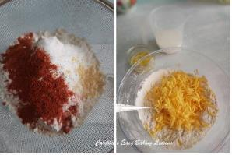
Photo 1
1.Heat your oven to: 190c/170c Fan Oven/ 375f / Gas Mark 5
2. While sieving, measure out your flour (& baking powder if using), salt, garlic powder & Smoked Paprika (alternatively to these last 2, use 1 tsp Mustard Powder) into a large bowl. Then give a good mix through to evenly distribute the ingredients. Next add in the grated/shredded cheese (but hold back about 4 or 5 tbsp for later) and mix through. See Photo 1.

Photo 2
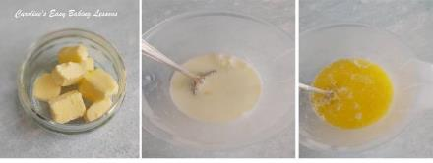
3. Now prepare your wet ingredients by melting the small amount of butter (I just used the microwave for 2 30 second bursts, mixing in-between). Then measure out your milk, add in the melted butter and finally crack in one egg. Whisk together lightly. See Photo 2 above.

Photo 3

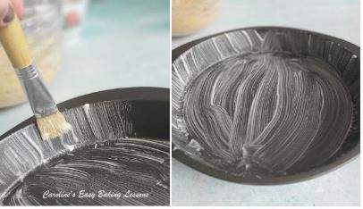
4. Grease your cake tin or dish - I used Great British Bake Off (Great British Baking Show) winner Nancy Birthistle's recipe for Lining Paste. It is cheaper than using butter and is quickly prepared and stored in the fridge, easy to use whenever any greasing is required. Works great on Bundt cakes too. Apply in upward strokes to the inner sides of the tin, to make it easier to come out later. See Photo 3. Alternatively use butter or cake release spray.

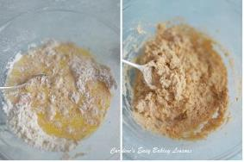

Photo 4

5. Next, add the wet ingredients to the dry and mix well until all combined and no more dry flour patches are visible. Be sure to check through the bottom of the bowl. See Photo 4.

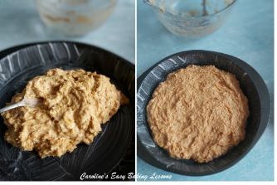
Photo 5
6. Finally, spoon the thick mixture into the cake tin and spread out as best you can, right to the edges. It is quite thick, and a little tricky to do, put keep going and it will fill the tin. See Photo 5 above. Then give the tin a few good taps on the counter/worktop and place in the centre of the oven.

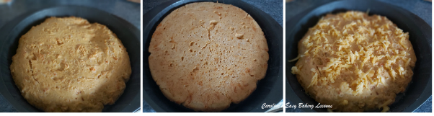
7. Bake for about 16 - 20 minutes. I have an oven that doesn't bake equally, and I use a thermometer to be sure of the temperature. So I baked for 10 minutes till the top was set up, and then turned out of the tin and placed back in the tin upside down. Have a feel of the bottom of the cake - it will be spongy and cake like. Then bake a further 3 minutes and the surface will be a little darker and more of a crisp than soft texture now. Turn back out and up the right way and sprinkle the remaining cheese on the top of the bread. See Photo 6 below. Then bake a further 3 - 7 minutes till the cheese is melted and when you put a wooden cocktail stick in the centre, it comes out clean of crumbs. See Photo 7 below.
Photo 6
Photo 7
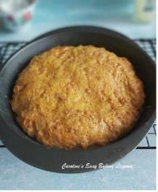
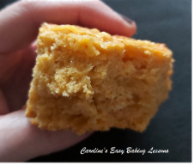
8. Leave in the tin and cool a little on a cooling rack, for about 10 minutes, before turning out of the tin and cooling on the rack alone. Leave to cool as much as you can (it won't take as long as yeast bread), before cutting into it. Slice with a large, serrated bread knife and enjoy! Will keep a couple of days if stored in a food baggie in a cool place.

Now that you have completed Savoury Lesson No.1, proceed onto Theory lesson No.3.
Caro xx

