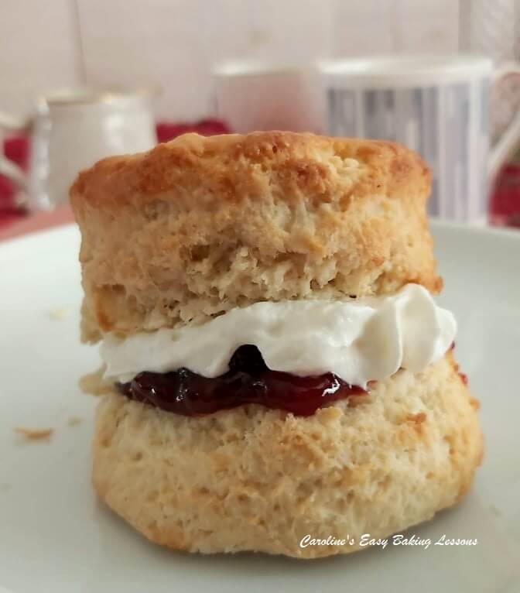
Classic British Scones – Only Recipe You Need!

Caroline’s Easy Baking Lessons
Scones That Rise To The Occasion -All You Need To Know
By Caro
Try my authentic Classic British Scones recipe & video tutorial, with tips on how to achieve the perfect rise for this classic British bake.

Difference Between British Scones & US Scones & Biscuits
US Biscuits look more like a British scone, than US scones (US scones don’t have the same rise & are often cut into triangles). British scones are traditionally made round & always with a cutter rather than a knife. Yes they are made from the same general ingredients. However, the proportion of these ingredients is different. This difference results in a different inner structure and texture when you eat them.

Tips For A Great Rise To Your British Scones

1. Don't use a recipe with too much baking powder, as it can cause a premature rise & sink.
2. Don't use a food processor or mixer for making scones.
3. A slightly sticky dough is good.
4. Don't roll out the dough, pat out with your hands instead.
5. Don't flatten too thin (1"/2.5cm minimum depth).
6. Don't twist the cookie cutter.
7. Don't touch the sides of the cut-out scone.
8. Don't let the egg/milk mixture run down the sides of the scones.
9. Minimal and gentle handling as possible.

A Note On Ingredients - SUGAR
If you can’t get extra/super fine sugar as an equivalent for the UK caster sugar, you can make your own by grinding regular granulated sugar a little bit or processing lightly.
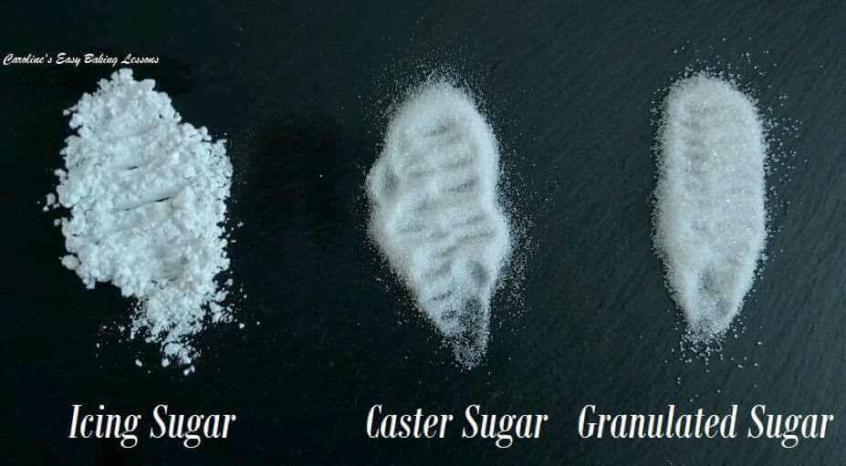
Do not go as fine as a powder, keep it as small granules.
See photo for a comparison of sugar grain sizes in the UK. Please also note that UK Granulated grain size is slightly larger than the US equivalent.
The use of fine sugar, is crucial in these scones, so should not be omitted. It’s only a small amount too, there in the recipe for structure rather than sweetness and also lengthens the life of the bake.
FLOUR
If you can’t get self-raising or self-rising flour, make your own from Plain/All purpose flour by adding baking powder. As a general rule, for every 125g (1 cup) of flour, add a scant 2 tsp of baking powder. For the recipe below, I have reduced the baking powder quantities a little. Too much baking powder causes it to prematurely rise, & then fall back down with not enough flour as support. It can also have a metallic taste if too much is used.
Gluten Free Flour & Alternative Milks
Many scones in a group bake-along were made using this recipe & All Purpose flour, with great success. Some even used Gluten free flour, and coconut milk for health reasons. This milk produces a scone, with the correct rise and texture, but the colour once baked, will be a little paler than when using cow’s milk. The same can be expected is the milk has a lower fat or sugar content. It will still all taste great through.
Adding Extra Ingredients
**Do not add too much chocolate or fruit to your scone dough as the added weight will reduce the rise of the scone significantly. And they will not rise as you want them too. I have calculated the maximum amount to add, and you can check that out in my Spiced Cranberry Scones recipe, (see recipe online for links).
INGREDIENTS
450g Self-raising Flour OR (3 & 2/3 cups AP/Plain Flour (15 3/4 oz) plus 5 + 1/2 (level) tsp Baking powder + scant 1 tsp salt)
50g Castor Sugar (1 3/4 oz or 1 level ¼ cup* – see note above)
75g Butter, cubed & at room temp (2 1/2 oz or level 2/3 stick or 1/3 cup)
225ml Milk approx. (up to 1 cup, or 7.5 fl oz)
2 tsp Baking Powder (rounded)
2 Eggs (med – large)
EQUIPMENT
- Scales or Measuring Cups Measuring Spoons
- Measuring Spoons Knife
- Small Jug Large Bowl
- Pastry Cutter (optional) Large Spoon
- Cookie Cutter (round), or Glass rim (6-7cm or 2 1/3 – 2 3/4″) Baking/Parchment Paper
- Spray Oil or Bottled Small Bowl
- Baking Tray – 1 Extra Large or 2 medium Timer or Phone Timer
- Pastry Brush or new Artist/Paint brush Cooling Rack
OVEN: 220c/200c Fan Oven/425f/Gas Mark 6.
INSTRUCTIONS
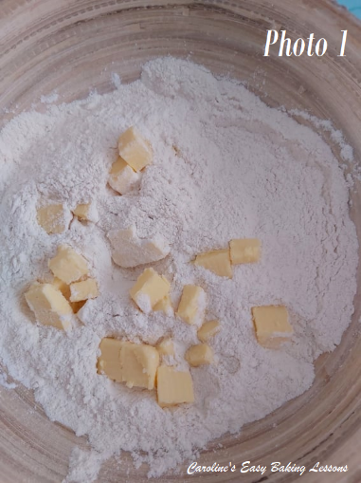
1. Weigh out the butter whilst cubing it and leave out to come to room temperature. I find smaller cubes (about 1/2″ or 1/ 1/4 cm is good since a smaller surface area means they will soften faster). See Photo 1.
If you forget to take out on time, try a hack I reviewed for softening butter in about 12 minutes. **Don’t use melted butter as it won’t create the correct structure. See my video for how to check if your butter is soft enough.
2. Next, lightly oil or grease the baking tray/sheet(s) and place baking/parchment paper on top. I only advise doing this if your baking tray/sheet doesn’t have a lip – I have had cookies slip off the tray onto the floor before! Not good.
3. Weigh or measure in the flour into the large bowl, spoon in the baking powder, give it a mix through & then add in the butter. See Photo 1. I like to then just give a quick mix through, letting the flour coat the butter cubes.
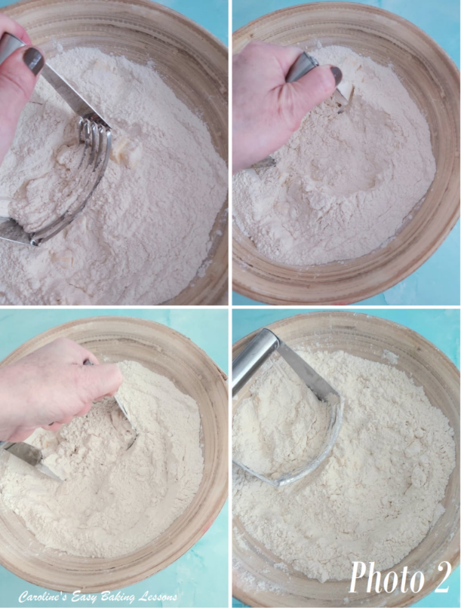
4. Using your fingertips, rub the butter into the flour & continue to do this until the mixture resembles breadcrumbs, tiny pieces). See my new video for how to do this by hand, also know as ‘cutting in’ the butter, which is also used when making pastry.
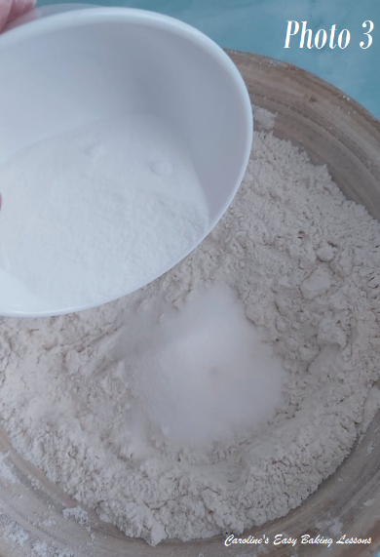
You can also use two butter knives, but I use a pastry cutter/blender for this job as my fingers get sore. (See Photo 2 above). You push down into the bowl and do a squishing motion whilst turning the cutter left and right.
Repeat this until all the butter is now in tiny pieces with the flour. See Photo 2 above or refer to the British scones video (click link below).

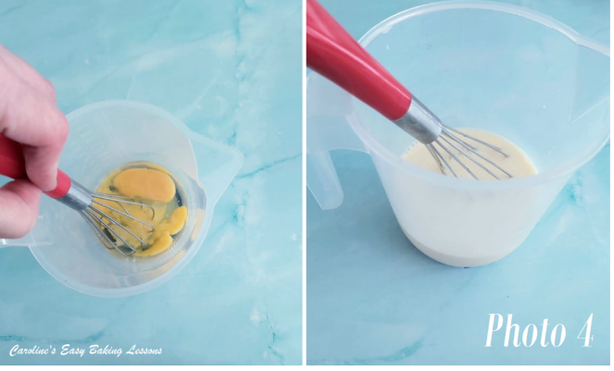
5. Add in the sugar, or put the bowl back onto the scales, TARE to zero, and weigh in the sugar. Give it a good mix through for even distribution. See Photo 3.
6. Put the bowl to the side, and beat the 2 eggs in a jug and then top up to the 300ml (10 fl oz or 1 1/4 cup) mark with the milk, (depending on the size of the eggs, you might not need as much milk). See Photo 4.
7. Give the liquid a good mix and then take 2 tbsp of it out and place in a small bowl to use later.
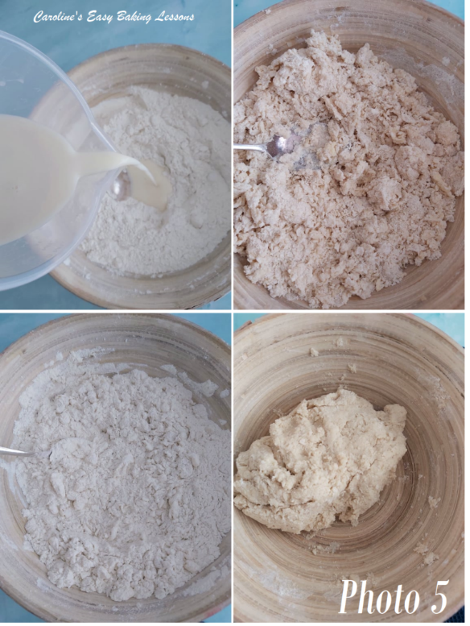
8. Gradually add the egg/milk mixture to the dry ingredients until a soft dough is formed. I tend to use a large spoon to start to mix it in, and then move on to using my hands, ensuring that there is no dry patches at the bottom. DO NOT USE A FOOD PROCESSOR OR MIXER. See Photo 5.
Be aware that the dough being a little sticky is good for the scones to rise. So only add enough of the liquid until just sticky. **So you may not need all the liquid. See Photo 5 or refer to the video for more guidance
9. Lightly flour a pastry board, counter/worktop or use some baking/parchment paper with a little flour on top.
10. Heat up the oven to: 220c/200c Fan Oven/425f/Gas Mark 6.
11. Meanwhile form the dough into a disc & then flatten gently with your hands until you have a level piece of dough about 1 inch (2.5cm) high. (Kids, measure this with a ruler). Try not to go smaller than this. Don’t be tempted to roll out the dough as this won’t help the scones to rise. (See Photo 6 where the tip of my thumb to first knuckle is about 1″/2.5cm).
12. Flour the cookie cutter & cut out the scones. Push cutter down, DO NOT TWIST the cutter. I know it’s tempting, but twisting can ruin the end structure of the scones– you want that characteristic ‘rise & split’ appearance.
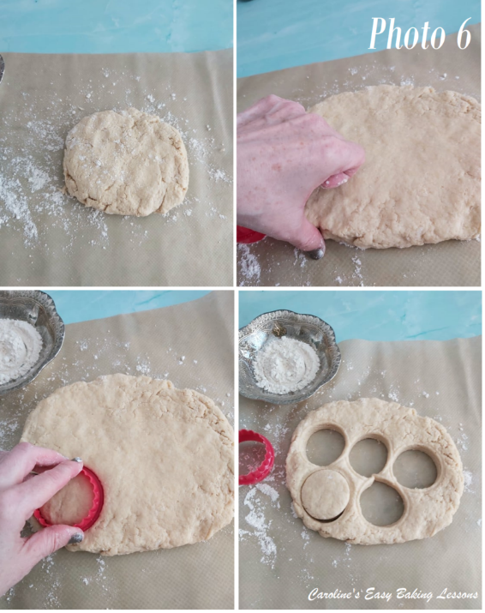
Let it fall onto the prepared tray or leave to the end if it doesn’t come up with the cutter. At which point you can just pull back the excess dough. Try to touch the sides of the scones as little as possible. See Photo 6.
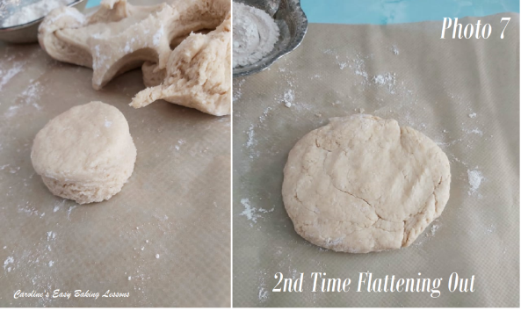
13. Gently roll up the scraps of dough by hand and flatten out to cut out however more scones you can get, remembering to only lightly handle and bring together. Refer to the video for this. Note that these last few scones, won’t be as perfect as the first ones, just because of more handling. See Photo 7.
14. Now using a pastry brush, very carefully brush the egg/milk liquid you reserved earlier, on to the tops of the scones only. If the liquid goes down the sides, it can ruin the rise of the scones.
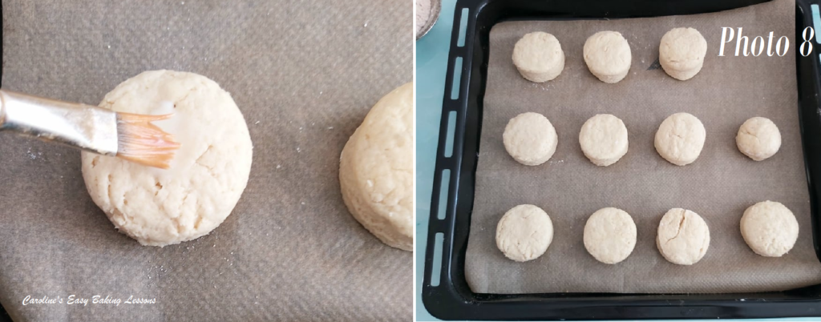
So, the best way to avoid it is by shaking/taping the brush before moving to the scone and starting to brush from the centre and go outwards, so there is less liquid on the brush to spill down the sides. See Photo 8 below & the video.
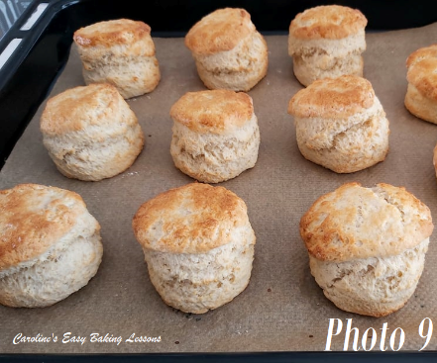

15. Bake for 8-12 minutes until well risen and golden in colour. Now I like to turn and rotate the baking trays between the shelves during baking, to ensure an even bake, (but I need a new oven!). See Photo 9.

16. Cool a little on a cooling rack and enjoy warm with whatever fillings you enjoy. Jam & cream are typical toppings.
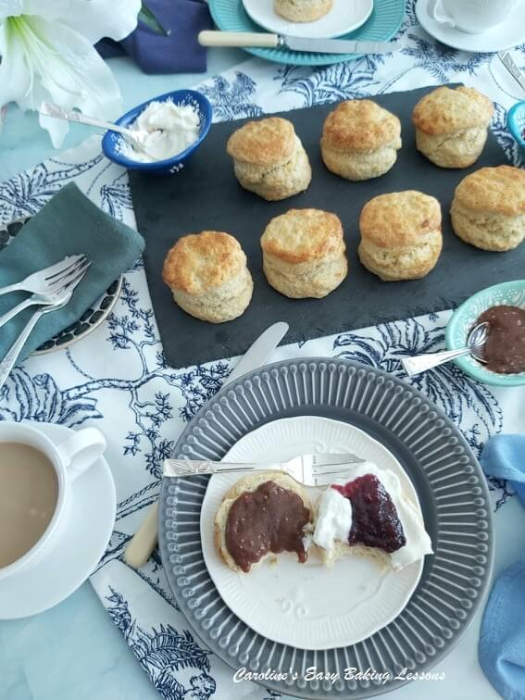
Storing Your British Scones
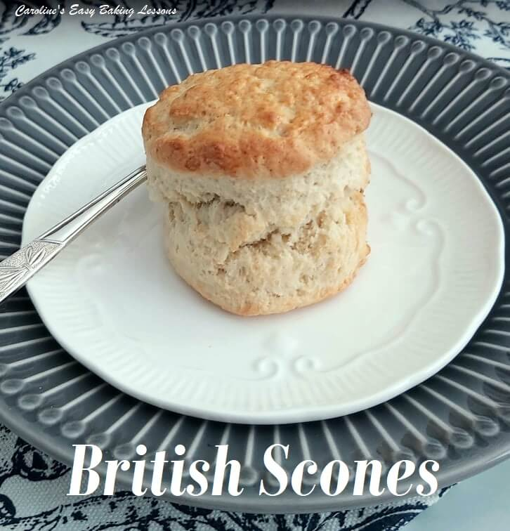
Store the scones in an airtight container, preferably a cake tin, and they will be good for 3 – 4 days, as long as kept away from too much heat.
You can absolutely freeze British scones and defrost at room temperature. After which, heat a little in a warm oven or slice in half and microwave for 20 seconds only.
Caro xxx
https://easyonlinebakinglessons.com

