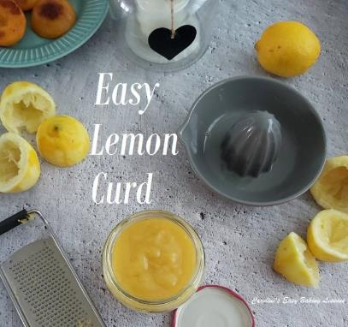
EASY LEMON CURD
Caroline’s Easy Baking Lessons

TRY MY SIMPLE LEMON CURD RECIPE, USING WHOLE EGGS OR JUST YOLKS
For the Valentine’s/Birthday cake for my husband this year, I had a lot of components to make and I wasn’t very well in the few days leading up to it. So everything was done at the last minute and I needed some help from my 13 year old son, who also likes to bake sometimes. While I was making Swiss meringue buttercream, my son made lemon curd. He made it all himself and I have to say it was really good. Nice and thick and zesty. And then I thought, why don’t I have this recipe on the website yet? So if he can make it, so can you. No special equipment is required, just a little time and obviously lemons
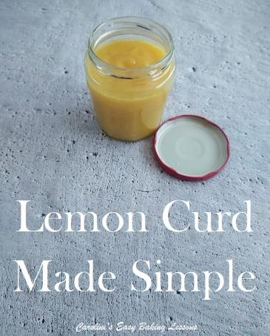
This recipe is for a reasonable amount of lemon curd, and I filled an old Lidl jam jar with it. That was a jar that held 450g (15.75 oz) of jam. And I calculated that to have a capacity of about 1 1/2 cups or 12 fl oz. This would be enough for any baking project. Filling 12 cupcakes with about 1 tsp lemon curd would use about 1/2 cup of the curd (1/3 of the batch).
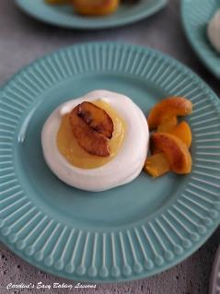
But if you want to make smaller amounts of lemon curd, or make according to however many eggs you have, I have included further down, how to also make 1/2 cup, 3/4 cup & 1 cup worth.
USING JUST EGG YOLKS
The recipe can also be changed up slightly if for example you have left over yolks after making meringue. You don’t always need all the egg to make curd. But you do need yolk. Just bear in mind though that it’s not a straight swap from 1 egg to 1 egg yolk. One egg is made up of about 30% yolk and 60% whites (the remaining 10% being the shell). So as a guide you could replace 1 whole egg in a recipe, with say 3 yolks. So for this recipe below that requires 6 eggs, 18 yolks instead would also work. Hope that makes sense. If not, let me know. I have included also tables below, with some other combinations for how it can be made. Please bear in mind too, that the recipe is based on medium eggs (UK size), which equates to about Large size in the US. For your reference, UK medium can range from 63 – 73g (2.25 – 2.5 oz).
Here are the number of eggs needed for making 1/2 – 1 1/2 cups (4 – 12 fl oz jar capacity) amounts of lemon curd. I have also listed in each of the tables, alternatives, if for example, you have left over egg yolks to use up (from say meringues or Angel Food Cake).
Example from Table 1(12 fl oz curd), instead of using 6 whole eggs, you can use 4 whole eggs and 6 yolks. Note for this table, you are using the recipe ingredients as listed below.

MAKES 1 1/2 Cups (12 fl oz) CURD | USING…
6 whole eggs | — OR
5 whole eggs PLUS | 3 Yolks
4 whole eggs PLUS | 6 Yolks
3 whole eggs PLUS | 9 Yolks
2 whole eggs PLUS | 12 Yolks
1 whole egg PLUS | 15 Yolks
————– | 18 Yolks
Table 1 – Making 1 1/2 Cups (12 fl oz) Lemon Curd

For making 1 cup (8 fl oz) volume of Lemon Curd, see Table 2 below. Note that for that amount of curd, you need zest & juice of 2 medium lemons, 134g Sugar (2/3 cup, 4.75 oz) & 90g butter, unsalted (1/3 cup, 3 oz) as well as the eggs/yolks listed below in Table 2, in any combination you have.
MAKES 1 Cup (8 fl oz) CURD | USING…
4 whole eggs | — OR
3 whole eggs PLUS | 3 Yolks
2 whole eggs PLUS | 6 Yolks
1 whole egg PLUS | 9 Yolks
————– | 12 Yolks
Table 2 – Making 1 Cup (8 fl oz) Lemon Curd

For making 3/4 cup (6 fl oz) volume of lemon curd, use Table 3 below for the number of whole eggs and/or yolks. For that volume you will also need zest & juice of 1 1/2 medium lemons, 100g Sugar (1/2 cup, 3.5 oz) & 67g butter, unsalted (1/3 cup, 2.25 oz).
MAKES 3/4 Cup (6 fl oz) | USING…
3 whole eggs | — OR
2 whole eggs PLUS | 3 Yolks
1 whole egg PLUS | 9 Yolks
————– | 12 Yolks
Table 3 – Making 3/4 Cup (6 fl oz) Lemon Curd

For making 1/2 cup (4 fl oz) volume of lemon curd, use Table 4 below for the number of whole eggs and/or yolks. For that volume you will also need juice & zest of 1 Lemon, 67g Sugar (1/3 cup, 2.25 oz), 45g Butter, unsalted (3 tbsp, 1.5 oz)
MAKES 1/2 Cup (4 fl oz) | USING…
2 whole eggs | — OR
1 whole eggs PLUS | 3 Yolks
————– | 6 Yolks
Table 4 – Making 1/2 Cup (4 fl oz) Lemon Curd

Caroline’s Easy Baking Lessons @ https://easyonlinebakinglessons.com

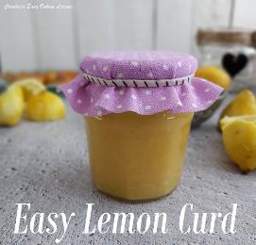
EQUIPMENT
- Sharp knife
- Juicer
- Scales or measuring cups
- Measuring spoons
- Wooden spoon
- Small Pot
- Stove top
- Small Jar
- Small Funnel (optional)

INGREDIENTS
- Zest of 3 Lemons
- Juice of 3 Lemons
- 200g Granulated Sugar (1 cup/ 7 oz)
- 6 Med – large Eggs
- *(or see alternatives in Table 1 above)
- 135g Butter, unsalted (rounded 1/2 cup, 4.75 oz )
- (See note above about just using yolks, & Tables 1 – 4 for
- making a different volume of curd.

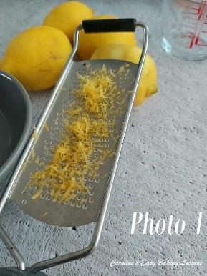
INSTRUCTIONS
1. First begin by zesting your lemon into the cooking pot.
2. Next, roll the lemon on the worktop/counter before cutting in half. This helps break the membranes, allowing more juice to be squeezed out. If you have any small old lemons, don’t bin them. Pierce a few holes in it with a knife, place in a bowl and put in the microwave for 30 seconds. Check and if it’s not hot yet, heat again for another 30 seconds. Once hot, roll whilst still in the bowl and then squeeze the juice as normal. You should get a lot of juice this way. So for this recipe, if you only have quite small lemons, I would advise using the juice of 2 of them. See Photo 2 below.

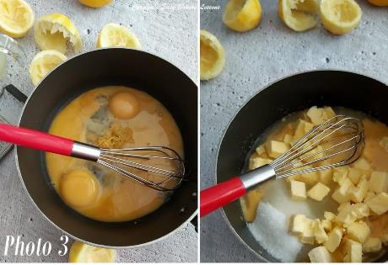

3.Weigh or measure in the sugar, before adding in the lemon juice, eggs and butter. Heat on a low-medium heat until the sugar is dissolved. Stir every so often until the sugar is dissolved. See Photo 3.
4. Increase the heat to medium and continue to stir until the mixture begins to thicken. To test when it’s ready, lift the spoon up, turn it over and lay across the pan. With a finger (or something similar, like the end of a small spoon, be careful as it will be very hot), drag a line through the curd on the back of the spoon. If it is now ready, there will be a clear line made. (See Photo ). It should also have more of an opaque consistency, with a sold lemon/yellow colour. (See right pic in Photo 4 below). If not, continue heating and stirring and check every 5 minutes till ready. Don’t worry if your curd is not quite as thick as mine. It will thicken more on cooling.
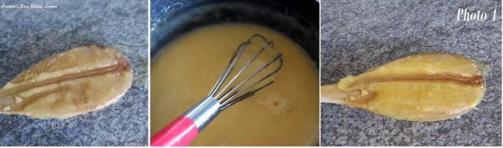
5. Leave the curd to cool a little, and meanwhile warm your jar by filling with hot water. Then rinse out thoroughly. Then fill with your homemade lemon curd. See Photo 5. Best stored in the fridge.

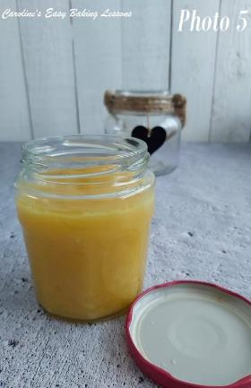
TOP TIP – If you use a different recipe and have very lumpy curd, just push it through a fine sieve.

See here the lemon curd used with my mini meringue nests (recipe coming soon, with several filling suggestions for summer desserts).

DIFFICULTY LEVEL: super simple, beginner

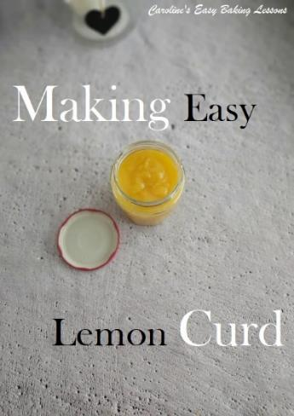
Thanks for reading
Happy Baking & Making
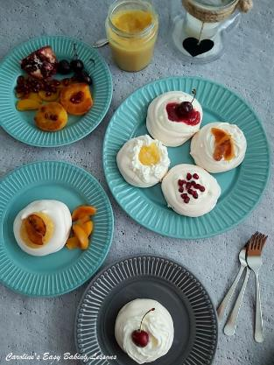
Happy Tummies & Memories!

Caro xx

