USING NANCY BIRTWHISTLE'S CAKE TIN LINING PASTE
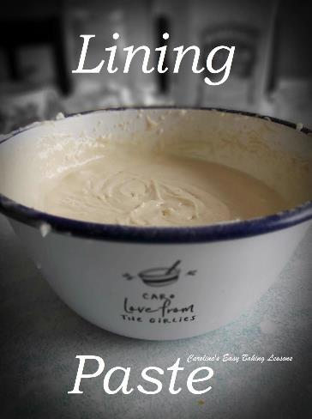
Caroline’s Easy Baking Lessons

Most people will know who Nancy Birtwhistle is but if not, she won The Great British Bake Off, (The Great British Baking Show), series 5 in 2014. She has daily baking and household tips on Instagram and her own website, and most recently released a new book called Sizzle & Drizzle. This is a recipe of hers I tried for my cake not to be partly stuck in the bundt pan. Normally I would have brushed butter or baking spray on the insides of the tin and then lined with a coating of flour. My bundt pan is a good solid one, and usually comes out well, with just a few taps, but wanted to try Nancy's recipe on this occasion.

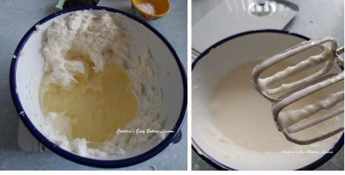

So I was making an orange drizzle cake to review, and before filling the bundt pan I made up Nancy's lining paste. It is made up of plain (All purpose) flour, vegetable shortening (Trex/Crisco) and vegetable oil. You simply mix the pieces of shortening and flour with a hand or stand mixer, until it resembles large breadcrumbs. Then mix in the oil gradually, while mixing, until you have a very thin smooth paste. And that's it! Just store in a glass jar, in the fridge and use whenever needed. I found using a good brush, softens the paste enough to be able to apply it easily to your pan, straight from the fridge.

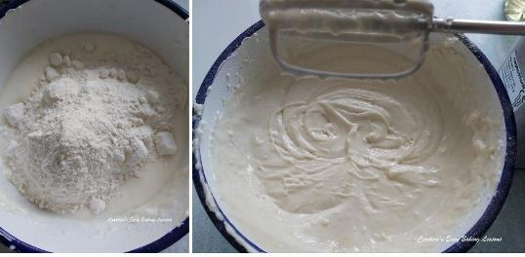
** Note at a later date, I prepared slightly differently, as in Photos 2 & 3. I beat the shortening before adding in the oil & mixing together. Then I added the flour and mixed well. This method worked just the same and was tested on the bundt cake in the Photo further down.

As I mentioned, I tested it on my bundt tin. I started brushing at the bottom, and on the middle area, working in upwards strokes. This is a tip for when making lava cakes or souffles, brush in upward strokes to encourage upward growth and brushing horizontally would create friction. See Photo. Once the middle sections were done, I brushed up the sides in the same way, applying a thick generous layer, paying attention to the difficult areas of the tin.
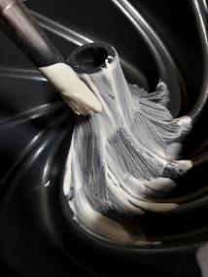

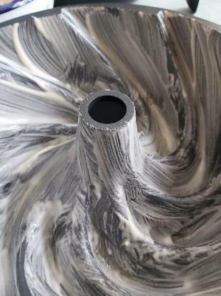
Then I simply filled the pan with my cake batter and baked as normal. After baking, as for all bundt cakes, leave in the tin to cool down. As this recipe included a drizzle, this was applied while 'upside down' if you like, so was cooled before I tried to turn the cake out. Now normally I give my bundt pan a few taps to release it, but when I was applying my drizzle, I could tell the cake was not sticking to the sides of the pan. So after putting a tea towel on top of a cooling rack and flipping everything over, the cake literally just popped out. Nothing stuck. All intact, even though the cake was now softer with the moisture of the drizzle. You could see all the definition of the bundt cake. See Photo below.

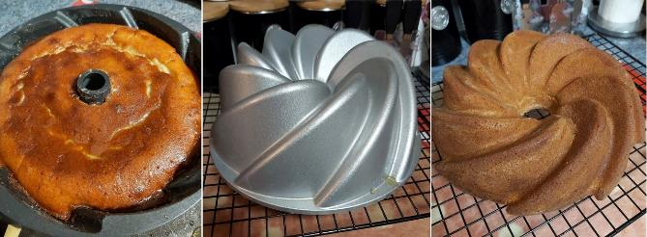

I was not too pleased with cake recipe I used, so will be using my own lemon poppy seed drizzle cake next time and making it orange and lemon. But as for the lining paste, well I highly recommend it. It worked as it's supposed to and was extremely easy to make and you don't have to make it up every time you need it. A cheaper alternative to expensive release sprays or butter.

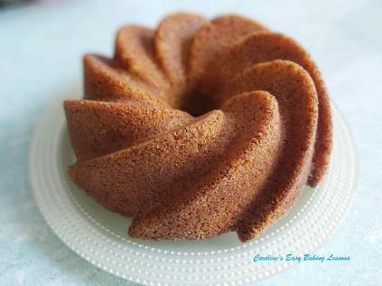
So for my rating of this recipe I give a 10/10, the highest I have ever given out. And that is down to it "doing exactly as it says on the tin"! Well worth the 10 minutes preparation time. Saves your beautiful cake being ruined and could not be simpler to make. Now I believe the recipe for this is in Nancy's book, but below I have included the US/Canadian cup measurements for your convenience. You can get Nancy's book only via her website, and the cost includes delivery to overseas if wished, as well as it being a signed copy (for a limited period only). It is a big hardback with 400 pages and special SQ technology that enables you to watch the videos for the recipes on your mobile phone. Here's a direct link to get the book: Get Nancy's book

**See my video for how I apply the lining paste & how easily the cake releases from the tin.
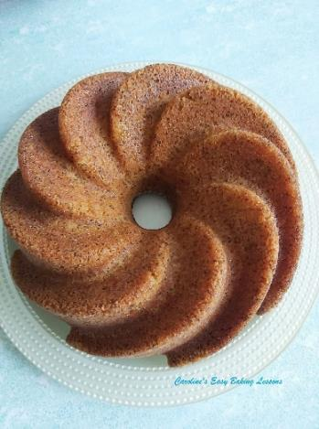

TOP TIPS

1. For hygiene and to preserve the life of the paste, remove a few tsp worth into a little dish and apply from that, rather than continually dipping into the paste jar.
2. For chocolate or darker cake, remove a few tsp from the jar and mix will a little cocoa powder and mix well. Add just enough to make the paste a pale brown colour. I would include carrot cake and any cake or bakes using wholewheat/meal flour.
3. For Gluten Free version, just use a generic Gluten Free blend (plain/All Purpose flour)

US/CANADIAN CUP MEASUREMENTS

1 cup (125g/4.5 oz) Plain/All Purpose Flour (or Plain/A.P. Gluten free Flour)

2/3 cup (125g/4.5 oz) Vegetable Shortening (Trex in UK or Crisco in the states)

1/2 cup (125ml/4.25 fl oz) Vegetable Oil

Just whisk all the ingredients together to form a smooth paste.

*This will make and mostly fill about a 500ml or 1/2 litre (17 fl oz) jar (making about 2 1/4 cups worth).

*Store in the fridge and keep as long as the shortest used by date off the ingredients.

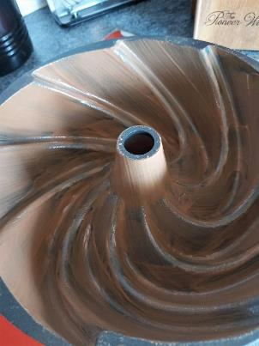
FOR DARKER COLOURED CAKES

*** If you want to use on a chocolate or red velvet cake, take a few tsps of the paste out and mix in a little cocoa powder just to change the colour of it and use as before. See photo 9 below. It worked and again the cake just fell out of the tin.

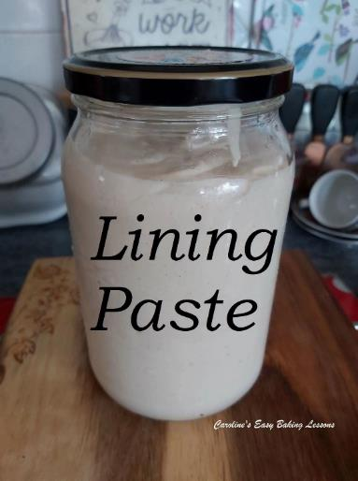

Happy Baking & Making

Happy Memories & Tummies

Caro x

