SPEEDY CHEESE SWIRLS
Caroline’s Easy Baking Lessons Yeast-Free Snacks In A Hurry
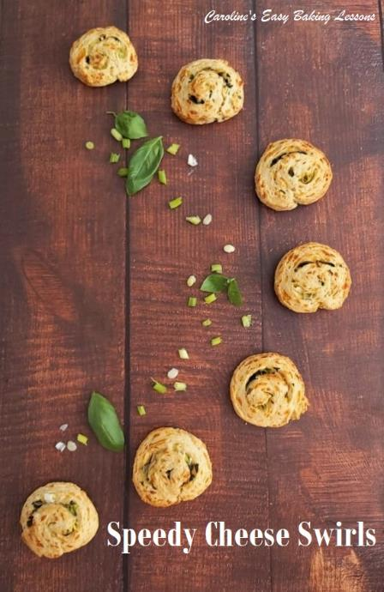
This is my adaptation of a recipe I reviewed about April or May 2020, (from ‘National Trust Teatime Baking Book – Good Old Fashioned Recipes’, by Jane Pettigrew (2014), when there were lockdowns, & shortages. It’s a great beginner baker recipe and you could easily get the kiddies helping with them. It’s a speedy recipe, when you want something cheesy, but have no time (or energy) to make a yeast dough or puff pastry and don’t have any shop bought puff pastry in the freezer.

A NOTE ON INGREDIENTS
You can roll up with any cheese you like but in the dough it’s best to have cheddar and mature/sharp at that, just to give the dough a nice taste. The dough is also made using self-raising flour. You can also use self-rising flour, but I have also tried them out using plain/All Purpose flour, but just added some baking powder to help them rise a little. All details are given in the ingredient list.

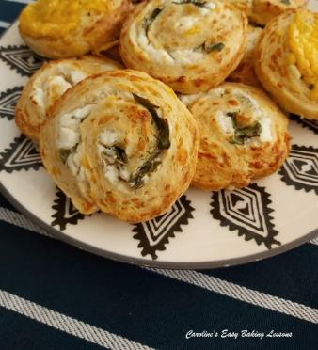
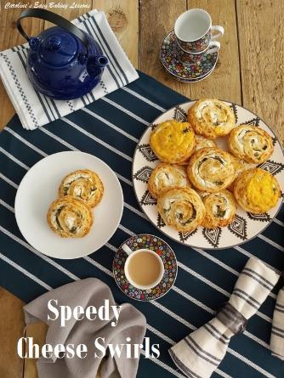
A great ingredient for any cheese bake is mustard powder. You can get this, by Coleman’s in the bigger supermarkets where the mustard and pickles are. An alternative I have been known to use is Smoked Paprika. Not the spicy one, and the smoked one gives a nice flavour. If you want to try the spicy one, I would suggest trying with the non-spicy version first just to see how it is.

As mentioned, you can roll up with any cheese fillings you like. I have used the extra mature Scottish Cheddar (extra sharp cheddar) and added some leeks before, (and I just left the ends with no leek so my youngest could have it). So you can make 2 different versions from the same roll. The cheddar with spring onion & basil is lovely. I also do with ones using Turkish soft creamy cheese (Peynir). You could use Feta, but that’s not as soft. Any soft cheese, mozzarella etc will work. For these white cheese ones, I added flat leaf parsley and a little bit of dill. The possibilities are endless. I am going to make some sweet ones sometime.

EQUIPMENT
Scales or Measuring Cups Measuring spoons
Grater/shredder Chopping board
Med-Large Mixing bowl
Baking spatula or wooden spoon

Measuring jug
Fork
Baking/Parchment paper
Scissors
Spare flour for rolling out
Rolling pin
Sharp knife
Large or 2 medium baking trays/sheets
Timer
Cooling rack

OVEN: 220c/200c Fan oven/425f/Gas Mark 7

INGREDIENTS
- 350g Self Raising Flour (12 1/4 oz, 2 3/4 cups) (OR Plain/A.P. Flour, plus 4 tsp Baking Powder)
- 1 1/4 tsp Mustard Powder** (or Smoked Paprika)
- 1 1/2 tsp Salt
- 1 tsp Garlic Powder/granules OR 1 -2 Garlic cloves grated
- 3/4 tsp Onion powder/granules (optional)
- 50g Butter Cubed (Unsalted, for salted butter half salt added) (2 oz, 1/4 cup)
- 1 Egg, medium to large
- 150ml Milk approx. (5 fl oz, 2/3 cup)
FOR THE FILLINGS:
Sharp Cheddar, soft white cheese, about 100 – 150g/5.25 oz, spring onions/green onions, finely chopped onion, basil, dill, flat leaf parsley, choice is yours.

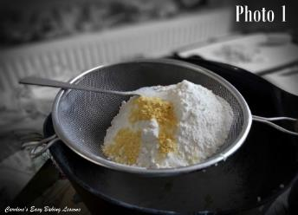
INSTRUCTIONS
1.Begin by washing and drying any herbs you might want to use.

2.Prepare a large baking tray/sheet or 2, by lining with baking/parchment paper (hold in position with some oil if there is no lip on this or your baking can go flying onto the floor).

3. Also prepare your area that your will roll out the dough on. I like to use baking/parchment paper to save on the mess. I buy quality paper, and often keep it and re-use it. Cut out a piece 35cm at it’s longest (14″). Have some additional flour handy for rolling out & place with the paper, to one side while you prepare the dough.

4. Heat the oven to: 220c/200c Fan Oven/ 425f/Gas Mark 7.

5. Start by adding the flour to a medium-large mixing bowl, and adding in all the dry ingredients – salt
(baking powder if using Plain/A.P. flour only), mustard powder (or smoked paprika), garlic & onion powder/granules. See Photo 1 above. Mix till combined.

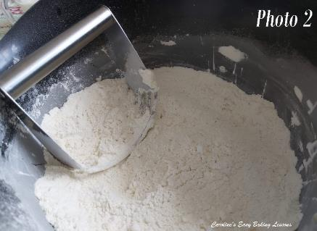
6.Now add in the cubed butter and by hand or using a pastry blender, ‘rub in’ the butter to the dry ingredients. This is like in pastry and scone making, where you are blending it to a ‘breadcrumb’ like consistency. However, there isn’t much butter in this recipe, so only a light rubbing of the flour and butter between your fingertips is required. Lift up between your fingertips, rub and let fall back into the bowl, before moving onto the next area and repeating. ( See my video 5 minutes, in if you want to learn this method more). You can also use a pastry blender/cutter to do this. Just push down on the bottom of the bowl, and perform a twisting left and right motion.
Then lift up and repeat on another area. This is great if you have hands/fingers that tire easily like me. But as said, there’s not much butter in this recipe, and so only maybe 20-30 seconds is required. See Photo 2.
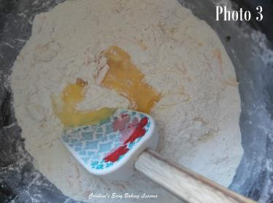
7. Now add in the grated/shredded cheddar cheese and mix through. **Note – if you want melted cheese on top of your swirls, only about 3/4 of the cheese at this stage and reserve the rest for later).
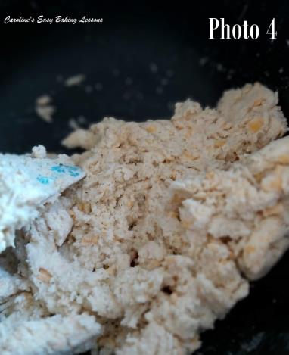
8. Make a well in the middle and add in the egg. Give it a whisk in this hole, and then add in half of the milk, & mix just the milk & egg together.
9. Now use a baking spatula or wooden spoon to mix the milk and egg with the dry ingredients. Keep pushing down on the flour, and let it take on as much of the liquid as possible, before any in any more small drops of the milk. You want the mixture to come together into a very rough ball that will be just a little sticky. So very gradually add the milk. You might not need all the milk, or might need a little more.
10. Place your ready-cut piece of baking/parchment paper down & dust that and your rolling pin with some flour.
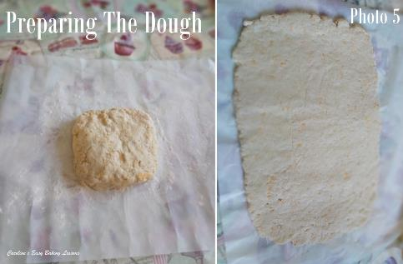
11. Next gather the dough together into a rough ball and then place onto the centre of the paper and form into a square or rectangle. See Photo 5.
12. Roll out the dough to a rectangle of about size 22.5 x 30cm (9×12″). See Photo 5.
13. Next sprinkle on top of the dough, all your prepared fillings. Note in Photos 6 & 7, I left the ends bare and that was just so my son, who doesn’t like all of the ingredients, could have some too. You can of course spread all your fillings to the ends. (For the soft cheese though leave just a little gap at the ends just in case). See Photos 6 & 7 below.
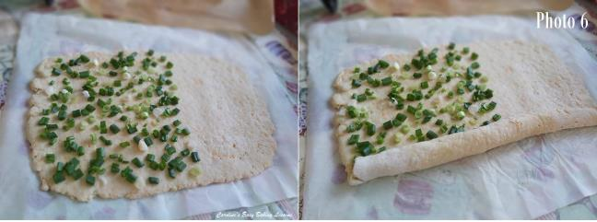
14. Now very carefully bend over the end nearest you and begin to roll up the dough. (Make sure you have the dough with the widest length running across the way, as in the photos, so you can cut more pieces). Squeeze a little once at the end and press down the seam to make it stick together, and leave seam side down.

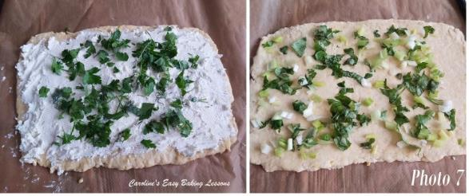
15. Using a long sharp knife, cut the roll of dough into slices about 1.5cm (2/3″) wide. This will make about 15 slices. See Photo 8.
16. Carefully re-shape any that have got a little squashed and lost their shape on cutting, before you place onto the prepared baking trays/sheets. See Photo 9 below.

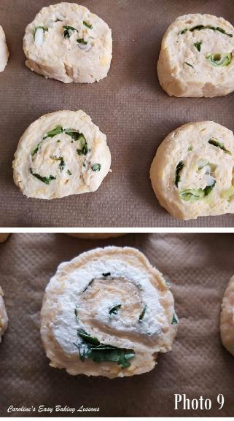
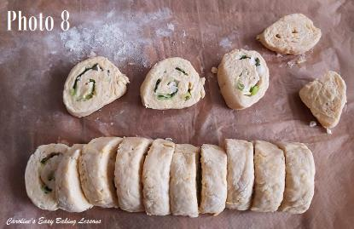
17. Leave at least 2.5cm/1″ gaps between the slices, (see Photo 10 ), and then pop in the oven to bake for 14-20 minutes.
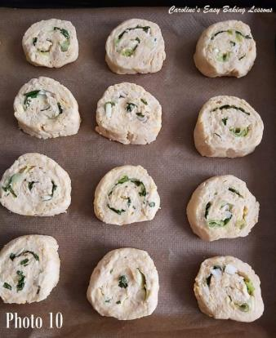
**Note if you want to add a little cheese to the top of the slices, only set your timer to bake for 10 minutes. Then add the grated/shredded cheese on the top of the part-baked swirls, before putting back in the oven and baking till done. See Photo 11 of the 2 different types of fillings, part baked. The swirls are ready when golden and the undersides are set and firmed up.
18. Remove from the oven, and place the baking sheet/tray on top of the cooling rack for 5 mins, before transferring, paper and all to the rack to cool down almost completely. See Photo 12.
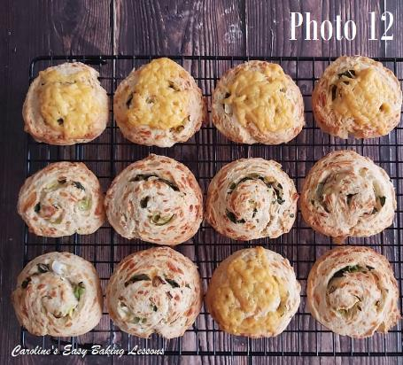
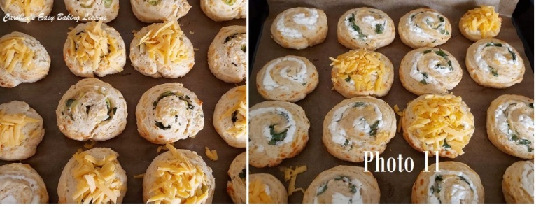
19. Can be eaten just a little warm, cold or even re-heated in a moderate oven for 5-10 minutes. Freeze great too, just wrap individually in paper and then with some cling film/plastic wrap or foil and a food bag. Defrost at room temperature. Will last at least 2 days if in a sealed container.

DIFFICULTY LEVEL: easy, beginner

Caro xx

