LEMON POPPY SEED DRIZZLE BUNDT CAKE
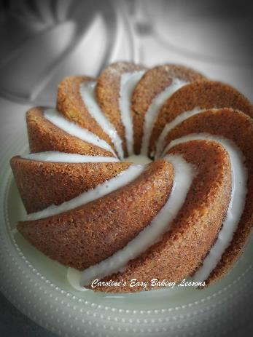
Caroline’s Easy Baking Lessons
This lemon and poppy seed drizzle cake is for lemon cake lovers. It has a great tart lemon taste, crunchy outer texture and soft inner. The addition of poppy seeds gives a surprisingly nice experience as it gives a texture you weren’t expecting. The seeds literally ‘pop’ in your mouth. The recipe is for a deep Bundt pan, but you can of course use any large/deep cake pan. Just remember that the mixture will rise once baked, so don’t over-fill.
A Note On Ingredients:
*For the UK ground almonds, it is a little more course than almond flour and more like almond meal. But if you can’t get this, you can crush and then process almonds (skins on) to like almond meal. There are YouTube videos of this on Google.
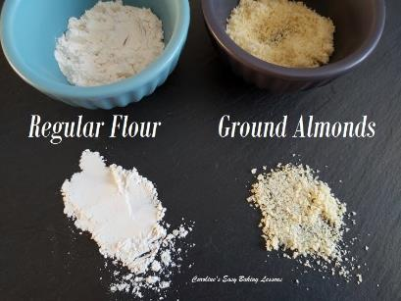
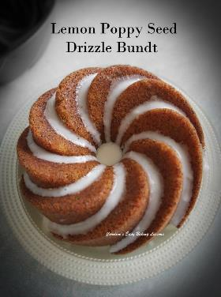
Note that almond flour will not give the exact same texture once baked, as ground almonds or almond meal, since their purpose to provide added structure to the cake. It is often used in cakes that are a bit more dense, so that they can take the added weight compared to light and fluffy cake which is less stable. Here’s a photo of a ground almonds. A true alternative for our UK icing sugar is powdered sugar. However is you only have Confectioners’ sugar, that will be fine too for the glaze. If you would like to read more about the different names with UK & US baking ingredients, go to my article.

INGREDIENTS
- 250g Butter, softened & cubed (1 + 1/8 cup or 8 3/4 oz)
- 2 tsp Baking Powder
- 4 Eggs (med – large)
- 250g Self-raising Flour (8 3/4 oz)
- ( OR 2 cups All Purpose/Plain Flour + 3 1/2 level tsp baking powder)
- 250g Granulated Sugar (1 + 1/4 cup or 8 3/4 oz)
- 50g Ground Almonds* (see above) (½ cup Almond meal or 1 3/4 oz)
- 3 tbsp Poppy Seeds
- 4 Lemons, zest only
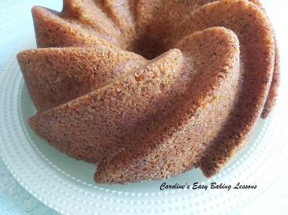
- 100ml Hot water (up to 7 tbsp or 3 1/4 fl oz)

FOR THE LEMON DRIZZLE
- 10 tbsp Lemon juice (150ml, 2/3c, 5 fl oz
- (from the lemons above)
- 8 tbsp Granulated or Caster Sugar
- (Regular or Super/extra fine sugar is fine since it will be cooked)
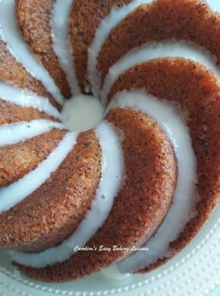
FOR THE LEMON ICING/GLAZE
- 125g Icing sugar, sieved (1 cup, 4.5 oz Powdered sugar)*
- Some Lemon juice (lime is also nice)

EQUIPMENT
- Scales or measuring cups
- Large mixing bowl or stand mixer bowl
- Sieve
- Measuring spoons
- Hand/Stand mixer
- Wooden spoon
- Small measuring jug
- Spray Oil, butter, or cake lining paste (See instructions), for greasing
- Bundt cake tin about 25cm/10 inch wide. Bigger or a bit smaller is fine. Any cake tin that can take a large quantity as the cake will rise.
- Timer or Phone Timer
- OVEN:180/160c fan oven/350f/Gas Mark 4
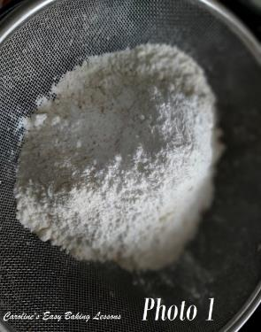
INSTRUCTIONS
1. Weigh out the butter, while cubing it & leave out on the worktop/counter to soften & come to room temperature. I cut to about 1cm (1/3″) squares as a smaller surface area will soften quicker and be easier to work into your batter. If you forget to take the butter out, here’s a hack I reviewed for softening the butter in about 12 minutes – got to review video.
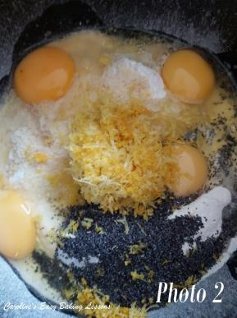
2. Once the butter is softened, place your large mixing bowl over the scales, with a sieve on top and set the scales to zero (tare). Weigh in the flour through the sieve and then add the baking powder also through the sieve. Alternatively add your cups of flour, making sure to sieve it. See Photo 1.
3. Remove the sieve, set the scales to zero (tare) and weigh in the sugar and ground almonds (almond meal).
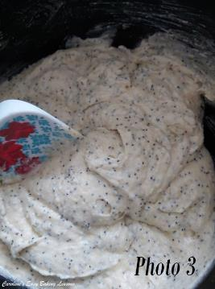
4. Next add in the softened butter, eggs, poppy seeds & lemon zest. With a hand/stand mixer, mix together until it comes together and is evenly distributed. You can of course do by hand with a wooden spoon and beat it well. Note the batter will be very thick. See Photo 2.
5. Heat up the oven to 180c/160c fan oven /350f/Gas Mark 4 (or do so sooner if your oven takes a longer time to come to temperature).
6. Now add the hot water & mix to get a slightly thinner consistency (note it will still be a thick batter). See Photo 3.
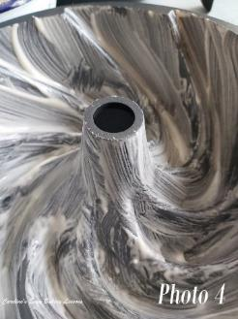
7. Generously oil or grease & flour the cake tin or use baking paper if not using a Bundt pan. You can also use cake lining paste – try this recipe for it that I reviewed, by Great British Bake Off winner Nancy Birtwhistle. It is excellent for bundt pans & more economical for any greasing you have to do – go to lining paste. See Photo 4.
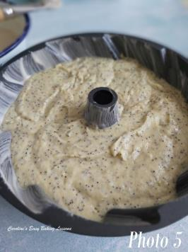
8. Pour the mixture into the cake tin and give a gentle couple of bangs on the worktop/counter to flatten out and expel any trapped air. See Photo 5.
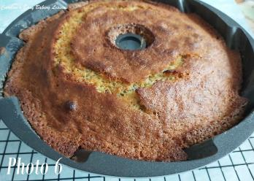
9. Bake the cake for approximately 25-35 minutes till deep golden and risen. My oven doesn’t cook evenly, so I turn the baking sheet the cake tin is on, after about 15 minutes and continue baking for 10 minutes. (Note I always wait till after the half way point to do this). From there I check every 1 or 2 minutes by inserting a wooden cocktail stick into the centre of the cake. If it comes out clean of crumbs, then the cake is ready. If not, continue cooking for another minute and check again till ready. (See Photo 6 ). Another visual cue is when the cake is coming away from the sides of the pan.

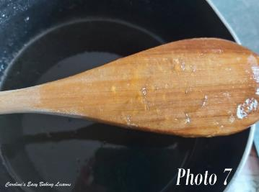
10. While the cake is baking, make up the syrup drizzle. Place the lemon juice and sugar into a small pan and heat it gently on low-medium heat, until it comes to a boil. Let it boil until the mixture is thick and syrup like. Remove from the heat and leave to cool down. It will thicken more on standing. If your aren’t sure, you can check it’s ready by dipping the wooden spoon in the syrup, turning it over and running your finger (or something similar as it will be very hot) across the spoon. You are looking for a visible line. See Photo 7.
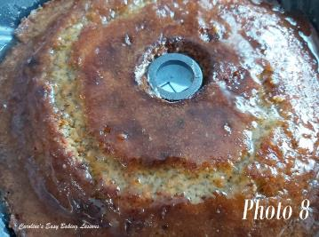
11. Leave the cake in the tin to cool down for 20 minutes & place on top of a cooling rack.
12. With the cake still in the tin, using a wooden cocktail stick, or BBQ skewer, make lots of holes all over the top of the cake, and go deep so lots of drizzle can soak in. If using the bunt tin, go down as deep as you can to almost the bottom, (which will become the top).
13. Now drizzle over the lemon syrup drizzle, making sure to go over the holes you made. See Photo 8.
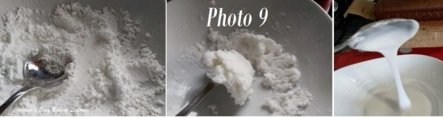
Making Glaze Very Gradually
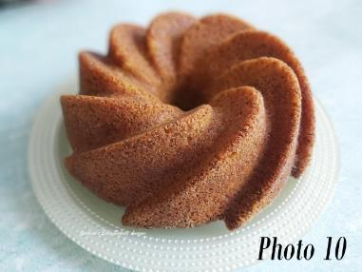
14. Leave to soak & cool down for at least 30 minutes, while you make the icing/glaze. Set a bowl over the scales with a sieve on top and set to zero. Weigh and sieve in the icing/powdered sugar. Now add the juice until you get a thick but pouring consistency. If too running, sieve in a little more icing at a time and mix well. I start off with only a tsp of liquid at a time and take my time to hand mix and push down to get the sugar to take on the liquid. Don’t rush the process or you will get too runny a glaze. See Photo 9 above.
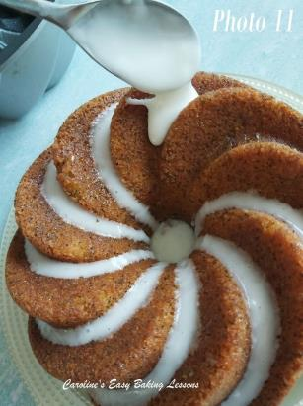
16. Turn the cake out onto a serving plate or cake stand (position on top, hold both together and turn over). With the use of the lining paste, it should come out very easily. See Photo 10 above. Now drizzle the icing over the top of the cake however you wish. I like the icing/glaze to drizzle down the sides of the groves of the bundt tin. To do this, your glaze shouldn’t be too runny. Spoon a small amount of the glaze on top of one of the groves and let it drop down the sides (inside and outer). You can give it a helping hand and guide it down gently. See Photo 11.
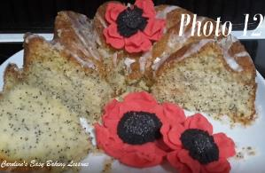
17. Leave the cake out for the icing to set and later enjoy with a tea or coffee. Slice with a large sharp knife.
18. Store in an airtight container for a few days. You could also freeze the cake undecorated, even in portions. Just wrap really well with baking/parchment paper and then cling film/plastic wrap and then put in food baggies. Leave out at room temperature to defrost.
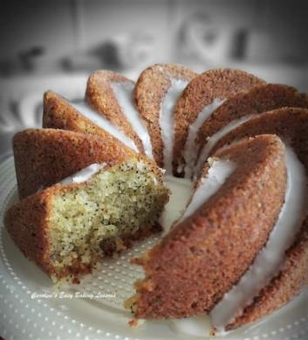
Here’s an old pic (Photo 12) from nearly 2 1/2 years ago, when I made some fondant poppies, including real poppy seeds in the centre.
DIFFICULTY LEVEL: Easy, beginner with guidance

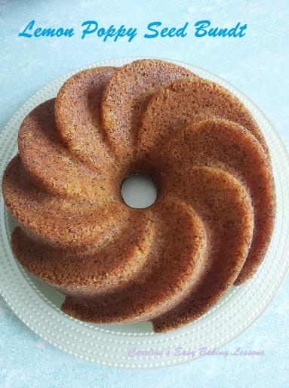
Thanks for reading

Happy Baking & Making
Happy Tummies & Memories!

Caro xx

