RASPBERRY SWIRL CUPCAKE TUTORIAL
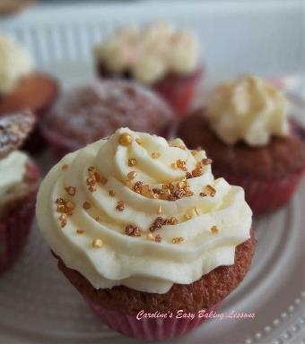
FROM: Caroline’s Easy Baking Lessons

SWEET LESSON NO. 3

***ALWAYS read the recipe through well before planning to do it or even weighing anything out. Often butter needs to be left out to soften & come to room temperature. The same can be said for eggs, if you store in the fridge only ever bake with ones at room temperature. In addition to these reasons, in my recipe lessons, if I can dirty even 1 less plate or bowl, then I will include this. For example weighing ingredients in order into the same bowl instead of weighing out into several individual bowls. You will also need to know what you will be baking in and adjust accordingly. Make sure you refer back to Lesson 1a - ESSENTIAL EQUIPMENT along with this recipe.
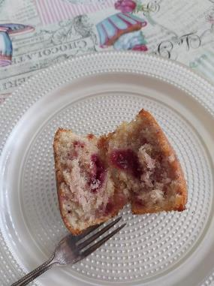

If you forget to take out the butter to soften in time, see this video, where I reviewed a hack to soften butter in about 12 minutes.

A little note on the ingredients - If you are in the US/Canada and can't get extra/super fine sugar in place of the UK caster sugar, you can make your own by grinding regular granulated sugar a little bit or processing lightly. Do not go as fine as a powder, keep it as small granules, because US granulated sugar is slightly smaller granule size than ours in the UK. See the photo below for the sugar we have in the UK.
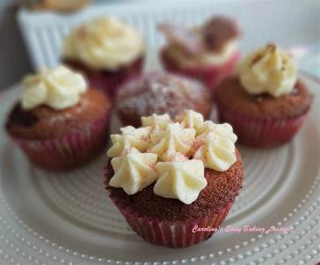

You can also read my article on the differences between UK and US/Canadian baking ingredients, including the different names used - go to article. The recipe is also based on using UK self-raising flour. This is slightly different to US/Canadian Self-rising flour. For using Plain or All Purpose flour, I recommend adding 3 tsp plus a level 1/2 tsp of baking powder to the flour for this recipe.

UK SUGAR - icing/powdered sugar (L), Caster Sugar (C) & Granulated Sugar - UK (R)

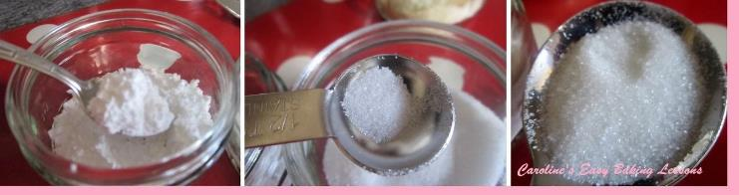

I have also made a video to accompany the recipe for beginner bakers, and also updated the photos. 2 years ago my camera didn't take such good photos as the phone I have now!

INGREDIENTS

225g Butter, unsalted, cubed and softened (1 cup/2 sticks)
225g Castor sugar (1 & 1/8 cup of extra fine or super fine sugar - see note above*)
4 Medium - Large Eggs
Splash of Vanilla Extract
225g Self-raising flour, sieved
OR 1 & 3/4 cups All Purpose/Cake or Plain Flour, plus 3 & 1/2 Level tsp baking powder + scant ½ tsp salt ** See notes above.
6 - 8 tbsp Raspberry jam/jelly/preserve (little water to thin down)
1 tbsp Milk

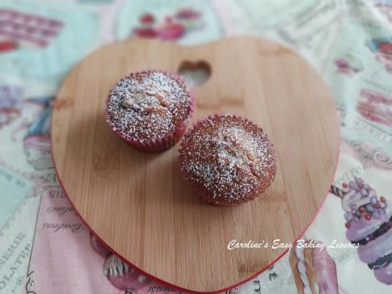
EQUIPMENT

12 hole cupcake tin (OR 6 hole cupcake tin x 2)
12 - 14 cupcake or muffin cases
(** Depending on how big the cases, sometimes I get 14 cupcakes)
Scales or Measuring Cups
Measuring Spoons
Hand or Stand Mixer (or a wooden spoon)
Large Mixing Bowl
Small bowl for butter
Small bowl for jam/jelly/preserve
Sieve
Large Metal spoon
Ice-cream scoop (or dessert spoon)
2 Small spoons
Cocktail sticks
Timer or Phone Timer

OVEN: 180c/160c Fan Oven/350f/Gas Mark 4

DIRECTIONS

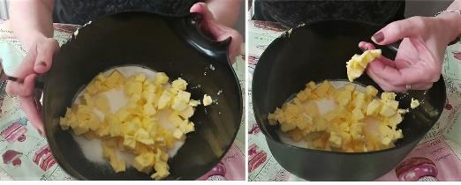
Photo 1 - cubed butter (L) & testing it's ready (R)

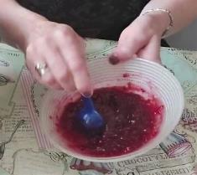
1. Weigh or measure out your butter and cube it while doing so. I like to make roughly 1.25cm (1/2") sized squares or rectangles. A smaller surface area, and the butter will soften quicker. If you are short on time, see this hack I tried for softening butter quicker. Also take eggs out of the fridge if applicable. To check if it's ready, you should be able to squash it, by squeezing between your thumb & index finger. (See Photo 1 above, right pic, or the video).

2. Mix the jam/jelly in a small bowl with 1 or 2 tsp of water and thin out slightly. How much is needed will depend on how thick or 'jelly-like' your jam is. (See Photo 2 or video for consistency).
Photo 2 - thinning down the jam
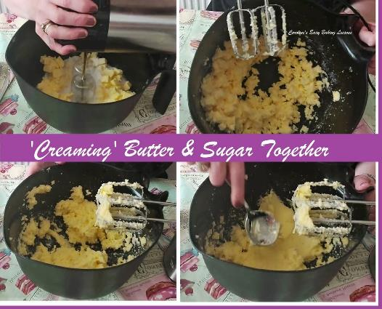
Photo 3 – creaming the butter & sugar

3. Weigh out the sugar in a large bowl or in your stand mixer bowl. Add the softened butter and beat well until it becomes paler, soft and fluffy. This is known as 'creaming' the butter & sugar together. It breaks down the sugar and creates a lot of air in the cake batter, which produces a lighter cake that isn't dense and heavy to eat. So a very important stage in baking. This might take you anything between 1 & 4 minutes to do, depending on the power of your mixer and how soft the butter if. (Just make sure the butter is not melted or the 'creaming' will not work). Photo 3 above shows the stages the mixture goes through. It will be like small pebbles at the beginning and then suddenly start to soften and smooth out. Pics 3 and 4 in Photo 3 show the creamed mixture. Please also see the video for reference in terms of time taken. Alternatively, use a wooden spoon and beat together really well.

Photo 4-cracking & whisking egg before adding in

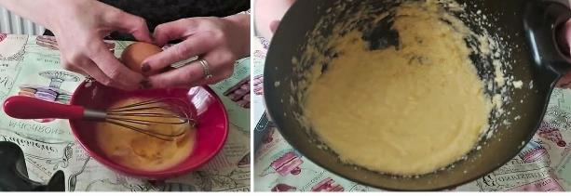
4. Next add in the eggs gradually. To create an even lighter cake, I like to crack the eggs open and whisk lightly. Doing so 'wakes up' the protein in the eggs and protein in baking provides structure. All these little tricks and techniques, get more air into the batter to make a nicer lighter cake. So gradually add in the eggs, in 2 or batches, and mix till incorporated. Don't worry if the mixture looks curdled or split. This is simply a reaction between the fats. it will all bake up perfectly and taste great. See Photo 4 above.

Photo 5 - Adding & mixing in the flour. Note the thick consistency.

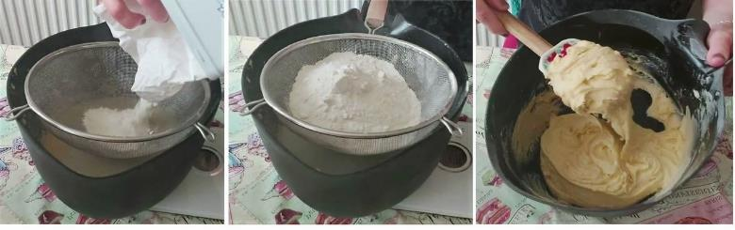

6. Now place the bowl on the scales, as well as the sieve and set to zero. Weigh or measure in the flour and sieve through. You can mix a little by hand first (or use a splash guard). Then start the mixer on the lowest speed and don't move it around. Let the liquid mixture take on some of the flour, before moving around. Only mix until all flour is no longer visible and remember to scrape down the sides of the bowl too. This should only take seconds to a minute to mix. Over mixing knocks air out of the batter and cakes can deflate and be very dense and heavy. Note the mixture (batter), will be very thick. See Photo 5 above or the video for reference.

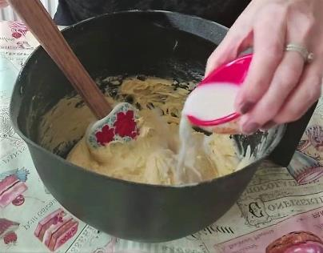
Photo 6 - Adding in the milk & vanilla to thin down

5. With a spatula or wooden spoon, fold in half the milk and mix through. Add in the vanilla and then the rest of the milk. Mix just until incorporated - remember no over-mixing. See Photo 6.

Now heat the oven up to 180c\160c Fan Oven\ 350f/ Gas Mark 4.

Photo 7 - adding in the jam & folding in for marbling effect & not over mixing.

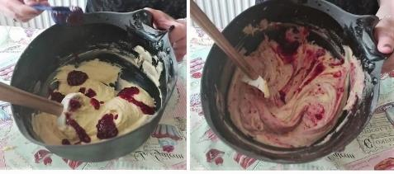
6. Now add tbsp worth of the jam to the top of the batter, in random areas. Then using your spatula, lift up the batter from the bottom and fold it over the jam area very carefully. No mixing, just folding. This will expose batter with no jam, so drop some more jam like before, and fold gently over. Continue to do this, and hold back about 1.5 - 2 tbsp worth of jam. See Photo 7 above for this process and how it should look.

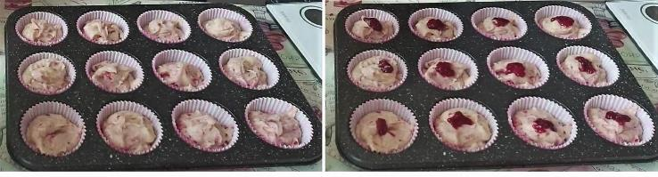
Photo 8 - filling the cases & adding more jam

7. Spoon this batter into the cupcake cases already in the cupcake tray. I get 14 cupcakes out of it by filling at least 3/4 of the way up. If you want bigger ones, simply divide between 12 cases. A dessert spoon & tea spoon will do but ice-cream scoops are best as they can produce even amounts into each cake case. Add a spoon to each and then go around dividing equally between the cases till all finished. Next, add about a 1/8 - 1/4 tsp amount of the reserved jam onto the top of the batter and again divide it up among all cases. Then tap the tray(s) on top of the worktop/counter a few times, to release any trapped air. See Photo 8 above, where I made 14 cupcakes worth.
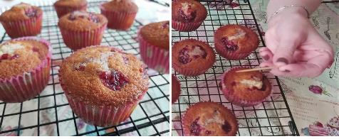
Photo 9 - the baked cakes & checking baked fully

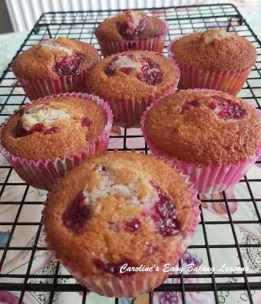

8.Bake for approximately 18-22 mins until the cakes are risen & golden on top. (Turn the tray around during cooking if you have a rubbish oven like mine.) Start testing if they are done at about the 18 minute mark. Do so by inserting a wooden cocktail stick into the centre of the largest cake and if it comes out clean it is ready. If there are crumbs on the stick, give it a minute more and keep checking. Another way to test is to press the top of the cake gently and if it springs back it is usually an indication that it is done. Be careful not to insert where the jam is. See Photo 9 above, and the video for reference. Also note that if you make 12 bigger cupcakes rather than 14, they will take a few minutes more to fully bake.
Photo 10 - Raspberry Swirl Cupcakes cooling

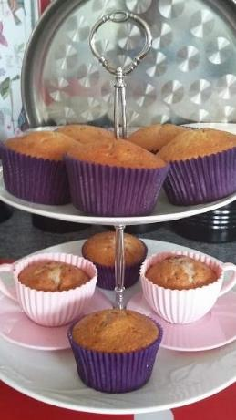
Remove from the oven and allow to cool for 5- 10 mins with the tray on top of a cooling rack. Then take the cakes out of the cupcake tray to cool completely on the rack. See Photo 10.

Photo 11 - old photos using tea-cup cases

9. Eat warm or store in an air-tight container and they will keep for a few days (if you are lucky!).

Here are my cupcakes on my cake stand with 2 actual cup cakes in silicone tea-cups! These I bought on sale at Lidl and I just sprayed them with butter cooking oil before pouring in the batter and they came
out perfectly.

WAYS TO DECORATE THESE CUPCAKES

A few methods for beginner bakers of how to decorate these simple cupcake:

Method 1
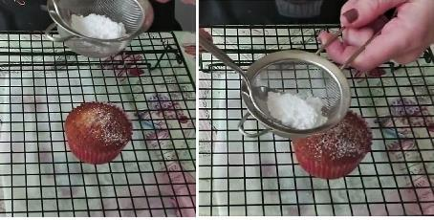
Photo 12 - dusting the cupcakes with icing/powdered sugar

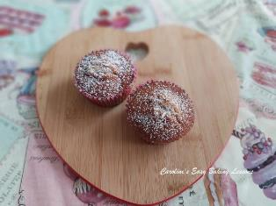
Photo 13 - Simple Icing/Powdered sugar decoration on the cupcakes

These are tasty on their own because of the addition of the raspberry jam, so just add a simple dusting of icing/powdered sugar to finish them off nicely. Simply place the cupcakes on the cooling rack and place some baking/parchment paper underneath it. Then sieve over some sugar, by pushing the spoon on top of the sugar and rubbing the bottom of the sieve. Let it come out gradually and in a very fine dusting. Then go over it till all covered. See photo 12 above. Always sieve the sugar, to remove lumps but also to give a more professional finish. And you are done.

Method 2 Photo 14 - beating the softened butter

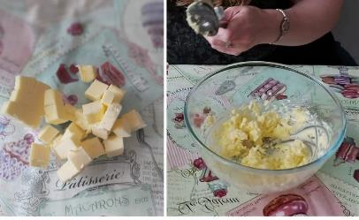
1. To make up the buttercream, beat the softened, cubed unsalted butter until soft and creamy. See Photo 14 & my video for how it should look.
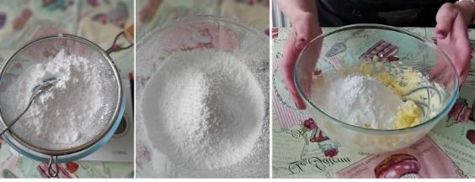

Photo 15 - sieving the icing/powdered sugar and adding most of it to the whipped butter

2. Now sieve the icing/powdered sugar & add in about 3/4 of it to the whipped butter. Use a spoon or spatula and mix it roughly together for a few seconds. See Photo 15 above.

3. Next beat together with a hand or stand mixer, starting on lowest speed. Once fully incorporated, have a taste test. The reasons for not adding all the sugar at once, are you want to get the correct consistency and thickness, but also to add according to your own taste for sweetness. See Photo 16 below.
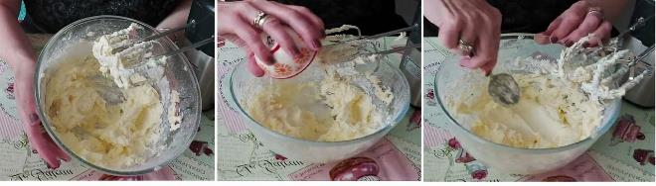
Photo 16 - mixing the sugar & butter, adding a little milk & the correct piping/spreadable consistency

4. You want a spreadable consistency that you can also pipe easily. So then add in a bit more sugar if needed and mix as before. I used all the sugar, but you might not want to. If once it's sweet enough, the consistency is a little too thick, simple add in splashes of milk and mix together. You can also add a splash of vanilla if you like. See Photo 16 above & also the video for how it should look.
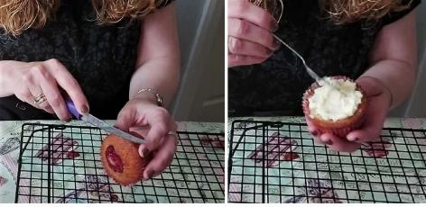
Photo 17 - preparing the butterfly cakes

5. For Butterfly/Fairy Cakes, simply take one of the cakes and slice of the domed (rounded) part of the top of the cupcake. Then cut in half and you have the 2 'wings. See Photo 17.

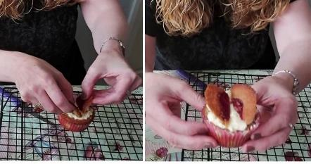

Photo 18 - positioning the 'wings'

6. Take some of the buttercream on a small spoon and spread on to the top of the cupcake. Add more if needed and spread out to the edges. See Photo 17. To give a neater finish, use the back of the spoon and spiral round in a circle, ending in the centre.

7. Take the two 'wing' and position on top of the buttercream, at an angle and you have your 'butterfly wings'. See Photo 18 above.

8. Dust over some more icing/powdered sugar on top of the wings and add two sprinkles as antenna and you are done.

Method 3

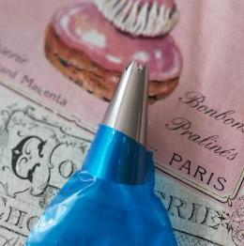
1. Piping Buttercream - Now I used a really big piping bag as I had ones I wanted to try out and see how big they were. Regular sized piping bags, or even a large food baggie would do. Cut the end of the bag and fit the nozzle (and couplet) or simply cut the end of a food baggie and pipe without a nozzle. If just using a baggie, don't cut the end off till filled with buttercream. See Photo 19.

2. Place the bag inside a large glass or jug that is big enough for the bag to go in and the ends folded over. See Photo 20.
Photo 19 - the star shaped piping nozzle

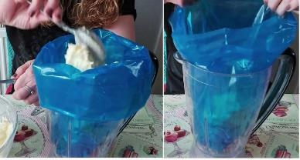
Photo 20
3. Have the piping nozzle pointing upwards and fold the top of the bag over the rim of the glass or jug and open the bag. This allows you to fill the bag easily without having to hold the bag.

4. Simply spoon and scrape the buttercream into the bag till nearly filled. Then unfold the ends of the bag and twist the top of the bag closed. See Photo 20.
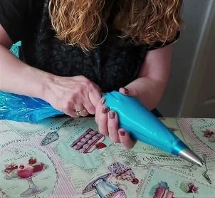
Photo 21 - getting the piping bag ready

5. Then start squeezing and pushing the buttercream down the bag to near the nozzle tip. If you used a food baggie, cut the tip off once the buttercream is near the bottom of the bag. Point the bag upwards and let air come out while squeezing until the buttercream starts to appear. See Photo 21.

6. And you are ready to pipe. Use one hand to keep the bag twisted and closed and to squeeze the bag. Use the other hand to guide the nozzle.

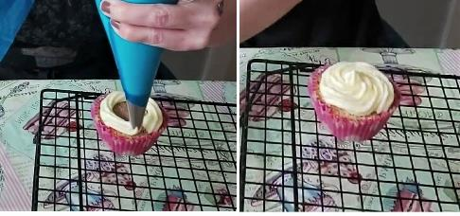
Photo 22 - piping a swirl of buttercream

7. Start piping from the outside edge and pipe a circle, working your way into the centre. Squeeze to pipe it out and let it touch the cake. Just before you want to finish piping, stop squeezing and pull the bag upwards. See Photo 22. Finish off if you like, with sprinkles or coloured sugar or lustre dust.

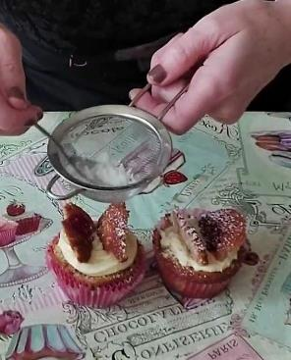
Method 4
Photo 23

1. Pipe buttercream like in method 3, Photo 22 above.

2. Then cut 'wings' like before and position the two wings on top of the buttercream, at an angle. Then dust over icing/powdered sugar on top of the wings and add sprinkles for antenna. See Photo 23.

Method 5

Pipe small peaks on top of the cupcake (uncut). To do so, point the tip of the piping nozzle downwards at a vertical angle. Squeeze and let the buttercream come out and touch the centre of the top of the cake. Let it pipe out and expand a little, for 1 or 2 seconds at the most and then un-squeeze and lift up. See Photo 24 below.

2. Repeat the same again over the top of the cupcake till covered. See Photo 25.

3. Finish optionally with some sprinkles or coloured sugar or lustre dust.

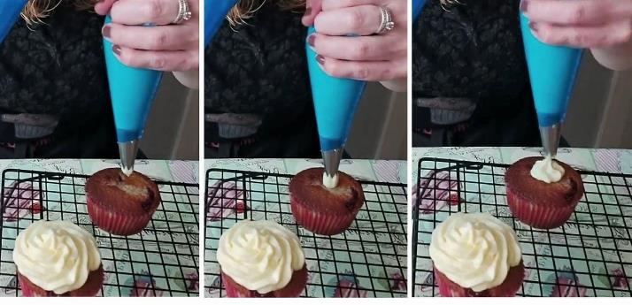
Photo 24 -

Method 5
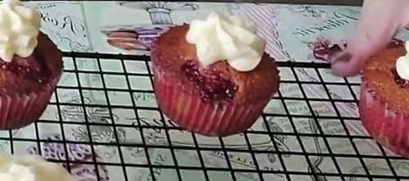
Photo26
1. Pipe a single peak into the centre of the top of the cupcake, like in Method 4 above. But instead of squeezing for 1 or 2 seconds, squeeze a little longer, letting the peak expand. Let it expand until about 1" or 2.5cm wide and then let go and pull up. See Photo 26.

2. Finish off with sprinkles or coloured sugar.

FINISHED OFF

The cupcakes can be finished off with some sprinkles or coloured sugar or lustre dust. Best to place the decorated cupcakes in the fridge or somewhere cool, to let the buttercream firm a little and the definition will show more clearly.

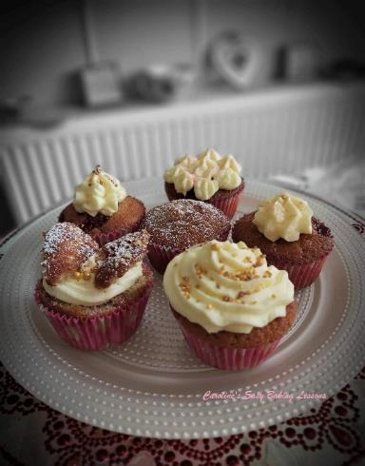
Selection of Raspberry Jam Cupcakes decorated in different methods

I hope you enjoyed and learned a lot form this recipe and tutorial and can use it in further recipes you make.

Remember the complete recipe and pics can be downloaded from the Sweet Lessons section - go to downloads.

Once you have completed lesson 3, proceed to Lesson 4 or move on to the savoury lessons. Thanks for reading.

Happy Baking & Making
Happy Memories & Tummies!

Caro x

