COCONUT PARADISE SLICES
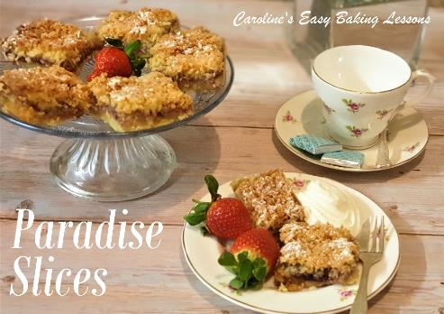
Caroline’s Easy Baking Lessons

This is a great dessert as it combines a biscuit/cookie base and a coconut sponge cake, sandwiching yummy raspberry jam/jelly. The ingredients list is long, but the process is quite straight forward and easy enough to do. It is also one of my most visited recipes, and popular among fellow bakers in Facebook groups. My friend Diana, who I met through our love of baking and the Great British Bake Off, joined the team and tests my recipes, as well as taking lots of pics for me. So pretty much all the photos in this updated version of the recipe on the new website, are taken by the lovely Diana. Thanks friend!
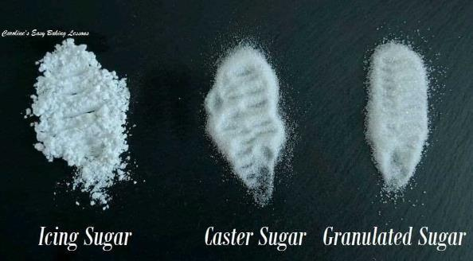
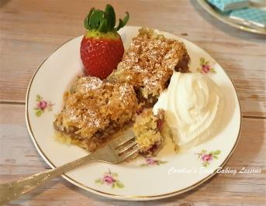
I was talking of ingredients, & there is caster sugar in the base and topping. If you are in the states or Canada, please don’t go to the bother of trying to source and paying through the nose to buy imports of this sugar. Super/extra fine sugar or baker’s sugar is a good equivalent. You can also make your own by grinding regular granulated sugar but only a little, as US granulated sugar crystals are actually a little smaller than our UK granulated sugar. Do not grind down into a powder or you will have icing/powdered sugar. See my photo below of a comparison of our UK sugars.

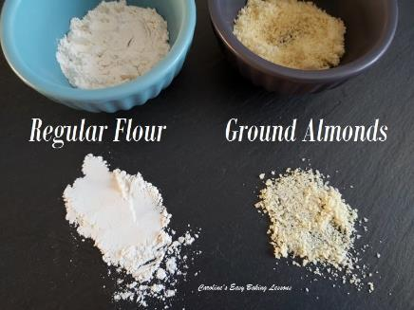
The same goes for the ground almonds. These are not quite the same as almond flour. (See photo). The flour is much finer and hence produces a different texture in the final bake. If you have to use the flour you can but there are lots of YouTube videos on how to grind your own almonds (shell and all) and can be cheaper than the flour. You basically bash them in a food bag first, and then process or grind to the consistency shown in my photo. Please note too, that ground almonds provide structure, and so a substitution of regular flour or almond flour, will not provide that same structure. Doesn’t mean that you won’t have a nice bake, but rather not be quite the same as the recipe was developed to be.
The only other thing to talk about is the baking dish size. This recipe can be made in a 30x23cm/ (12×9 inch) rectangular dish. I wouldn’t recommend anything much bigger. You can make in a square tin too. Just make sure that the length added to the width of the tin doesn’t exceed 55cm (22.5″). In other words, a 27 x 27cm (10.5 x 10.5″) square tin would also work fine. US 9×13″ (23 x 33cm) pan would also be fine.
Let’s get baking……
INGREDIENTS
For The Base:
- 175g Butter, cubed & softened (3/4 cup, 6 oz)
- 75g Caster Sugar* (1/3 cup, 2.5 oz Extra/Super Fine)
- 150g Plain Flour (1 1/4 cup A.P., 5.25 oz)
- 100g Ground Almonds (1 cup, 3.5 oz, ** see above)
- Finely grated zest of an orange
For The Filling:
- 300-500g Raspberry Jam
- (1 – 1 1/2 cups, 17.5 oz Jelly/Preserve)
- (Water down with a few tbsps of water to make spreadable.)
For The Topping:
- 110g Butter, unsalted, cubed & softened (1 stick/ 1/2 cup, 3.75 oz)
- 150g Caster Sugar* (2/3 cup, 5.25 oz)
- 4 Eggs (med – large)
- 150g Coconut, shredded (1 1/2 cups, 5.25 oz unsweetened shredded coconut)
- 1 tsp Baking Powder, sieved
- Icing/powdered Sugar to dust (optional)

EQUIPMENT
- Scales or measuring cups
- Measuring Spoons
- Hand/Stand Mixer (optional)
- Food Processor (optional)
- Pastry Cutter (optional)
- Baking tin/dish – 30x23cm/ 12×9″ (see note above)
- Baking/parchment paper
- Lining paste or butter for greasing
- Fork
- Timer or Phone Timer
- Knife or baking palette knife
- Large spoon or spatula
- Cooling Rack
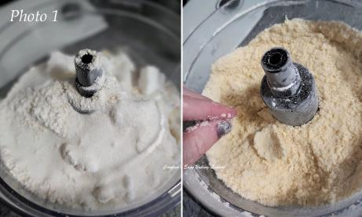

INSTRUCTIONS
1. Lightly grease and line a baking tin or dish, (see above for sizing) with baking/parchment paper. I either use some baking spray or Lining Paste. This is brilliant for when you can’t use paper, cheaper than cake release spray and the best for bundt pans. I highly recommend it. Here’s my review & how to make it. See also my article on how to line tins of any size or shape.
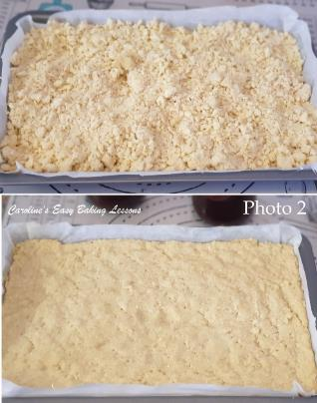
2. Next put the base ingredients (butter, sugar, flour, ground almonds and zest into a mixer or food processor and reduce down to crumbs and clumps. Alternately, mix the ingredients and then rub the mixture between your fingertips. You can also use a pastry cutter to reduce to breadcrumb consistency, by pushing down on the bottom of the bowl and rotating left and right. Try squeezing some of the mixture between your fingers and see if it hold together, like in photo 1. Because there’s a crumble topping too, I tend to use the food processor.
3. Tip the mixture into the prepared tin and spread it out evenly to cover all the bottom of the dish. Then gently push down on it till it comes together as one mass. Now very gently dock the dough with a fork (make lots of holes on the mixture). This is to stop getting a ‘soggy bottom’! You can do this after the chilling stage though if you prefer.
4. Cover the dish with cling film/plastic wrap and chill for 1 hour.
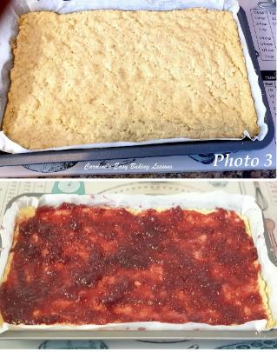
5. Heat up the oven to 160c/140c Fan Oven/ 325f/Gas Mark 3.
6. Bake the biscuit/cookie base mixture for about 18 minutes until just starting to colour. See Photo 3.
7. Increase the oven temperature to 190c/170c Fan Oven/375f/Gas Mark 5.
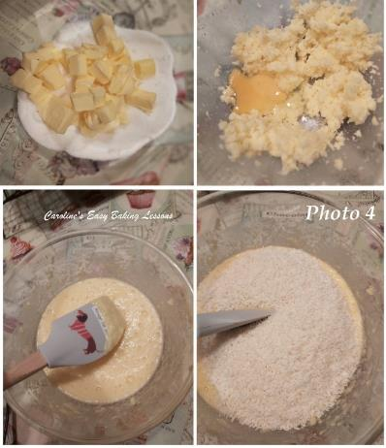
8. Mix the jam/jelly with a few tbsp of water to make easier to spread. Then spread the jam/jelly evenly over the base as best as possible. Depending on the size of the dish you used, you may need more jam/jelly. See Photo 3.

9. For the topping: cream the butter and sugar together, (until light and fluffy like in Photo 4, top right pic) and then gradually add in the eggs, one at a time.
10. Fold in the coconut and sieved baking powder until all incorporated. See Photo 4. Don’t worry if it looks curdled. That’s just a reaction between the butter and eggs. It will all bake out perfectly
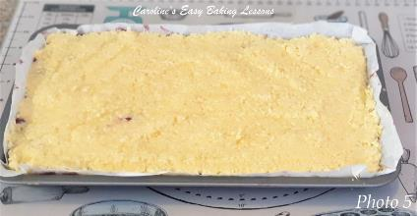
11. Now carefully spoon the prepared cake mixture evenly, all over the jam/jelly middle layer. Once all of the mixture has been added, ever so gently, spread it out as best you can, until you have minimal jam peeking through. See Photo 5. Also give the pan a few taps gently on the counter/worktop.
12. Bake the slices for 18 – 22 minutes, until golden brown. See Photo 6. Mine colours quickly but not evenly so I turn the tin during baking, but not until at least the half way mark (so at about 9 minutes). Use a tooth pick/cocktail stick to test the centre. It will still appear a bit wobbly when moved but the stick will be clean of crumbs when ready. Leave to cool in the dish on the worktop/counter for 10 minutes, before placing on top of a cooling rack to cool down completely.

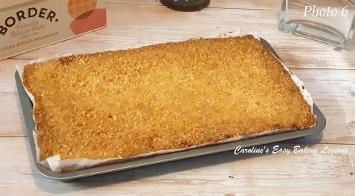
13. Once cooled you can cut into slices and dust with sieved icing/confectioner’s sugar if you like. You can get between 15 & 18 pieces depending on the size of your tin. As much as it’s tempting (boy is it ever), it’s always much easier to slice cakes & breads, if they are cooled completely. Especially so for a triple layered bake like this. You could also after about 10 minutes of cooling on the rack, place in the fridge to speed up the process, but don’t leave too long or condensation will result. I also recommend cooling down still in the tin.
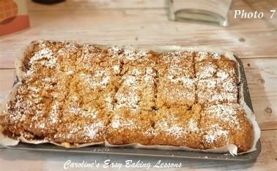
14. Once ready to serve, you can choose to sieve over a fine layer of icing/powdered sugar, if you wish. Serve as is, with fresh fruit, cream or ice-cream. Or simply with a tea or coffee, the choice is yours.
15. Left overs will stay fresh in an airtight container, for several days (if you are lucky!) As much as cake stands (even if you have a dome), are pretty and nice for presentation, they don’t keep quite as long. I like to use a metal cake or cookie tin to store my cakes and bakes.
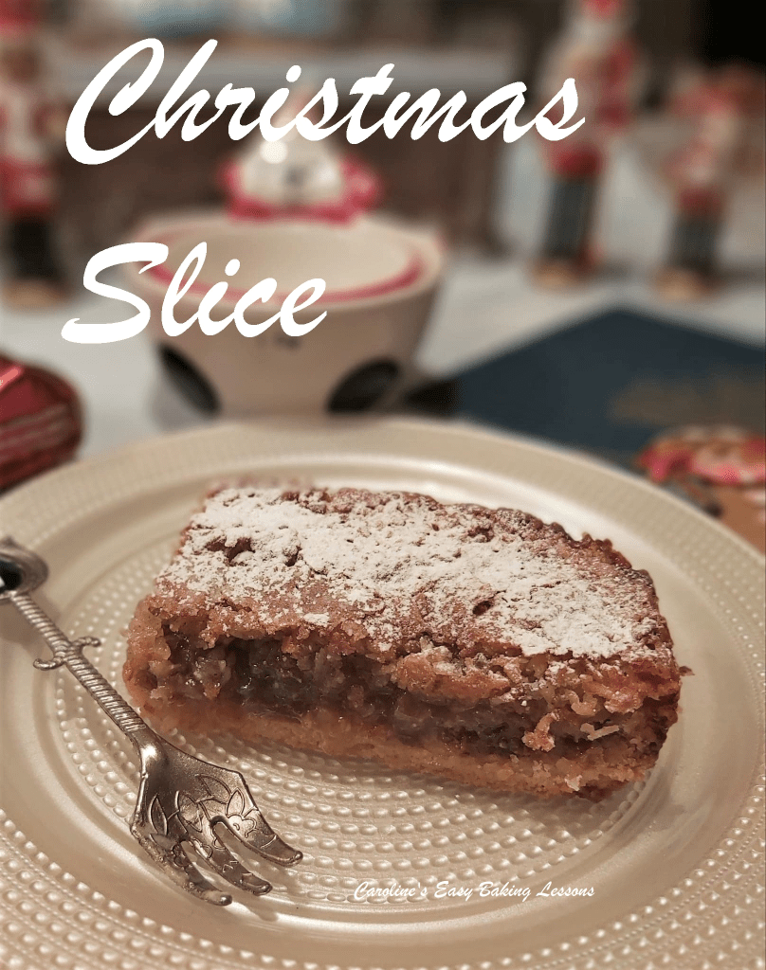
See Photo 8 of my seasonal version – Christmas Mincemeat Slices.

Caro xxx

