EASY TEAR-&-SHARE CHEESE SCONES -Savoury Lesson 2
Caroline’s Easy Baking Lessons
These are a simpler version of British scones that come in a ‘tear & share’ form so there is no need to cut out the scones. One of the common problems with scones is the cutting out part. Most people are tempted to twist the cutter when cutting out the scone & this is a big no no, as it means you won’t get that characteristic 'rise & split structure of a typical scone. So this recipe avoids that all together & doesn’t rise as tall as regular scones, but hey it’s worth it when you taste them. So an ideal beginner recipe.

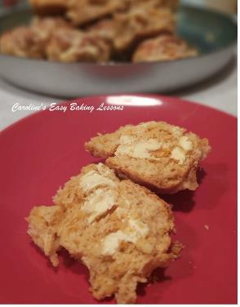
This is a great savoury recipe by Mary Berry & I have just altered the instructions to make them as simplistic as possible for baking beginners and made just a few changes. The original recipe called for mustard powder and whilst it is great combined with mature cheese (sharp cheddar), it's not always easy to find. So I have also tested it with smoked paprika and this is a very good alternative to mustard powder. I would advise using coloured cheese for the topping of the scones, so it will give a better aesthetic appeal. (Note though my most up dated photos are not with coloured cheese). My favourite cheese to use in baking is Scottish Mature or even better still, Extra Mature! For our US & Canadian friends, that's a mature cheddar, with a strong taste, I believe you call a 'sharp cheese'. Just be very careful with any white cheeses as they tend to burn quicker. I have also included how to make my version of self-raising flour from plain/A.P. flour, and this has been tested using US All Purpose flour, with just the same end results.

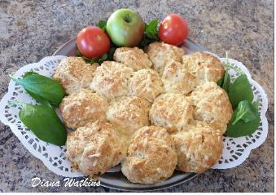
The original recipe also calls for crushed or grated garlic, but I have made sometimes just with garlic powder and with the same results. Friends have also made these and added lots of their favourite herbs, with great success too. So I suggest you try the recipe first and add some different herbs next time.
** Beginners, make sure you read the recipe all the way through before attempting it. I have also tried to minimise the amount of bowls used so the ingredients are listed in the order in which they are added. This recipe is so easy, my 13-year-old son made them on his own and I have now updated the photos with some of his as they were so good. These are really tasty freshly made, but still really good a day or two later.
INGREDIENTS

450g Self-raising flour (15 ¾ oz) (OR 3 & 2/3 cups Plain/A.P. Flour + 5 1/4 tsp baking powder + 1 tsp salt)
2 tsp Baking Powder
1 tsp Salt
100g Soft butter, cubed (1 stick less 1 Tbsp)
1 clove Garlic, crushed/grated OR 1 tsp Garlic powder/granules
150g Cheese, grated (shredded, 1 ½ c, 5.5 oz) **Extra Mature/sharp cheddar best
2 Eggs (med – large)
150ml Milk, approx. (2/3 c, 5.3 fl oz)
1 tsp Chives, finely chopped (optional)
2 tsp Mustard Powder OR Smoked Paprika (non-spicy)

EQUIPMENT

Scales or Measuring Cups Measuring Spoons
Stand Mixer or Large Mixing Bowl & Large Metal Spoon Pastry cutter (optional)
Knife Garlic Press/Fine Grater
Grater Small Measuring Jug
Pastry Brush or New Artist/Paint Brush Fork
Floured Pastry Board or Worktop Large Baking Tray/sheet
Spray Oil or Bottled Oil (optional) Baking/parchment Paper
Timer or Phone Timer

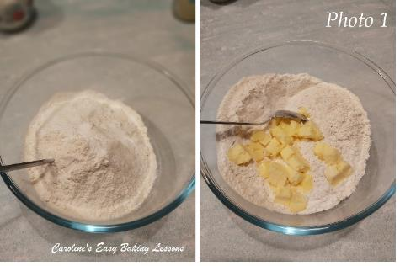
OVEN: 220/200c FAN OVEN/425f/Gas Mark 7

INSTRUCTIONS

1. Place your mixing bowl on top of the scales and weigh/measure in the flour, spoon in the baking powder & salt. Give it all a good mix through. See Photo 1.

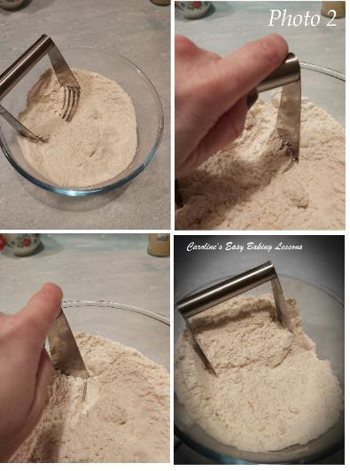

2. Add in the cubed butter and give it a little mix. Rub the flour & butter between your thumb & index finger on both hands and keep doing this until what’s left resembles breadcrumbs. See Photo 2, bottom right pic, for an idea of how this should look. Alternatively, you can use a pastry cutter to make this job easier. Just push down to the bottom of the bowl and perform a twisting left and right motion and repeat until the butter take on the flour. See Photo 2. Be sure to clear the cutter every so often when butter sticks.

3. Weigh out the grated (shredded) cheese into a smaller bowl. Add about 2/3 of this cheese to the flour mixture & give a quick mix. Reserve the rest of the cheese for later.
4. Grate the garlic clove into the dough & mix through. Alternatively, you can use 1 tsp garlic powder or granules. See Photo 3.

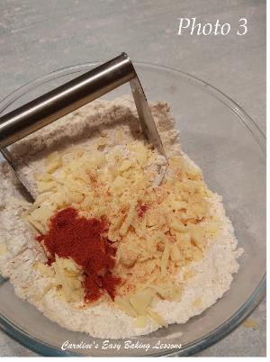
5. Break the 2 eggs into the small jug & beat with a fork. Now top up to the 300 ml mark (10 fl oz) with the milk & beat well. Remove 2 tbsp of this egg mixture and place in a small bowl for later. See Photo 4.

6. Gradually add this wet egg mixture to the dry mixture, (the flour mixture). The dough will be a bit sticky at this point - do not add any more flour. Just a little sticky, but still manageable, so you might not need all the wet mixture See Photo 5.
7. Lightly flour a pastry board, counter/worktop or lay out some baking/parchment paper and knead the dough together for just 15 seconds until it is nice and soft, easy to handle & form into a ball then a disc.

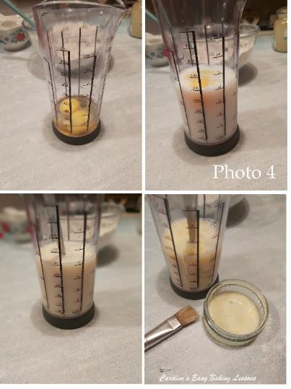
8. Prepare the baking tray by lightly oiling/greasing it and place baking/parchment paper on top. **This is for if the baking tray/sheet does not have a 'lip' on it, otherwise, you bake can slide off and onto the floor!
9. Now divide the dough into 16-18 pieces, (bigger than a golf ball size) and roughly form them into a ball shape. Make them approximately 2” or 5 cm in diameter. See Photo 6 for idea of how they should look. Be sure to not keep re-rolling them as too much handling will result in a tough bake.

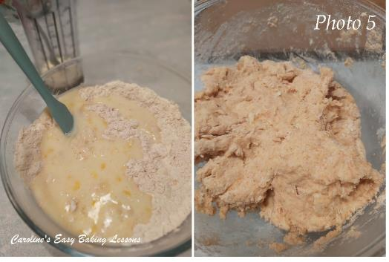

10. Place the scones on the baking/parchment paper and arrange in a circle, making sure you fill in the middle section. Let the scones almost touch each other, with only very small gaps as best as you can. See Photo 7.
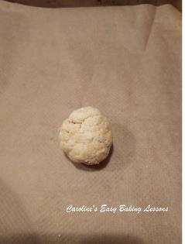

11. Heat up the oven to 220c/200c Fan Oven/425f/Gas Mark 7
12. Now use the egg mixture you reserved earlier and brush the tops of the scones with this & ensuring you brush down the visible edges/sides too.
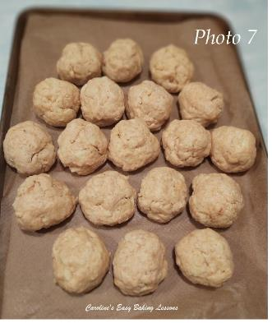
13. Bake the scones in the oven for 25-30 minutes until golden brown on top. Since my oven doesn’t bake evenly & to help you learn how to work out when your bake is ready, do the following: bake for 10 minutes, turn the tray and add on the reserved cheese. (See Photo 8 above). Bake a further 10 minutes. Now if the tops are the colour as in the Photo 10, then the tops are done. If not bake a further 2 – 3 minutes. Once the tops are ready remove from the oven. Whilst holding the tray with an oven glove, place another baking tray or chopping board on top of the scones & turn everything over. Now slide the scones in one piece back onto the baking tray. If the scones are a little dry & you have some egg mixture left, brush onto the bottoms of the scones. Put back in the oven & bake the underside for 3 – 5 minutes until the same colour as the top of the scones is achieved. Throughout this turning process, I also like to touch up any dry areas with the left-over egg mixture to give a nice colour as, colour = flavour!

14. Remove the tray from the oven and leave to cool down a little, (about 5 minutes), on top of a cooling rack.

15. Now transfer the scones onto a cooling rack, using the baking/parchment paper & cool until you are able to tear apart without burning your hands.
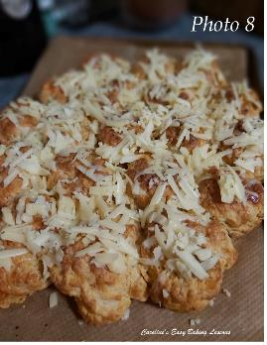
16. Cut in half, spread butter or cream cheese on the halves and enjoy.
17. These will keep for a few days in an airtight food bag or container. Keep them in a cool place, (I prefer not to place in the fridge as I don’t like them when too cold). You can of course re-heat in the oven for a few minutes or place in a sandwich toaster machine/panini press, in between baking paper until warm enough. More recently though, I have sliced and warmed in the microwave for 15-20 seconds.
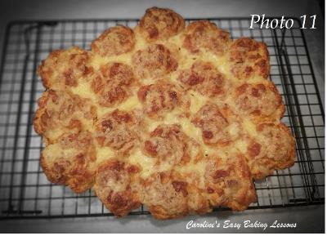

READER’S PHOTOS
Here's a pic of the tear-and-share cheese and garlic scones one reader made from my recipe in 2019. Well done Robyn, those look so good with the addition of lots of herbs!

NEXT STEP
Now that you have completed this Savoury Recipe, have a go at the recipe again with different flavours if you like. Then proceed onto Theory Lesson 4.

Thanks for reading.
Happy Baking & making
Happy Memories & Tummies.
Caro x

https://easyonlinebakinglessons.com

