AUTHENTIC SCOTTISH SHORTBREAD

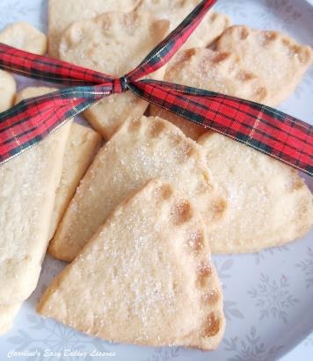
Sweet Lesson 5

Caroline’s Easy Baking Lessons

Try my recipe for traditional Scottish Shortbread as it is supposed to be made & with a soft & melt-in-the-mouth buttery texture everyone loves.
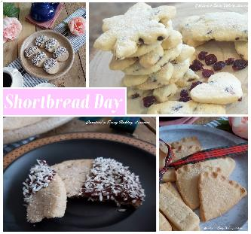

Why Use This Recipe?
This recipe is for traditional Scottish Shortbread as it is supposed to be made, no margarine or baking spread in sight, just real butter. You can trust me – I am Scottish These soft and melt in the mouth buttery biscuits are surprisingly only made up of 4 main ingredients: butter, flour, corn flour & Sugar. The corn flour (corn starch), helps to give that extra soft texture that I mentioned & just ‘melts in the mouth’. Be very careful when baking, as you want them to be baked but still very pale in colour. They will still be soft when taken out of the oven, so make sure when transferring to a cooling rack, that you use the baking/parchment paper or else you will have a crumbled mess on the floor! Once you master this recipe, it is perfect for gifting, as it tastes so much better than shop bought shortbread.

A NOTE ON THE INGREDIENTS
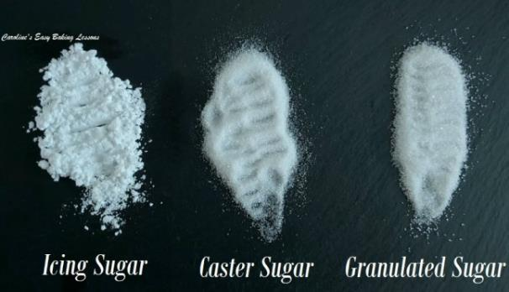
* If you are in the US/Canada and can’t get extra/super fine sugar for the UK caster sugar, you can make your own by grinding regular granulated sugar a little bit or processing lightly. Do not go as fine as a powder, keep it as small granules. Just note that US granulated is slightly smaller a granule size than our UK version. See below for a photo of different sugar from the UK. (Read my article on differences of UK & US baking ingredients). Also note the recipe used Cornflour which gives it the melt-in-the-mouth texture. The US/Canadian name for this is Corn Starch.

Ingredients
225g Butter, cubed & softened (1 cup/2 sticks or 8 oz)
110g Caster Sugar* (3 3/4 oz)
(½ cup Extra/super fine sugar, see above)
225g Plain Flour (1 ¾ cups All Purpose or 8 oz)
110g Corn Flour (3 3/4 oz) (1 cup less 1 tbsp Corn Starch)
Pinch Salt, Some Granulated Sugar for topping
Equipment
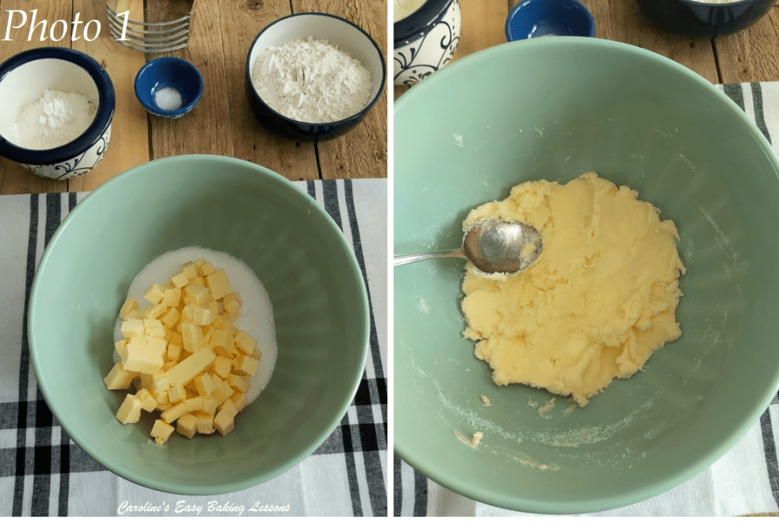
- Scales or Measuring Cups
- Measuring Spoons
- Large spoon
- Stand or Hand Mixer, (or Medium-Large Mixing bowl & spoon)
- Sieve
- Pastry Cutter (optional)
- Baking/parchment Paper
- Baking Sheet/Tray x 2
- Palette knife or sharp kitchen spatula
- Timer or Phone Timer
- Cooling Rack
- OVEN: 180c/160c Fan oven/350f/Gas Mark 4

Instructions
1. Weigh out and cube the butter and leave out till softened. I like to cut my butter into about 1cm (less than 1/2 inch) cubes as a smaller surface area will soften faster. See Photo 1.
If you forget to take the butter out to soften, here’s a hack I reviewed to soften butter in about 10 minutes.
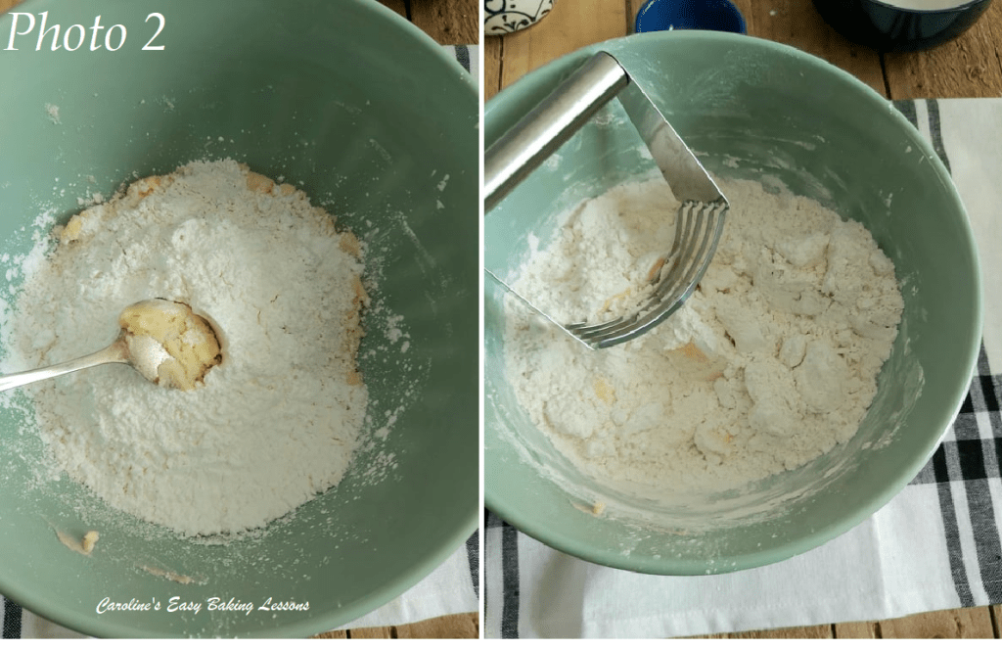
2. Weigh the sugar into your mixing bowl and add in the butter. Combine these two ingredients, firstly with a quick mix by hand with a spoon or spatula. Then mix on low speed with a stand/hand mixer until light and fluffy, (known as ‘creaming the butter’). You can of course do by hand with a spoon and some elbow power! See Photo 1 for how it should look once creamed. Soft and paste like and easy to spread. Don’t over beat it though as much as you would for cakes.
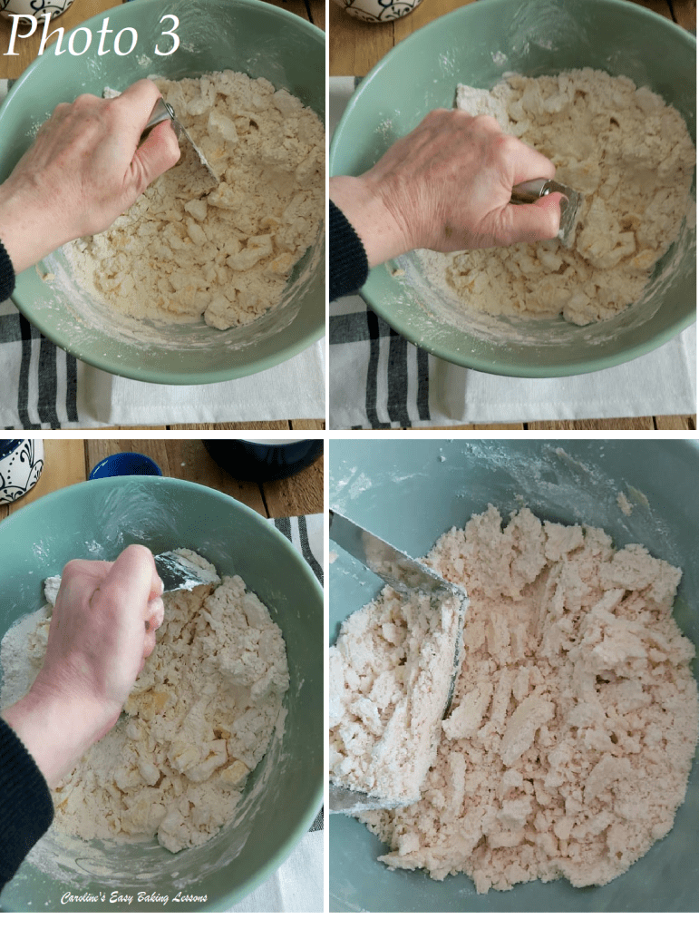
3. Lightly oil/grease the baking sheets/trays before placing baking/parchment paper on top. This is a good idea if your baking trays/sheets are completely flat, with no lips. I have lost cookies before, when the paper slid off the tray – so best to avoid that
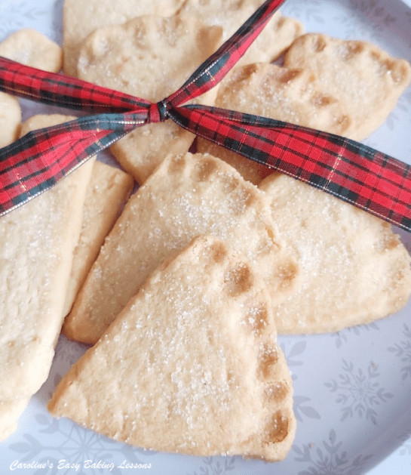
4. Place the bowl back on the scales with the sieve on top and set to zero (TARE). Weigh in the flour, corn flour/starch & salt through the sieve. (Alternatively add in with a measuring cup). Mix in by hand, don’t use a mixer . See Photo 2.

Using a Pastry cutter/pastry blender for Scottish Shortbread
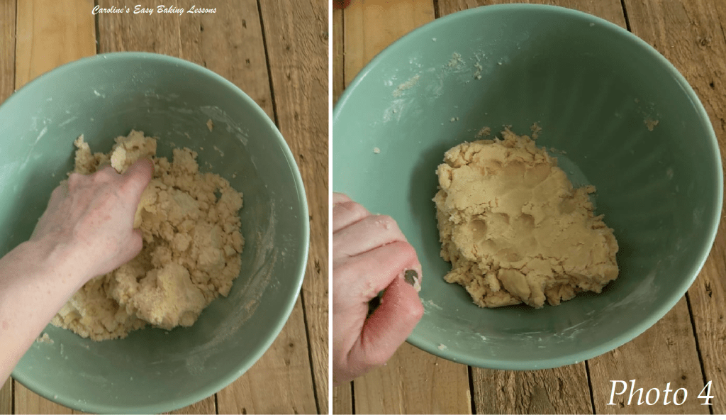
5. Now I like to use a Pastry Cutter/blender for this part- it helps you incorporate the flours into the butter/sugar mixture much more easily and is quicker, (especially when your hands hurt sometimes like mine!) See Photo 3 above. With the pastry cutter, you push down on the bottom of the bowl and perform a crushing and turning motion, rotating left and right. Do this to all the mixture until the butter had taken in all the flour, (see Photo 3). Alternatively, you can do this ‘cutting in’ process, using 2 butter knives. Note though that the mixture will not come together into a ball at this stage. It will be very crumbly and that is fine.
6. Next, in the bowl or on a large sheet of baking/parchment paper very gently knead the dough just until it starts to come together, and no more. It will change from a white lumpy powder into a beige smooth dough. See Photo 4.
7. Next form the dough into a very rough square shape, by using you hands and pressing down. Push in the end pieces to make sure the ends are the same height as the middle of the dough. Do this until the dough is about 1/2cm (5mm or 1/5in) thick. See Photo 5 below, for an idea of how it should look. You can of course place baking/parchment paper on top of the dough and roll out, but I prefer to be gentler and do by hand.
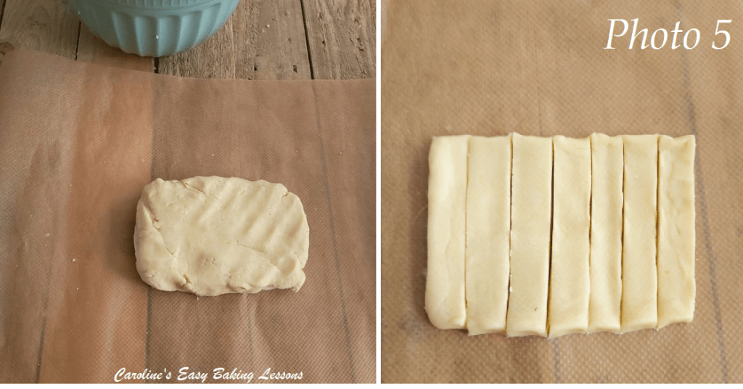
8. Now using a sharp knife, trim around the dough until you have a straight square shape. Place the scraps of dough, back in the bowl. Cut down the middle of the dough, and then cut ‘slabs’ as in Photo 5. I got 18 slabs, that were between 1.5 – 2cm (approx. 2/3 – 3/4 inch.) wide and about 8cm/3 inches long. (Note that in Photo 5, I was making a half batch, but you get the idea!) Don’t worry if the slabs look too thin when cutting as they do expand once baking. So try to cut a little thinner than you want them to bake out at.
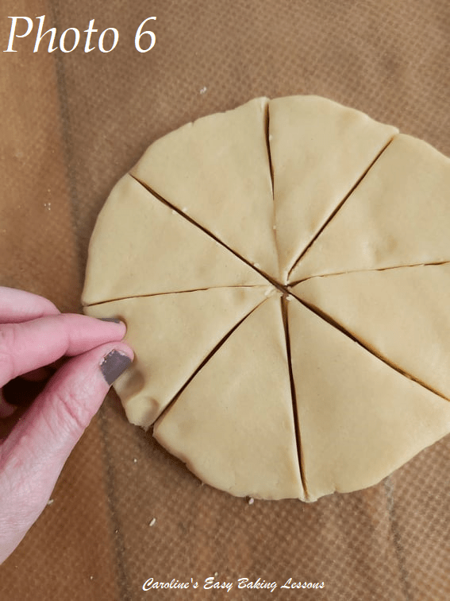
9. Now very carefully transfer them with a palette knife to the prepared baking trays/sheets. If any pieces break/fall off, carefully put back and squash together. Remember to leave a good 2.5cm/1 inch gap at least, in-between the biscuits. Now make holes with a fork all over the slabs, but very carefully not to go too far down and break them.

10. Using the scraps left over, gently squish the dough together into a ball and flatten into a disc shape, pushing up the edges to make an even thickness like before. Cut this disc of dough into equal sized slices, (I got 8 pieces). Using your thumb & index finger, pinch the ends of the round dough to give the standard shortbread decorated edging & shape known as Petticoat Tails. See Photo 6 for how it is done. Carefully transfer the dough to the baking tray & then make holes with a fork over the dough like before. (See Photo 7 below). Alternatively, make some more ‘slab’ shapes.
11.Place both trays/sheets in the fridge (or somewhere extra cold) for 60 minutes. If you omit this step, the shortbread will be too soft and not hold any of it’s shape. If you can’t get the baking trays/sheets into the fridge, you could try transferring with the paper, to regular trays.
12. When the time is nearly up, heat up the oven to 180c/160c Fan/350f/Gas Mark 4, (or sooner if your oven takes a long time to come to temperature).
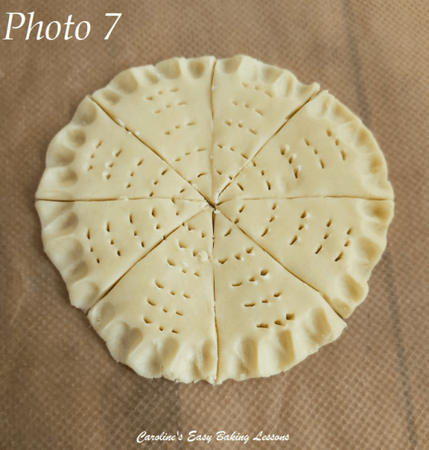
13. Place the 2 trays/sheets in the oven and bake for approximately 15 minutes. You may need a little longer, but you want to take them out when the edges are just starting to turn a very pale golden colour. (See Photo 8). I turned and rotated the trays during baking to ensure an even bake. If the biscuits move when very gently pushed, they are ready. Be warned though that they are still soft, so take the trays out and leave for 5-7mins before touching them. At this just out of the oven stage, sprinkle plenty of granulated sugar on top of the biscuits.
14.After the 5-7 minutes, transfer (very carefully) to a cooling rack by lifting the baking/parchment paper. Leave the biscuits to cool down completely.
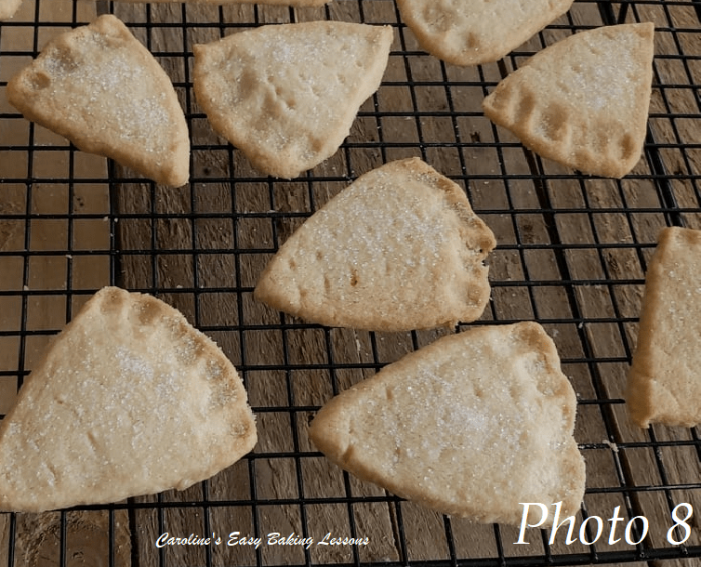
15. Enjoy now with a cup of tea or coffee (or Whisky) or store in an airtight tin or container where they will last at least a week.
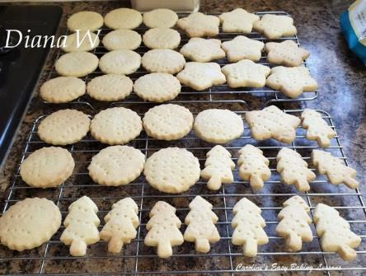

Bake For The Holidays

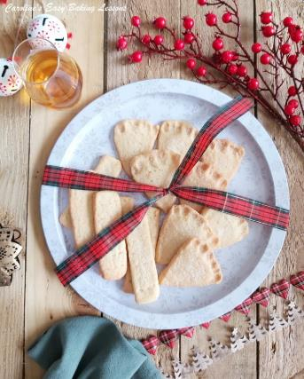
Thanks for reading & downloading the recipe.

Happy Baking
Caro xx

