CHOCOLATE BROWNIES – Easy, Proper, Gooey Brownies

Caroline’s Easy Baking Lessons
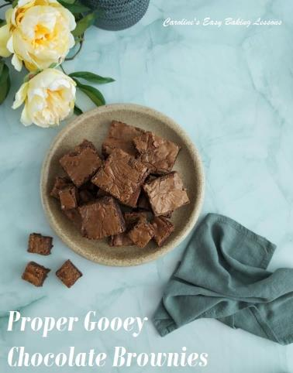
Brownies only take a few minutes more of gentle mixing & getting out the oven a bit sooner than if you were making a chocolate. The secret is whisking the sugar & eggs for 5 minutes till mousse like, very pale in colour, with a noticeable increase in volume. After this you don’t want to mix in as normal. Fold the other ingredients in the shape of an ‘8’. As if you were writing the number 8; where the spatula is your pen & the batter your paper. Only until all flour is no longer visible. Over mixing can also ruin the brownie texture. There is cocoa powder in the brownie & I use cheap dark (bitter) chocolate for the gooey centre chunks, with milk/semi-sweet chocolate melted & added to the batter. (Lidl or Aldi value chocolate is fine for this). Note the brownies are very rich & go nicely with some ice-cream or whipped cream.

EQUIPMENT
- Scales or measuring cups & spoons
- Knife
- Microwave safe bowl to hold butter & chocolate
- Microwave or use stove top for melting
- Spoons (several)
- Mixing Bowl
- Sieve
- Stand or hand-held mixer & whisk attachment
- OR bowl and hand whisk
- Timer or phone times
- Plastic baking spatula
- Baking tin (approximately 23 x 23 cm (9in square). Don’t use too small a dish or it will take too long to cook. You want the sum of the length + width to be about and not to exceed 46 cm (18 inches) or they will be too thin).
- Spray, ling paste or butter for greasing
- Baking paper/parchment
- Scissors & pen/pencil (optional)
- Cooking rack.
- OVEN: 180/160c Fan Oven/350f/Gas mark 4

INGREDIENTS
185g Butter, cubed & unsalted (1 stick + 1/3c or 6.5 oz)
185g Milk chocolate (6.5 oz semi-sweet)
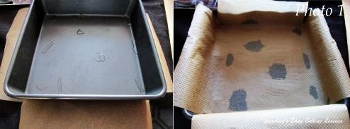
75g Light Brown (1/3c, 2.5 oz) & 200g Granulated (1 c, 7 oz)
3 Eggs (med-large) (Large -XLarge US)
85g Plain/AP Flour ( 2/3c, 3 oz)
40g Cocoa (1/3c, 1.5 oz)
100g Dark Chocolate (3.5 oz bitter)

INSTRUCTIONS

1. Break up the 185g/6.5oz milk/semi-sweet chocolate and place in a microwave safe bowl with the butter. Melt by heating in 30 second bursts, stirring well in-between each. The butter will melt first but keep mixing and the heat will melt the chocolate. Leave to cool as we will be adding to the eggs later and don’t want scrambled eggs! Alternatively, melt in a bowl over a pan of barely simmering water.
2. Weigh out the flour and cocoa through a sieve into another bowl. (Not the mixer bowl).
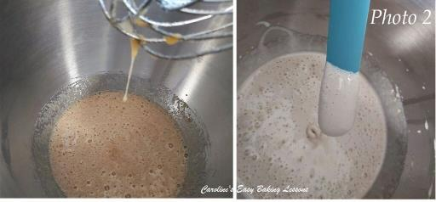
3. Oil or grease your baking tin and place baking paper/parchment inside it. See photo 1 for how to cut your paper to fit. I usually hold in position with cake lining paste. To make some or read about it – click here.
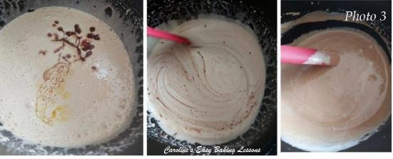
4. Next place the 3 eggs and sugar in a mixing bowl and whisk with a hand/stand mixer for approximately 4 – 5 mins, on medium to high speed. You want the mixture to become thick and cream like, paler in colour and increased in volume. See Photo 2 .
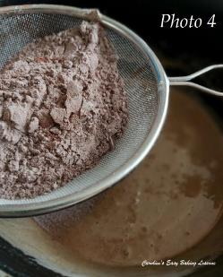
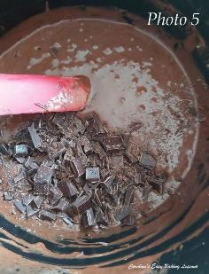
5. Now gently fold in the melted chocolate and butter mixture with a plastic or silicone baking spatula and do so in the shape of a number 8. Think of the batter as your paper and the spatula your pen. Mixing too vigorously will undo all the whisking from earlier so it is to be avoided. Remember to scrape down the sides and tilt the bowl to make sure of getting to the bottom of the bowl (as the chocolate mixture will have sunk when added). Mix just until all mixed in and no more. See photo 3.
6. Place the sieve over the mixing bowl and re-sieve the flour and cocoa mixture, into the batter. See Photo 4.
7. Mix it in again like before until no flour is visible and scraping down the sides too. See photo 5.
8. Roughly chop the remaining 100g/3.5 oz dark/bitter chocolate and add to the mixture, folding in lightly till evenly distributed.
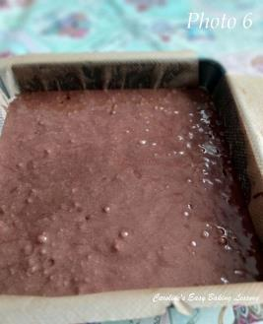
9. Now carefully pour the brownie batter into the prepared pan and level off if required. See Photo 6. Leave to sit so that it will form a crust later. (Leave at least 10 mins).
10. Heat up the oven to: 180/160c Fan oven/350f/Gas mark 4 while the brownie sits.
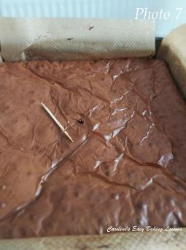
11. If the brownie has sat long enough, when you try to shake it, it won’t wobble too much.
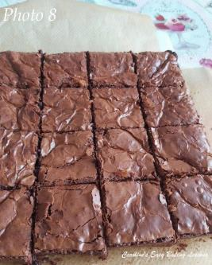
12. Bake for about 18 – 25 minutes, turning the tray every so often. I did so at the 15 minute mark and then checked every minute after that. The top will had formed the crust, (see photo 7) and I inserted a tooth-pick/cocktail stick to check if ready. The outer edges produce a clean stick whist the centre is a little moist with just a few crumbs. This is what we want. Leave the brownies to sit to cool down in the tin for 5 minutes. Then lift out using the paper and place on a cooling rack to cool down. Leaving in the tin any longer, will cook the centre of the brownies and you won’t have a gooey centre.
13. Once cool enough to cut, lift the paper onto a chopping board. Very gently and carefully, cut into 16 squares (or however many you want . Have a tea or coffee and enjoy. See Photo 8.
14. Store in a tin an airtight container if there is any left.
DIFFICULTY LEVEL – simple, easy when followed

