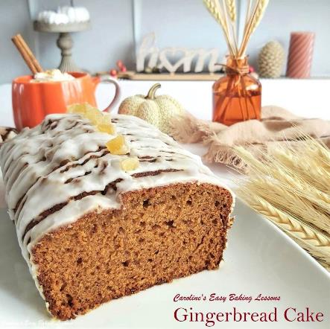
Easy Gingerbread Cake - Sweet Lessons No.3

Caroline’s Easy Baking Lessons
Gingerbread cake takes me back to my childhood, & a truly simple cake to prepare, I had to include in the Sweet Lessons. Made with Golden Syrup, Black Treacle & ginger, (of course), this is one of our popular & classic British cakes.
*Original recipe 7/10/2018, photos updated 22/11/2022

‘How Is British Gingerbread Cake Different?’
Although it is named gingerbread cake, British gingerbread cake doesn’t have a very strong ginger taste. It’s hard to describe it & it’s because of the also unique taste of the Black treacle & Golden Syrup that is used in the batter.
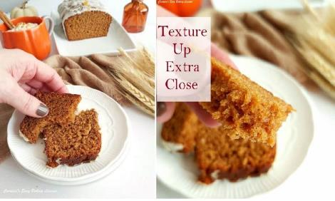

Black Treacle, Golden Syrup & Corn Syrup Debate
“Is Black Treacle Same As Dark Corn Syrup (Dark Karo)?”
Now I see debates about what Black Treacle is like on Facebook groups, people saying it is the same as molasses & dark corn starch (dark Karo). Black Treacle is definitely not the same as dark corn starch. It’s closest is probably black strap molasses. However, there is no guarantee they will taste the same or have the same over-all effect on the baked cake.
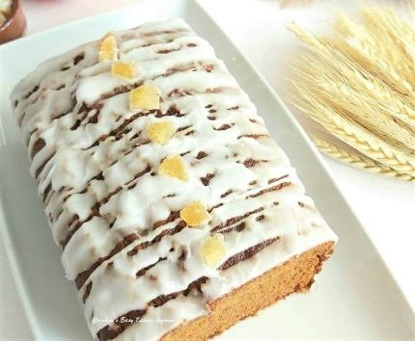
If I ever get some of that molasses sent over from the states, I will taste and do a test. In the meantime, some internet sites selling British products have this in stock and those that do often have the golden syrup. Yes, another British product.
“Is Golden Syrup Same As Light Corn Syrup (Karo)?”
No, Golden Syrup is not the same as Corn Syrup or Karo Light Corn Syrup. Not the same colour, consistency, taste, or how it is made.
**Below is a list I compiled from readers in the States & Canada, of where to buy Black Treacle & Golden Syrup.
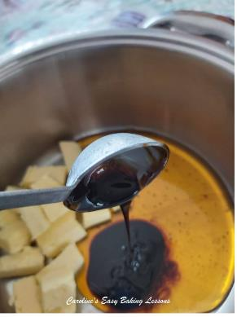

WHERE TO BUY GOLDEN SYRUP & BLACK TREACLE
These are both widely available in the UK and even shops like Aldi sell their own version of the syrup. But for bakers in the US & Canada, here is a list of where you can source these:
World Market, some Walmarts in Canada, Sobys, ‘Stop & Shop’, Wegmans, Frys (Smiths), Woodmans, Nugget Store, The Scottish Bakery, The British Store, Talin Market, Albertsons & in Dorgnacs. It is also available online at Amazon (free delivery for Prime accounts), 647-Florist.com, British Food Depot.com, UK Gourmet.us, World Market.com, Cost Plus World Market & Marina Market.
(Information current at October 2019).
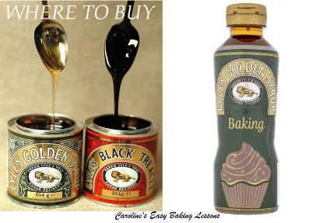
Now I am also told, that you can get both the Golden Syrup & Black Treacle from: Nugget Store & online from: Marina Market, UK Gourmet, British Food Depot & Amazon. So if possible, try to get both. The Golden Syrup can even be used as is on top of desserts and cakes so won’t go to waste.
**You also don’t need to get the brand Tate & Lyle for the Golden Syrup (this brand however is a deeper colour).

WHY THESE INGREDIENTS ARE BEST
Apart from being the original ingredients intended for the recipe when it was designed, a friend from the Facebook GBBO Fans conducted a little experiment and halved the recipe. She baked half with the Golden Syrup & Black Treacle, and the other cake with US Grandma’s Molasses & Karo Dark Corn Syrup. Not only was the taste different, but the colour and more surprisingly the texture was different too. Here are Jennifer’s results in her own words:

The Evidence
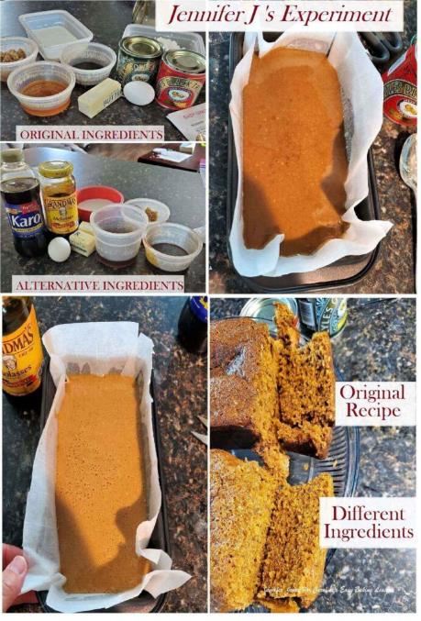
Comparison Of US Vs UK Ingredients For Caro’s Gingerbread Cake
“I used Karo Dark Corn Syrup in place of Golden Syrup and Molasses in place of Black Treacle in the US version.
Golden Syrup taste is just incomparable to anything I’ve ever had in the US products. It’s very similar to butterscotch, but not as heavy. Corn Syrup just does not compare at all.
Black treacle tastes very like the Sorghum Blackstrap Molasses that my Grandfather used to love. I couldn’t get any of that, but I believe it would be a good substitute.
On oven exit, the UK cake seemed fluffier than the US one. US is much lighter in colour, and lacks the strong flavor of the UK ingredients. It’s still very good, but I would recommend purchasing UK ingredients if at all possible. The taste is just that much better.
As always with Caro’s recipes, I highly recommend. “
Jennifer Jones
FACEBOOK, OCTOBER 2020.

Cake Tin Used
I used a 22 x 11cm x 6.5cm deep 2lb bread tin (8.5 x 4.3 inches x 2.3 inches deep).

Ingredient List
As well as the Golden Syrup & Black Treacle, what else is in this British Gingerbread cake? This gingerbread cake recipe was originally written using UK Self-raising flour, but I have subsequently tested it using Plain (All Purpose) flour and have listed below how much baking powder you will need if using this flour. Gingerbread cake also has eggs, unsalted butter, milk, light brown sugar, ground cinnamon & ginger and finally bicarbonate of soda (Baking Soda). Any milk is fine and dark brown sugar or coconut sugar would also work. Have undecorated or add a simple glaze of icing/powdered sugar, & add some chopped crystallised stem ginger if you like.
INGREDIENTS
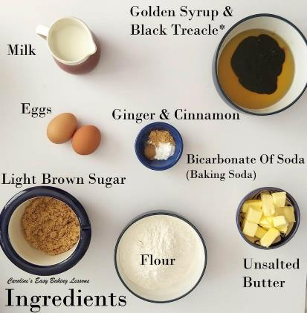
- 113g Butter, unsalted (4 oz, 1 stick or 1/2 cup)
- 150g Golden Syrup ( 5.25 oz or 1/3 cup)
- 75g Black Treacle (see note above) (2.5 oz, 1/4 cup or 3 3/4 tbsp)
- 113g Light Brown Sugar (4 oz or 1/2 cup)
- 1 tsp tsp Ground Ginger
- 3/8 tsp Ground Cinnamon
- 188ml Milk (1 fl oz or 3/4 cup)
- 2 Medium – Large Eggs (Large-XLarge US)
- 3/8 tsp Bicarbonate of Soda (Baking Soda)
- 225g Self-raising Flour (8 oz) (see note above)
- OR 1 3/4 cup Plain/All Purpose plus 2 3/4 tsp Baking Powder (be sure to also add the 3/8 tsp above too, so that would make a total of 3 1/8 tsp)
For Icing/Glaze (optional)
- 125g Icing/Powdered or Confectioners’ Sugar, sieved (4.5 oz or 1 cup)
- Few tsp Water or milk
- Crystallised Stem Ginger Pieces, chopped (optional)

EQUIPMENT
- Scales or measuring cups
- Measuring spoons
- Small measuring jug
- Small cooking pot
- Medium – Large mixing bowl
- Hand Whisk
- Baking/parchment paper or loaf tin liners
- Spray oil, (Frylight), Cake release spray or butter for greasing (For metal tins use homemade lining paste – see instructions).
- Loaf tin (I used a 21.5 x 10cm / 8.5 x 4 in, see note above)
- Sieve
- Medium bowl x 2
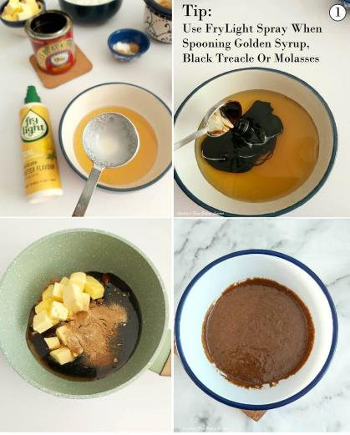
- Metal spoon
- Timer or phone timer
- Cooling rack
OVEN: 180c/160c Fan Oven/350f/Gas Mark 4

INSTRUCTIONS

1. Place the butter, golden syrup, black treacle, sugar, cinnamon & ginger in a small saucepan and warm on medium heat until everything is dissolved and melted.
** Tip for using the syrup & treacle – spray oil on the measuring spoon and it will slip off easier. See Photo 1. I use & recommend Frylight cooking spray (full disclosure – no sponsorship or payment from Frylight). I also use on silicone bakeware, especially silicone mini bundt cake cases (see it used for my mini gingerbread bundt cakes recipe, or in the video above). I also use it for greasing cake & bread tins/pans, when not using homemade Lining Paste. Less expensive than cake release spray or butter & flour. Don’t buy from the bigger supermarkets, but pay less by purchasing from the likes of Aldi, Lidl, B&M or Home Bargains.
Once the ingredients are melted & dissolved, mix everything thoroughly and remove from the heat. See Photo1. Allow to cool while you prepare all the other ingredients & the cake tin. (This is because we don’t want it too hot when adding to the eggs, or it might scramble them.)

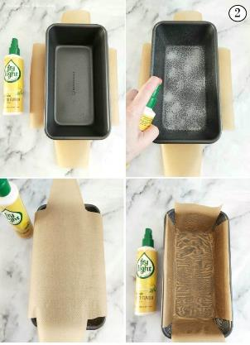
2. Grease & line your cake/bread tin with some baking/parchment paper. You can buy paper liners for loaf tins, but I just cut out my own. Here is how to use less paper, & for it to fit better in the tin (Not doing so, can result in the paper can ending up baked into the cake at the corners).
Place the paper under the tin & cut out a cross shape, (like in Photo 2), ensuring the paper is long enough to go up the sides & for just a little excess. I cut in angled lines, so there is little or no over-lap once positioned inside the tin. Then simply grease or oil the tin well and place the paper in position. See Photo 2. You can also draw lines for where to cut out, and then simply turn the paper over when placing in the tin. Add more oil if needed & only grease shortly before adding in your batter.
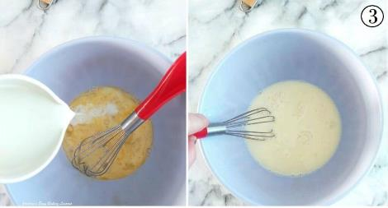
For metal tins, I also recommend making your own lining paste. Also known as Cake Goop, it is less expensive that cake release spray, or using butter and flour. Can be used for any greasing in your baking or cooking & even made gluten free. Read my review of lining paste and how to make it at home.

3. Heat the oven to 180c/160c Fan Oven/350f/Gas Mark 4.
4. Place the egg in a medium sized mixing bowl & whisk lightly. This ‘wakes up’ or activates the protein in the egg & helps provide structure for the cake. Add in the milk & bicarbonate of soda (baking soda) and whisk till all combined. See Photo 3.
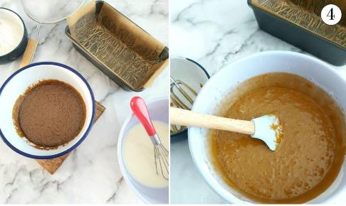
5. Next add the cooled syrup mixture to this milky-egg mixture, and stir continually until all incorporated. See Photo 4.
6. Finally sieve over the flour (and baking powder if using Plain/All Purpose Flour instead of UK Self-raising), into the mixture. Beat until combined and the batter is smooth. (A few small lumps is fine and you can use a hand-held or stand mixer for this if you like). Note that this batter will be thin and runny in comparison to some other cake batters. See Photos 5 & 6.
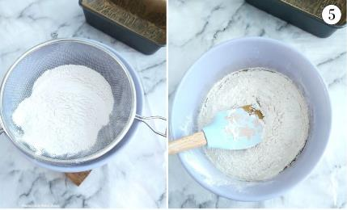
7. Carefully pour the gingerbread cake batter into the prepared cake/bread tin, and then give a few gentle taps of the tin on the counter/worktop to expel any trapped air. See Photo 6.
8. Bake in the centre of the pre-heated oven, for about 25 minutes, until a deep golden colour, set and when you insert a wooden cocktail stick into the centre of the cake, it comes out clean of crumbs. Note if colouring too soon, cover the top of the cake in foil till cooked through. (Don’t cover at the beginning of baking as the foil will stick to the cake as it rises, so best to check & cover if needed, at some point after 15 minutes of baking.) It will be very soft on top. 9. Leave to cool in the cake tin for about 10 minutes, before transferring, paper and all, to a cooling rack.
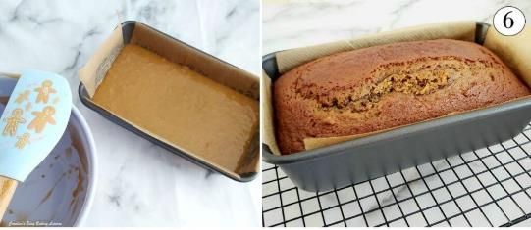
Alternatively, you can leave in the tin for longer or overnight if not decorating or eating same day, provided you have greased and lined your tin. Leave out at room temperature to cool completely, before wrapping in cling film/plastic wrap. Leave out at room temperature and not the fridge, as condensation will occur and wet the cake.

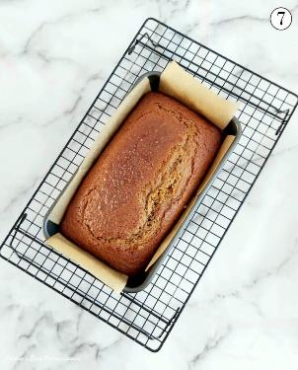
Make The Icing/Glaze
10. While the cake is cooling, make up your icing/glaze if you want some, (believe me it’s nice without it too). Begin by sieving the icing/powdered sugar into a medium sized bowl, (otherwise you will get the sugar everywhere). See Photo 8.
11. Add 1 tsp of water (or you can use milk), & mix with a spoon. Once the water is in, use the back of a large spoon to push down on the sugar that will keep absorbing the liquid. Keep doing so – you will be amazed at how much liquid this sugar can absorb if you keep at it. Then gradually add in a 1/2 tsp of water at a time & the sugar will become paste like. (See Photo 8 & 9). Keep rubbing in, & adding 1/8 tsp drop at a time, until you get a thick but pourable icing/glaze.
Thick is best as it will form a nice layer and not ‘melt’ into the cake.

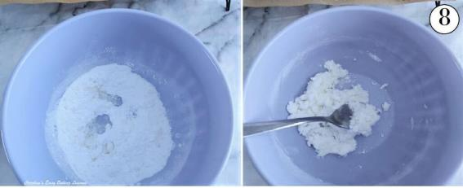
To test if it’s right, hold your spoon up high above the bowl with some icing/glaze on it & point it downwards to let it drip off. (You can also test on the bottom of a small upside-down bowl). You want it to run down gently. (See Photo 9). If it stays where it is, add more water a tiny drop at a time. If you have added too much water at once, sieve in more sugar and repeat until you get it right. Very, very gradually is the key here. Watch my quick video showing how the glaze will fall.
If you want to make using a mixer, start by adding in 1 1/2 tsp & again very gradually adding more drops in.

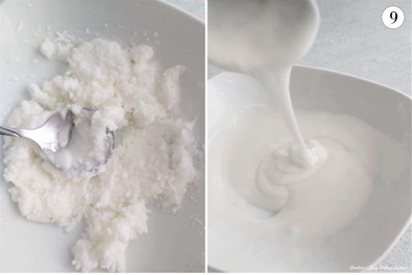
12. Leave the cake on the paper you used to bake with, still on top of the cooling rack, with some more paper underneath, to catch any drips of the glaze. (See Photo 10 below). Alternatively, you can transfer the cake to a platter with some paper underneath, that you can remove once the glazed cake is set.
13. Once the cake is cooled down, take a spoon’s worth of the icing/glaze & hold high above the cake. I like to start at the end/edge of the cake and draw it across the cake as the sugar drips down. Holding up high gives you a thinner drizzle.
Just move your hand left & right while drizzling above the cake and do any pattern or random drizzle that you like. See Photo 10 where I started with some thicker lines and then added some thinner ones in-between until I used up all the glaze.

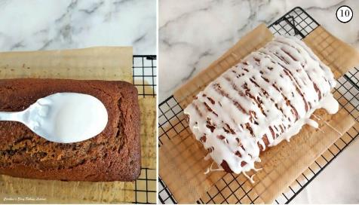
Alternatively, you can pour the glaze over the cake, or keep the glaze slightly thick & spread it on, starting from the middle with a thick amount and then spreading out to the edges. It should set up in minutes if the room isn’t too war, so you might need to work quick if spreading on. Having the paper still under the cake comes in handy for the drips of the glaze!
14. Add some chopped crystalized ginger if you like & let the glaze set (dry to touch). See Photo 11. Now go ahead and slice the cake with a large serrated knife, very gently (hold the cake if you can at the sides, as the crumb is very soft and delicate). Serve as is & enjoy!

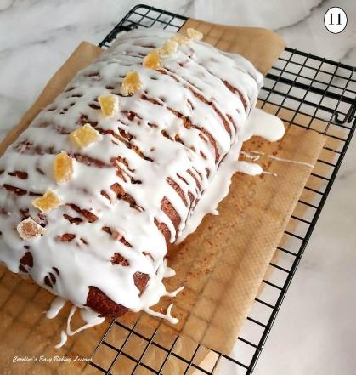
Storing & Freezing
15. Store in an airtight container or cake stand & dome, for at least a few days. (I recommend cake tins for most of your baked goods).
Can easily be frozen too. Just include some kitchen paper/paper towel in with it, so that this absorbs any moisture when defrosting, and wrap in baking/parchment paper, before some cling film/plastic wrap or a food bag. Date and label the bag – should be good for a few months. Thaw at room temperature. Can be frozen with or without glaze.

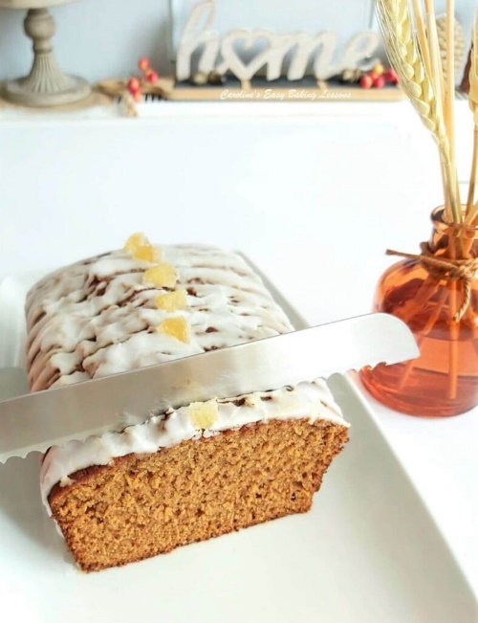

DIFFICULTY LEVEL: Super Easy, Beginner.
Posted on 07/10/2019 by Caro

