MAKE-UP THEMED CARROT CAKE - A Photo Tutorial
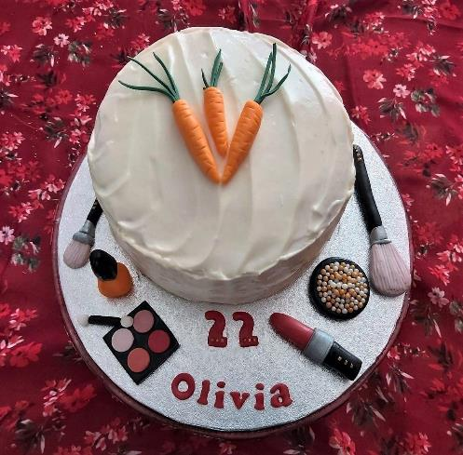
From: Caroline’s Easy Baking Lessons

EQUIPMENT
For Cake, see Carrot Cake recipe

For Make-up Fondant Toppers-

Red, orange, black & white fondant/ gum paste (or just white & black and the food colouring - gel or paste is best).
Silver spray or brush on food paint (I used Dr Oetker - Shimmer Spray)
Some yellow & brown colouring for the brush bristles or just brown
Green fondant or colouring for the carrot tops (if using)
Gold/bronze & white pearls - I used cupcake sprinkles for this.
Vodka, clear alcohol or egg wash for glossing the toppers
Food Glue, or water or egg white
Very Small brush for gluing in position
Small Brush for glossing the finished toppers
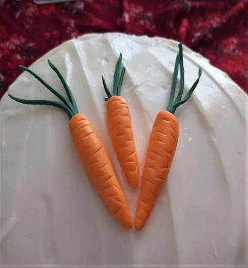
Gold cake topper sprinkles for 'bling'
Small sharp knife
Pastry or fondant mat (optional) or baking/parchment paper
Tray for drying the toppers on
Cling film/plastic wrap
Wooden cocktail sticks
Letter and number cutters (optional)
Rolling Pin (small fondant one preferably)
Tylo powder (optional)

INSTRUCTIONS

CARROTS - See cake recipe for tutorial - GO TO CARROTS TUTORIAL

MAKE-UP BRUSHES

Roll a large ball of black fondant into a slim sausage shape. Do this according to whatever size of brush you want. If it's too long, simply cut some off the end and then round and taper the cut end between your palms. Once happy with the thickness and length, place on baking/parchment paper and let it dry and harden.

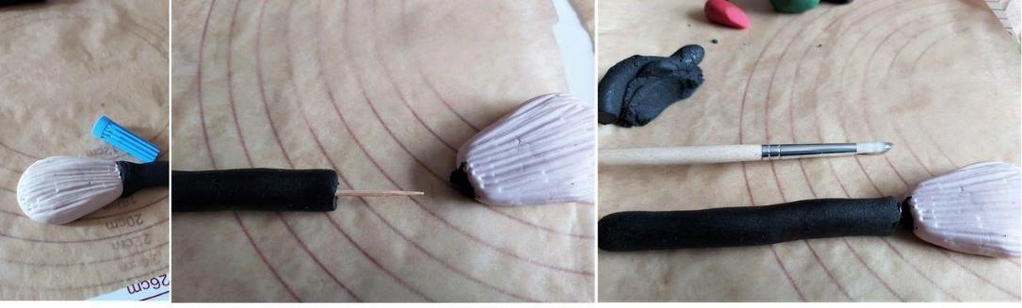
Photo 1 - Making the fondant make-up brush

To make the bristle end of the make-up brush, I used some white gum paste that I had previously coloured to a skin tone (using a little brown and yellow colouring). You could buy skin tone fondant or gum paste, or even a pale brown. Gum paste is better as it will harden better and take the shape and markings better. You can also add Tylo powder to fondant for it to harden. Roll a ball of the fondant/gum paste and then flatten to the thickness you want. Then make one end thinner (the end that will be attached to the handle). Try to make it the same width as the brush handle. (See Photo 1 above).

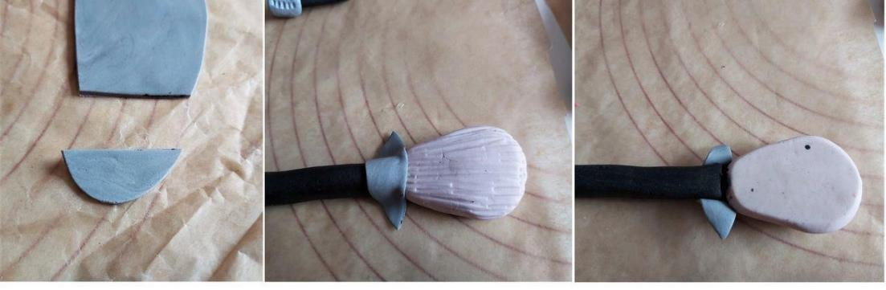
To make the bristle impressions, I used a food pen lid that had lines on it and just pressed it down on it. Be sure to remember to do the sides and also the tip of the 'brush head'. (See Photo 1 above & 2 below) Leave to harden.

Photo 2 - joining the brush handle to the bristle head of the make-up brush

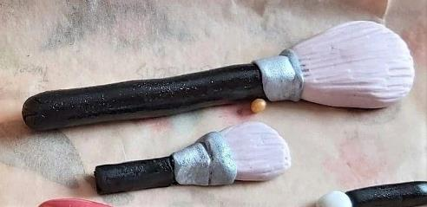
Photo 3 - the finished make-up brushes.

To make the silver part to join the brush handle to the head, I made up some grey fondant using white and a little black fondant. I rolled it out and then cut one of the ends off that was wide enough to wrap around the brush handle but also shaped and curved like a wide 'V'. (See Photo 2 above, left pic). Once the other brush parts were a little harder, I inserted a wooden cocktail stick into the brush handle to join them together. You can also use some food glue in between to help them stick together. I then brushed some more glue onto where I would be putting the grey fondant strip and placed in position and wrapped around the back of the brush. Once in position, (See Photo 2 above, middle and right pic). I made an indent in the grey fondant. (See Photo 3 above). To get the metal effect I used a silver shimmer spray, but actually sprayed onto some baking paper and then simply brushed onto the grey fondant. Then I left to dry and set flat on a tray.

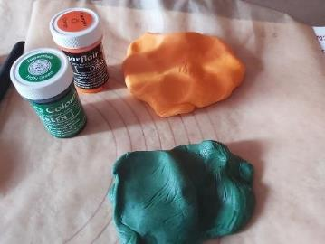
NAIL VARNISH/POLISH

Photo 4 - colouring the fondant/gum paste

I used some white fondant that I coloured with orange paste food colouring (Sugarflair. See Photo 4. To make into gum paste I added Tylo powder as this hardens better.

I rolled the orange ball of gum paste into a thick sausage shape, then flattened one of the ends that would be the bottom of the bottle (do this by rubbing against the bottom of the fondant to remove the rounded end). Then I thinned the opposite end between my fingers (what would be the neck of the bottle). Once happy with the size, roll a little gently in one palm to regain the rounded shape. (See Photo 5 below, left pic). Then I placed on baking paper to harden and set.

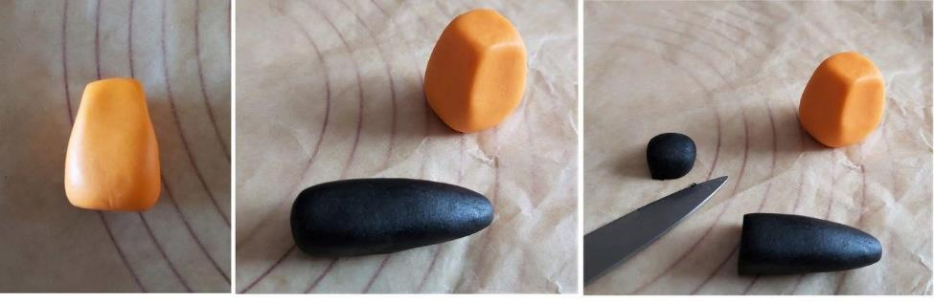
Photo 5

To make the bottle top, roll a ball of black fondant/gum paste into a fat sausage shape and taper the end you want to be the top. (See Photo 5 above, middle pic). Once you have the same width as the top of the bottle neck, compare on top of the bottle to see if the top is the correct length. If too long, cut some off the bottom end. (See Photo 5 above, right pic). Then smooth the cut edges with the tip of your finger. Leave to harden a little.

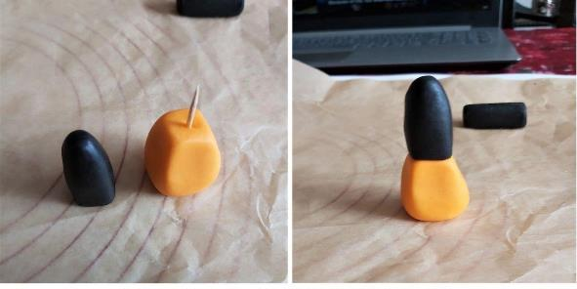
Photo 6 -

Insert half a wooden cocktail stick into the bottle piece and join together with some food glue in between. (See Photo 6 above). Leave to harden and set in an upright position. If it doesn't want to stay standing, rub on the paper gently to flatten it until it stands. Leave to harden and set. Give a gloss finish and top details (see further down the tutorial for details on this)

LIPSTICK

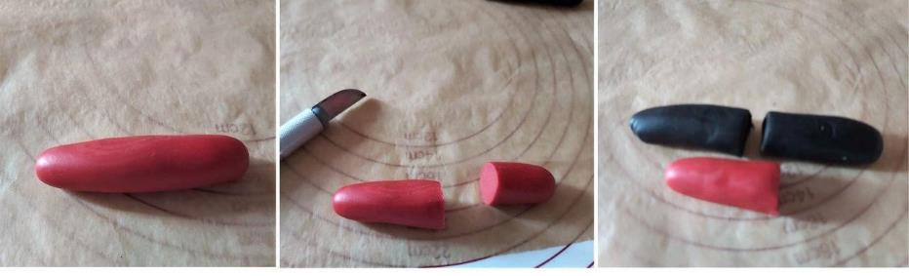
Roll a ball of red fondant/gum paste into a sausage shape, longer than the length of lipstick you want (as some of it will be covered). See Photo 8 below, left & middle pics. For the end that will be covered, taper slightly to make joining easier. Leave to harden on baking paper.

Photo 8 - forming the fondant lipstick.
Roll a ball of black fondant/gum paste into a sausage shape, a little wider than the lipstick part you made. Then cut off what will be the base of the lipstick and smooth the edges. (See Photo 8 above, right pic). Then taper the opposite end a little. If you want the lipstick to be less rounded, use 2 fingers from both hands and squeeze the black fondant to give more straight edges. Once happy leave to dry lying down.
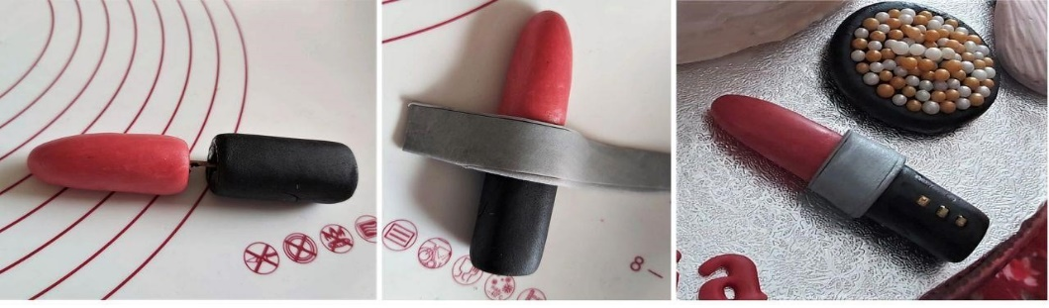
Join the two lipstick pieces with half a wooden cocktail stick and some food glue. See Photo 9 below, left pic.

Photo 9 - Joining the lipstick together.

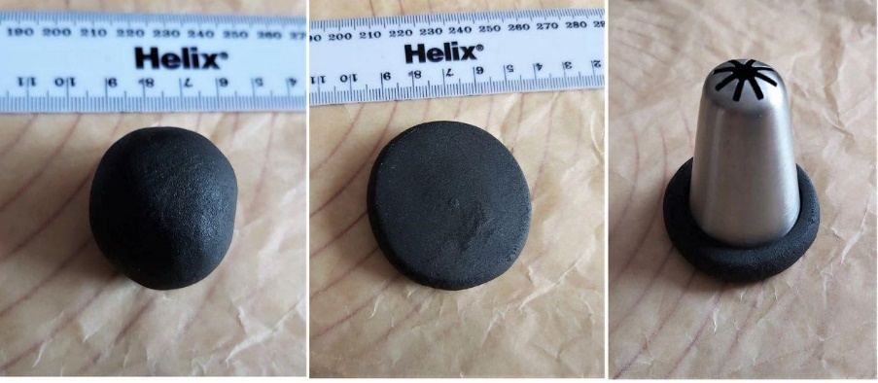
Using the grey fondant/gum paste from before, make a long rectangular strip that will wrap around the lipstick. I used a knife to make some indents in the strip so as to give some detail. I then glued the strip in position over the join and around the back of the lipstick. (See Photo 9 above, middle pic). If you want you can cut the red end of the lipstick at a slant to look like a new lipstick. Note that after leaving to harden too much it doesn't always work out right. Leave to dry.
Photo 10

BLUSHER PEARLS

Using a ball of black fondant/gum paste, I flattened to the width I wanted for the blusher pearls dish to be using the base of a small bottle. I then used a large piping nozzle to mark a circle that would be the inner rim of the 'tub'. I then pushed the fondant down a little in the middle of this area. (See Photo 10 above).

For the blusher pearls, I used cupcake sprinkles in gold and pearl white shades. I formed a ring with the pearls around the circle impression I had made (gluing them in position) and then brushed some food glue on the inner section, before placing more pearls, being sure not to leave any gaps. Then I brushed a little glue on top of the centre pearls and placed a few more on top. See Photo 11 below.
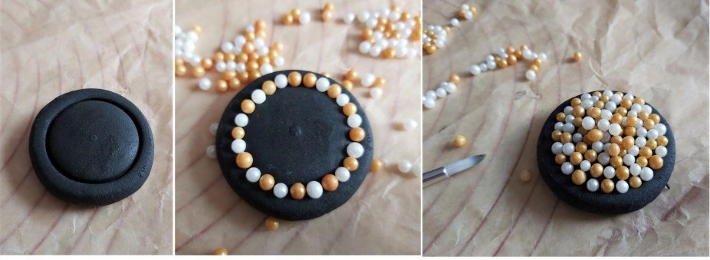

Photo 11

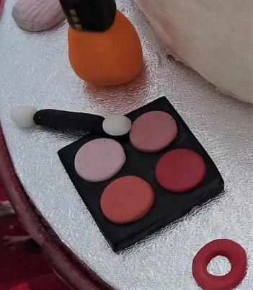
Photo 12 -

EYE SHADOW PALETTE

Roll out black fondant and cut out a square (free hand with a knife and ruler or something square the correct size). Then make up the colours or shades of eye shadow you want with your fondant/gum paste and roll out thin. Cut out circles for the eyeshadow, using the wider end of a piping nozzle or something similar and the correct size. For this one she made 4 circles of 'eyeshadow'.

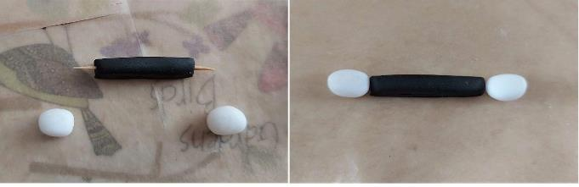

Then simply glue in position. To make the applicator, cut a thick strip of black fondant/gum paste the length you want, then use your fingertips to make it have more straight edges. Take 2 very small balls of white fondant/gum paste and flatten slightly, making one end more pointed than the other. Insert 1/2 wooden cocktail sticks into both ends of the black piece and
then place the white ends in position with the pointy edge to the outer most edge. You can hold in position with some food glue. Leave to dry and harden. See Photo 13 below.

Once all the toppers are dry, the colour can fade a little and go more of a matte tone, so you can gloss these by brushing on clear alcohol (I use Vodka) but there are other options like egg whites (see Google for alternatives). Leave them out to dry to the touch only and then cover in their tray with cling film/plastic wrap until ready to use. At this stage I also added some 'bling' to the make-up on the black areas with some 'gold' sprinkles, to make them look like a more expensive brand. I also added a few onto the '22' I had cut out, along with the birthday girl's name from the red fondant.

The toppers can be made in advance as they do take some time to complete. Be sure to wrap as advised and keep away from direct sunlight and heat.

To assemble everything, I placed my carrot cake towards the back of the cake board so that I would have lots of space for the topper, did a crumb coat before chilling overnight and then another 2 layers of thick cream cheese, (chilling in between times). It was then just a case of positioning the fondant toppers in place. I didn't glue them, as it can melt the fondant a little and placed in the fridge until time to be sent off. (Only next door so nothing feel off thankfully!).
Thank you for reading the tutorial. I am sorry it's not as thorough as usual, but into day 10 and still not well (actually wearing sunglasses typing this to see if it will help). If you make any of the toppers of the cake, I would love to hear about it and even better still see some pics.

HAPPY BAKING

