THE MOST SIMPLE YET VERSATILE CHOCOLATE CUPCAKE RECIPE – Can Be Made Vegan or Into A Layer Cake

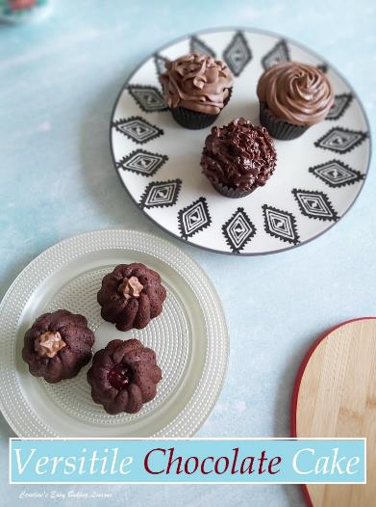
Caroline’s Easy Baking Lessons

A GREAT QUICK ONE-BOWL CAKE TO WHIP UP IN AN HOUR
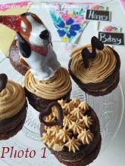
This recipe comes from my friend Robyn in America, and I first tired it last year to make mini layer cakes. Her original recipe came with an Espresso Buttercream frosting, that everyone loved, even my son who doesn’t like coffee. So that became a Valentine’s recipe for 2020. See Photo 1.

USE AS A LAYER CAKE
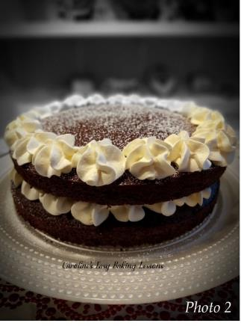
Later in the year, when lots of people were baking, but baking ingredients were in short supply, I used the recipe for making a simple layer cake. That time I simply paired it with some raspberry jam and fresh cream. (See Photo 2 – go to recipe). We even used it in the Facebook group, Great British Bake off Fans for a competition. Our friend Diana won that one where she used cream, cherries, cherry jam and chocolate work to make it a yummy Black Forrest Gateau style cake. (See Photo 3 below). Now yes, it sounds very rich, especially when there were shortages, but this recipe does not use any eggs or butter, so you save on that. It requires some milk, but I know it can be made completely vegan if need be, as Robyn makes it using coconut milk for herself for health reasons.
HALLOWEEN CUPCAKES
For Halloween I used the recipe to make regular cupcakes, just as Robyn has done with her eyes closed, dozens and dozens of times and you can see all the different types or frosting she used before finishing off with sprinkles of choice for the occasion. (See Photo 4)
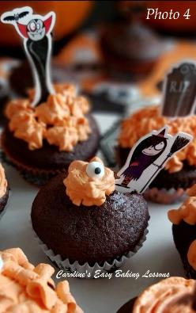
MINI BUNDT CAKES
But it’s versatility does not end there. The recipe requires plain/All Purpose flour. But I at one point only had self-raising in bulk (wanted to keep the plain/A.P. for bread making, so I used self-raising, omitted the raising agent and vinegar and I also one time, ran out of brown sugar, so in the end it was a concoction of dark brown & granulated and it all worked out just as well as any other time. I also tried out some of the batter in silicone mini bundt cases and guess what? It worked perfectly and they didn’t stick. Not only are they very cute, it took on the shape/pattern well and the middle was a perfect place to fill with some jam or ganache or buttercream. (See Photo 5).
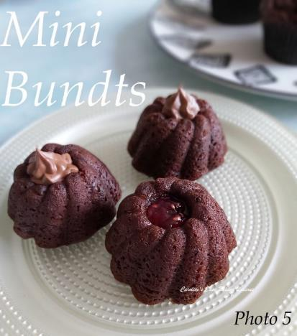
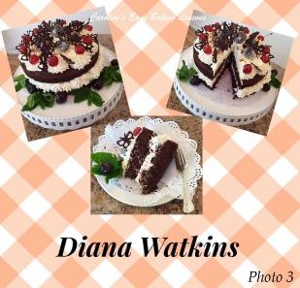
Is that all enough to convince you to try out this recipe? If not, what if I tell you, that you don’t even need to ger the hand or stand mixer out? All can be make super easily and quickly by hand (and you don’t knead a lot of hand or arm power to do it).
Top with anything you like – buttercream frosting, cream cheese frosting, whipped cream, ganache, glaze or even just dust with some icing/powdered sugar. The choice is yours. I am going to try this recipe with wholemeal flour too, as I know that works really well with chocolate cakes and you just can’t tell the difference. Would love to also try a vanilla or even lemon version, so stay tuned. But before that, I also have another variation of the recipe, coming out soon.
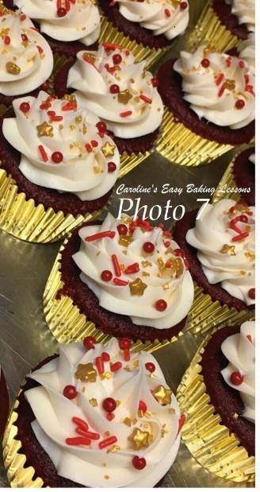

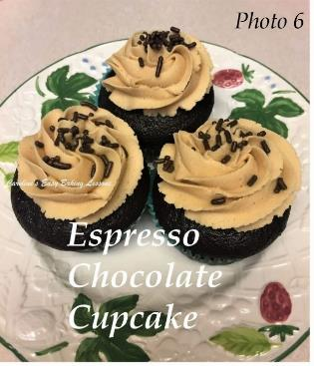
INGREDIENTS
209g Plain Flour (7.25 oz)* (1 & 2/3 cups All Purpose)
200g Dark Brown Sugar (7 oz) (1 packed cup)* see below
31g Cocoa Powder (1 oz, 1/4 cup)
1 tsp Bicarbonate of Soda (Baking Soda)*
1/2 tsp Salt
1 tsp Instant Espresso powder
240ml Milk (8 fl oz, 1 cup)
80ml Vegetable Oil (2.75 fl oz, 1/3 cup)
1 & 1/4 tsp Vinegar *
1 & 1/2 tsp Vanilla Extract
* If using self-raising flour, omit the vinegar & bicarbonate & it will rise nicely. For the sugar you can use any or a combination of more than one sugar.
DECORATIONS (Optional)
240ml Double Cream (8 fl oz whipping or heavy cream), buttercream, chocolate ganache, simple glaze or even just a dusting of icing/powdered sugar.
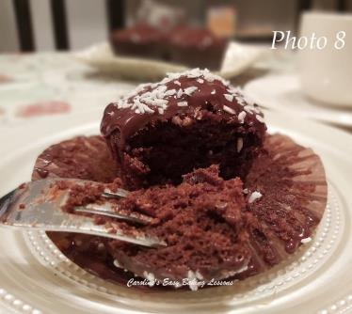
EQUIPMENT
- Digital scales or measuring cups
- Measuring spoons
- Large mixing bowl
- Stand or hand-held mixer (not needed for cake, but will be needed for whipping the cream if using).
- Sieve
- Small measuring cup/jug for the milk/oil
- 12 Cupcake/Muffin Paper Cases
- 12 Hole cupcake tray
- Timer or phone timer
- Cooling rack
- Spoon for mixing
FOR DECORATING (Optional)
- Piping syringe, or piping bag
- 1cm (1/3″) piping nozzle (optional)
- Or Small sieve & icing/confectioners’ sugar
- For other equipment, see my ganache recipe.
- OVEN: 180c/160c Fan oven/350f/Gas mark 4

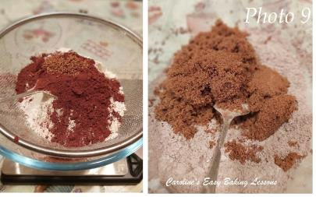
INSTRUCTIONS
1. Weigh or measure out the flour, while sieving into a large mixing bowl & repeat for the cocoa powder.
2. Next spoon in the sugar, bicarbonate of soda (baking soda), salt and instant espresso/coffee powder or granules and mix everything together till evenly distributed. See Photo 9.
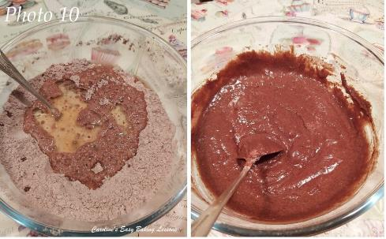
3. Now using a hand/stand mixer or even just a spatula or wooden spoon, add in the vegetable oil, vinegar and vanilla extract. Start on the lowest setting, before increasing the speed and mixing till all combined. Last time I just used a spatula and kept the mixer clean to use for whipping the cream.
4. Finally, add in all the milk at once and mix like before, until thoroughly incorporated. You should have a relatively liquid batter once ready. See Photo 10.
5. Now pre-heat your oven to: 180c/160c Fan oven/350f/Gas mark 4 (or earlier if your oven takes a longer time to heat up).
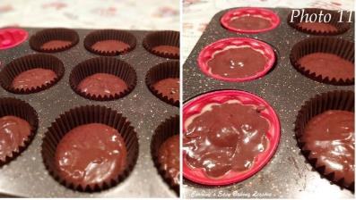
6. Now line the cupcake tray with your 12 paper cases (or silicone bundt cases), and divide the batter equally among them. See Photo 11 and note how much they are filled. (Note if using mini bundt cases, you will probably get more than 12 from the batter).
7. Give the cupcake tray a few taps on the counter/worktop to expel any trapped air before placing in the centre of the oven.
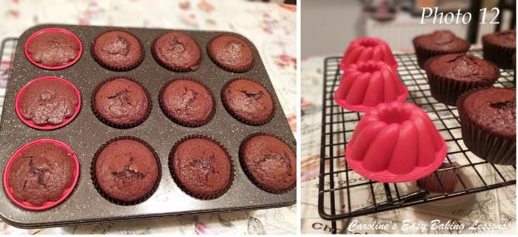
8. Bake for about 18 – 25 minutes till done. Mine took 23 minutes and I turn the direction of the tins after about the half way point, for an even bake (but I do have an old oven). Because of the colour, they will look done on the outside early on, but are not ready in the middle yet. So start testing with a wooden cocktail stick at about the 16 minute mark. You want the stick, when inserted in the centre of the cake, to come out completely clean of crumbs or batter. Be sure to go deep down as they are big cupcakes. If not ready, bake a further 1 minute or 2 and check again. See Photo 12.
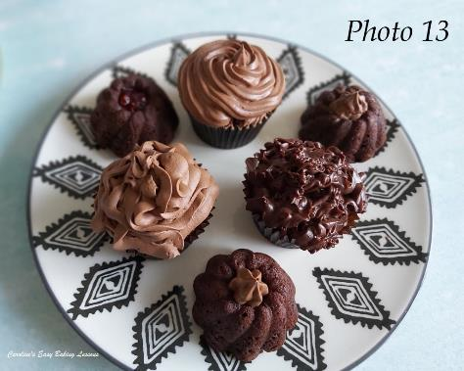
9. Remove from the oven and place the cupcake tray on top of a cooling rack for at least 10 minutes. Then you can remove the cupcakes from the tin and leave to cool down completely on the cooling rack. Note for the bundts, I left them cooling the correct way up so that they could develop a more flat bottom to sit easier. See Photo 12.
10. Once completely cool they can be eaten, or decorated or even stored or frozen. Wrap in baking/parchment paper and then place in a food baggie for freezing. To defrost just leave out at room temperature.
11. You can decorate simply by sieving over some icing/powdered sugar and adding some themed toppers like the Halloween ones in photo 4 further up. Alternatively you can colour some whipping cream orange and pipe crazy patterns on top. Same can be done with buttercream. The choice is yours and will suit any occasion. You can also top with fresh cream, a dusting of icing/powdered sugar, a simple glaze or even chocolate ganache, (See Photo 13 & Photo 14).

DIFFICULTY LEVEL: easy, beginner
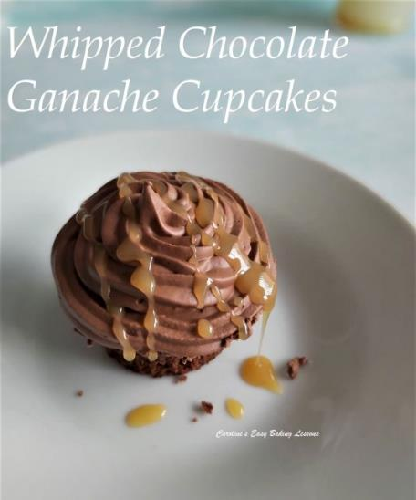
Thanks for reading. I also have more to come with this versatile cake recipe, so look out for that, coming soon!

Happy Baking & Making
Happy Memories & Tummies

Caro xx

