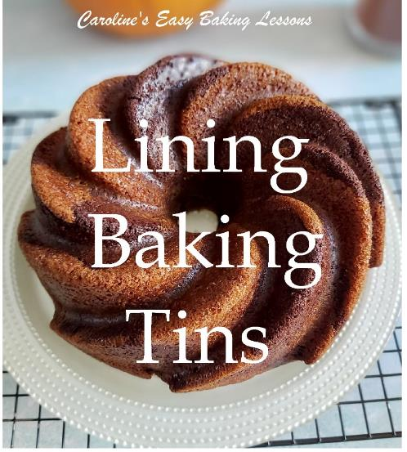
HANDY BAKING TIPS - Lining Baking Tins
Caroline’s Easy Baking Lessons Theory Lesson 4
So I thought I would let you all know some of my tips for successfully getting your cake out of the tin, no matter the shape of tin. All my tips are within each recipe or review, but I thought I would put them all together here in one place for some more baking theory, that you can easily apply at home.

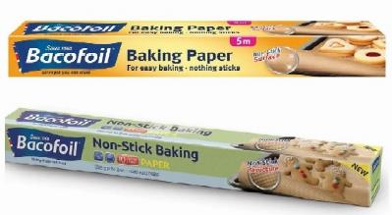

In my baking, whether it's cakes or cookies, I always always use baking/parchment paper. I have found over the years that the cheap white kind or greaseproof paper is not ideal if you don't want the bake to stick. So I always pay a bit more and buy brown baking/parchment paper and use a brand called Bacofoil and usually to get it from a discount store in the UK called Savers for about £1.70 for a 10 metre role ($2.13) and it is actually much more expensive in the supermarkets. Nothing has ever stuck to it and I re-use it. I also use it when making fondant decorations too. I used to get the plain flat one,(the top one in the pic), but they changed to an embossed one that I guess helps with the non-stick. I am never without the paper, as it also preserves the life of your tins and oven trays/sheets.

LINING COOKIE TRAYS/SHEETS

One tip for when using on an oven tray/sheet for cookies etc. If it doesn't have a lip/edge, grease it before placing the paper in position, as you don't want the cookies or cookie dough to slide off. That has happened - for real!!

STANDARD SHAPED TINS

Round Cake Tins:

Ok so most of us have round cake tins, also known as sandwich tins if they are shallow and they come in deep ones too, and some with a loose base or spring release for easy removal of the cake. However, the tricky part is often ensuring the bottom of the cake comes out in one piece. So I have a handy trick for cutting that circle to cover the bottom of the cake tin, no matter the size. No need to buy pre-cut paper liners. Can be used for any round dish that you don't want any sticking. Here's how:

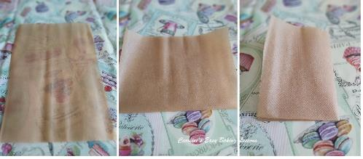
• Begin by cutting a piece of baking/parchment paper wide enough to cover the bottom of the tin.

• Next fold it in half so you have a rectangle (see Photo 1, middle pic)

• Now fold that in half again (3rd pic, Photo 1).

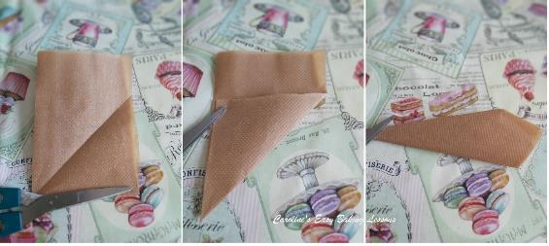
• Turn the paper like in Photo 2, & next fold up the right bottom corner of the paper.

• Now fold at the point like in the middle pic, Photo 2.

• Fold over the lower right edge, to meet the left edge, making a pointy 'dart' like shape. See Photo 2, right pic.

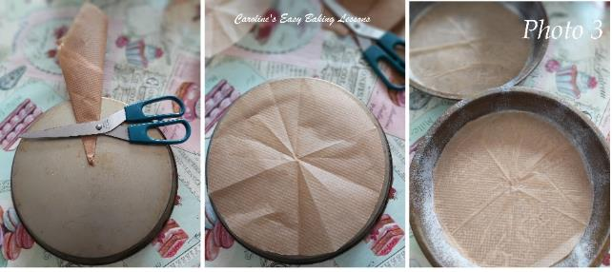
• Now place the thinnest point of the folded paper to the centre most point of the underneath of your tin. See Photo 3, left pic.

• From this you can then see where you need to trim off the excess paper so that it fits inside of the tin. Cut at a straight angle.

• Now open out the paper and try it out for size. If too big, simply fold back along the creases and trim off a tiny amount and repeat until you get it right.

• Then grease the bottom of the tin and up the sides, before placing the paper in position. See Photo 3. Lining just the bottom will be fine for most recipes & greasing the sides, unless the recipe specifically states to paper the insides too. In which case, cut thin strips, and make little tears along one long edge and this will allow it to sit better in a round tin.
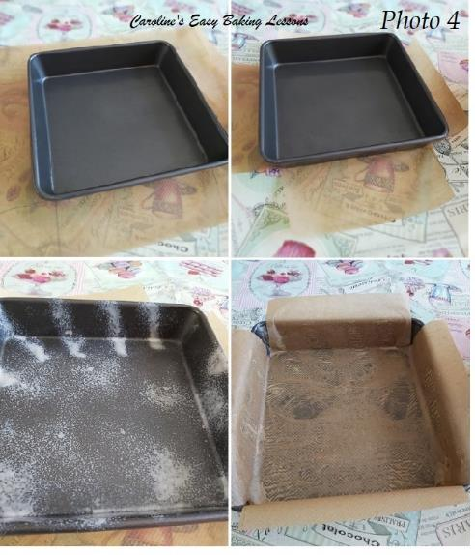

For Square or Rectangular Tins

• Open out your baking/parchment paper and place under the tin. Pull the paper so there is plenty on the left and right side of the tin. Going up over the edge of the tin is ok. Cut to that width. See Photo 4.

• Position the tin so that the edge nearest and furthest away from you has enough paper to go up the sides of the tin. You really want to centre the tin in the middle of the paper.

• Then take a pencil or marker and draw a square at the where the corners are - this is what will be cut out. (See Photo 4, top left pic) and you do to all the four corners. It will produce a thick cross shape.

• You can now lift the tin off and cut out the corner areas. I like to cut at an angle just so that the paper does not overlap once in the tin, as it can stick in the cake.

• Finally, spray oil or grease your tin well, turn the paper over and positioning inside the tin. Apply more oil if need be. See Photo 4.

• Not only is this beneficial in getting the cake out, but you can lift it out with the help of the ends of the paper. Also, for some cakes or traybakes, I keep them on the paper and store in a metal tin. I find it helps keep the moisture in.
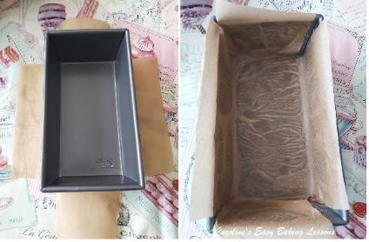
• The same method is used for rectangular tins too, like loaf tins. See Photo 5.

Other Shaped Tins

• For awkward shaped cake tins, the easiest way to line the tins, most people use oil/butter & flour/powdered sugar or cocoa powder if it's a dark cake like chocolate.

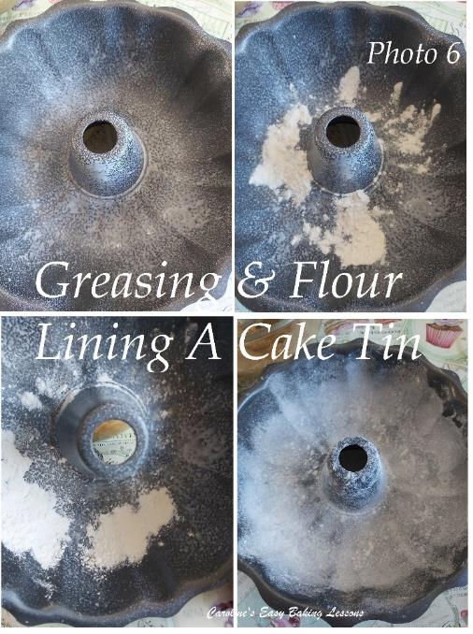
• For this bundt tin, I sprayed baking oil on the inside. Alternatively you can use melted butter & brush on in upward strokes (this makes it easier to release the cake as there is no friction). See Photo 6 top pic.

• Then sprinkle on some flour & then tilt the tin and let the flour fall to the bottom and then rotate the tin slowly, allowing the flour to cover the sides of the tin. Repeat this process until all inner areas have a layer of flour and then shake off the excess. See Photo 6.

For Bundt Pans And Even Just For Greasing Other Things

I mostly now use a recipe by Great British Bake Off winner Nancy Birtwhistle. You make up her lining paste and store in the fridge, ready to use whenever you want it. Cheaper than using butter or release sprays. Here's my review of her lining paste. Photo 7 - coating a ramekin dish
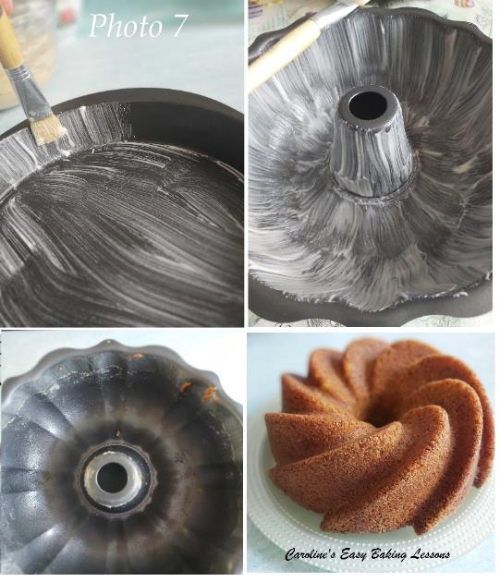

For Dark Coloured Cakes

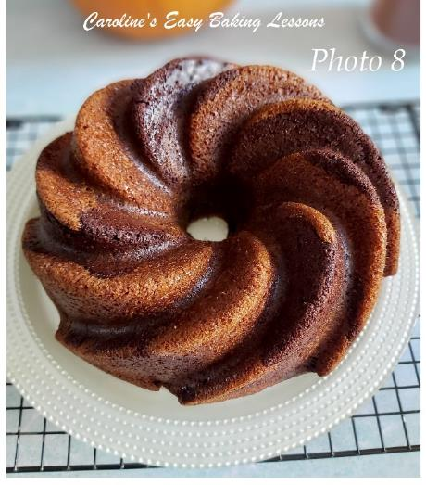
For the likes of chocolate cake, when using the lining paste, just take a few tsp of the paste out of the jar as normal, and add a little cocoa powder to colour the paste.

Don't make it dark brown, just give it a light brown colour. This ensures no white residue is left on your bakes.

Cupcakes & Muffins:

I see so many people on tv making their cupcakes and muffins directly in their trays without any paper cakes. In reality, we need our baking equipment to last us and don't have someone else to clean up the mess for us. So I always use paper cupcake or muffin cases. Please please avoid getting the metallic ones, as they are really bad and always cause the cakes to stick. The cases make it easy to get out, you don't need a plate to eat from it, and you can clean the tray easily.

Thanks for reading & I hope you find these tips useful. Please pass them onto others and let them know about my website - that would be great.

Happy Baking & Making
Happy Tummies & Memories

Caro x

