Lemon Meringue Pie Tutorial Caroline’s Easy Baking Lessons

‘Luscious and Lemony Loveliness in a Pie’

By Caro

I call my Lemon Meringue Pie – Luscious Lemony Loveliness In A Pie! Indulgent, tangy, and light all at the same time, with contrasting soft and crispy textures. Let me guide you in making all the elements that produce this classic bake.

Mrs D’s Photos
Point to note too, that lots of the end baked pie pics, are by my friend and fellow baker Diana, who also tests my recipes for me – so thanks Diana!
The Recipe Process
You begin by making the pastry casing, then the lemon curd filling and finally the pillows of meringue, and all is baked off in the oven. I didn’t have a cooking blow torch, (I really want one – but can I really trust myself with one?? My long hair and well, me – you can see where I am going with this! 😉 ).

A Note On The Ingredients
The equivalent for Caster Sugar, is called Super/extra fine sugar. If you can’t source it, don’t go to the bother & expense of buying Caster Sugar on-line, make your own. You can make it from regular granulated sugar by lightly grinding it to a finer crystal.
Please be sure not to make it into a powder like powdered sugar (known as icing sugar here in the UK). Also note that US granulated sugar is a slightly finer texture than the UK equivalent, so only a little grinding is required. See my photos below of the main UK sugars.

UK SUGAR COMPARISON PHOTOS
For more on different ingredient names, see my article Differences Between UK & US Baking Ingredients.
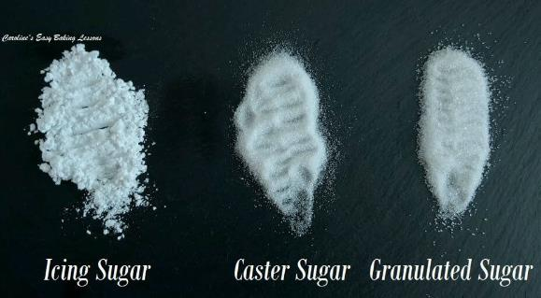
Why Use Certain Sugars?
See Photo for a comparison of the sugar crystals as a guide. In some bakes using granulated sugar as is, will not ruin the bake but not produce a precisely similar bake in texture to how the original recipe was meant to be. However, using granulated sugar as is when making a meringue, will not be technically correct & you may be aware of the larger sugar crystals if it produces a more ‘grainy’ meringue texture when tasted. It is also used in the lemon curd recipe, (but I have made curd from granulated and it was fine as it’s melted as part of the recipe process). Other than that, I think we are all set and anything else will be covered in the recipe instructions.

Lemon Meringue Pie Ingredients

FOR THE PASTRY
225g Plain Flour (8 oz, 1 + ¾ cup All Purpose)
175g Butter, unsalted, cubed & softened (6 oz, ¾ cup + 1 tsp)
45g Icing sugar ( 1.5 oz, 1/3 cup Powdered Sugar)
1 Egg, medium – large UK (US large to extra large size)
1 Egg yolk (left over from the meringue, for egg wash)
1 tbsp Cold water (approx.)

FOR THE LEMON CURD
6 Lemons, zest & juice of (med – large)
250g Caster Sugar (8.75 oz, 1 Cup + 2 tbsp Extra/super Fine Sugar *see note above)
65g Corn Flour (2.25 oz, ½ cup Corn starch)
6 Egg yolks
450ml Water (15.25 fl oz, 1+ 3/4 cup)

FOR THE MERINGUE
4 Egg whites (left over from lemon curd)
225g Caster Sugar (8 oz, 1 cup Extra/super fine Sugar, * see note above)
2 tsp Corn Flour (Corn Starch)

EQUIPMENT
Weighing scales or measuring cups Cling film/Plastic wrap (optional)
Food processor or Pastry Cutter & Large bowl. Timer or phone timer
Measuring Spoons Lining Paste, Cake Release or butter for pie dish
Baking/parchment Paper Pastry brush
Rolling Pin & some icing/confectioner’s sugar Tin/Baking foil (aluminium) or parchment
Pie dish (23cm/9 inches wide) Silicone Baking Beans (or dry beans)
Mini pie or tart tins/dishes (optional – for leftovers) Fine zester
Small bowls for separating egg yolks & whites Fruit juice squeezer
Knife Spoons
Medium sized cooking pot Wooden spoon
Hand or stand mixer for meringue with whisk attachment. Whisk
Small bowls for sugar & yolks

Instructions

Making The Pastry
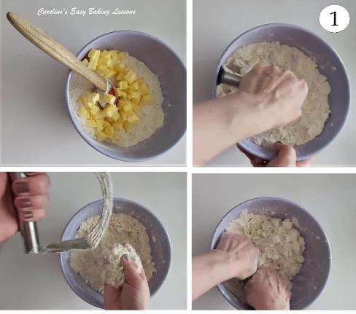
1. Using a processor, blitz the flour and butter together until the mixture resembles breadcrumbs. I prefer, and tend to use my pastry cutter, to literally ‘cut’ the flour into butter. (See Photo 1). You push down on the mixture, and perform a twisting motion, and scraping the bottom of the bowl a twisting motion, and scraping the bottom of the bowl.

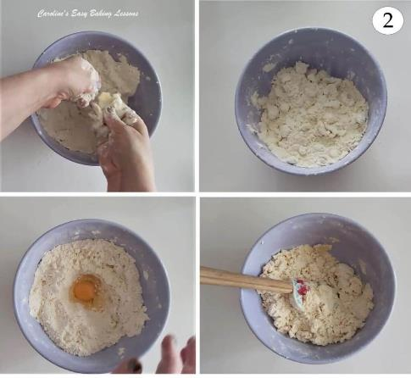
This is repeated all over the ingredients, (and the blender cleaned of any stuck mixture when needed), until all the mixture is in small pieces. The butter will be in smaller pieces, with the flour coating it. You are looking for the size and consistency of breadcrumbs. (See Photo 2 below). You can also ‘cut-in’ the butter, by using 2 butter knives. (You can watch me make the pastry in my Rhubarb Pie With A Twist video)

2. Next add the icing/powdered sugar, egg & 1 tbsp ice-cold water.

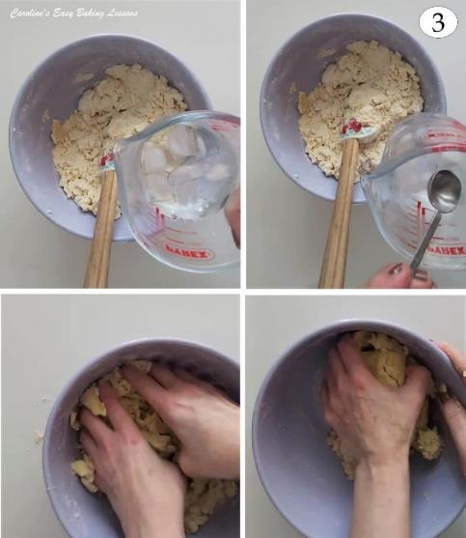
3. Using the processor, or by hand, combine all the ingredients together until it all comes together in a rough ball shape. When doing by hand, push down on the mixture with a spoon, getting the flour to take on as much liquid as possible. See Photo 2. Depending on the size of your eggs, and your flour, you might need a few small drops more of water. But first, keep squeezing the mixture between your fingers until it starts coming together. It should go from a ‘shaggy’ dry mixture, into a relatively soft smooth dough.

Do this before adding anymore tsps of water. You don’t want a wet or sticky dough but not one with dry patches either.

If using a processor, the dough is ready when it starts to come away from the sides, and cleans the bowl when it’s mixing.

Don’t over-mix as it can produce a tough pastry, so often I prefer to mix by hand as it only takes a minute and saves me getting the processor out and cleaning it up. For bigger jobs though it’s great. See Photo 3 where the dough has come together.

4. Form the dough into a nice smooth ball, kneading very lightly in your hands (see Photo 4).

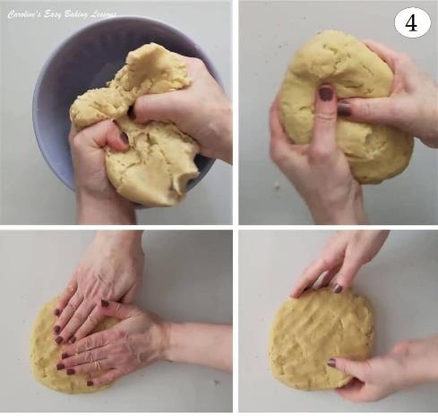
5. Flatten the ball of dough slightly into a disc shape, (this makes rolling out easier later). See Photo 4, where the pastry dough has also changed to a beige coloured dough, as opposed to an off-white colour in Photos 2 & 3 before it came together.

6.. Now I recommend chilling the dough before rolling it out for any pastry you make even if the recipe doesn’t instruct you to. Chilling is important to relax the gluten in the dough as well as firming it a little to enable easier rolling and less spreading once baking. So, once you have a nice disc shape, either wrap up in baking/parchment paper or some cling film/plastic wrap and chill in the fridge for 20-30 minutes.

If chilling longer, you might find it hard to roll out easily, so leave out to soften just a little before trying again. See Photo 5.

Rolling Out The Pastry
7. Meanwhile, prepare the baking dish you are using by greasing it well on the bottom and up the sides. I use a great home-make cake release paste, for all my greasing in baking and cooking. Here’s a link to make lining paste and a quick video of how to prepare it. When I don’t have that, I tend to use Fry Light One-cal Oil Spray, that works well too. See Photo 6
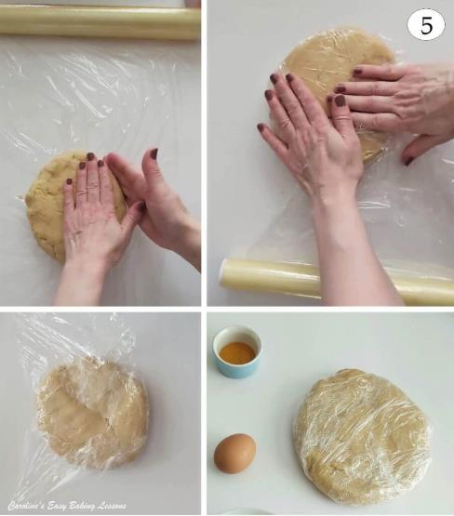
8. On baking/parchment paper, (and a dusting of icing/powdered sugar if the dough is a touch sticky), roll out the pastry dough with a rolling pin covered in the sugar (or a second sheet of paper instead), to a 3-4 mm (1/6 inch) thickness. Hold the baking dish over the rolled-out dough to make sure you have rolled a large enough diameter to fit the dish as well as up the sides. Try to give yourself at least 1″ (2.5cm) excess just to be sure. See Photo 6.

Transferring The Pastry To Tin

9. A few different ways to transfer the pastry dough to the tin. With one hand on top of the dough, flip it, including the paper upside down and hold over the pie dish.

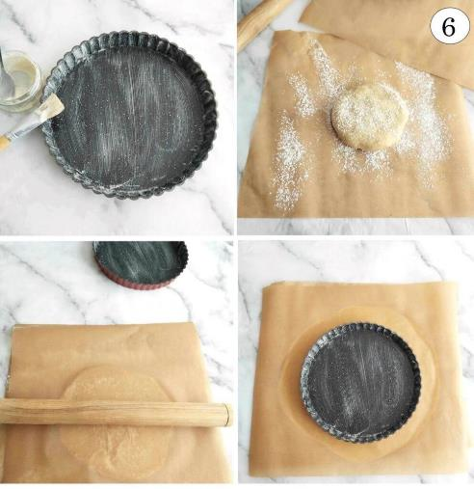
Alternatively, roll the dough over a dusted rolling pin and transfer carefully, placing on top. Another method is to use the paper to flip the pastry over on top of the base of a loose base pie tin, being sure to centre it & remove the paper carefully). Then carefully fold over the pastry excess into the centre of the bundle to make transferring it all to the pie tin ring easier. (Make sure that the tin base is greased before doing this). See Photo 7 for this.
10. Depending on which method you used, very carefully start to pull back the edges of the paper. With most of the paper still attached, use this to gently push the pastry into the dish to take on its shape, starting from the bottom, & pushing gently up the insides. See Photo 7. Check out my Rhubarb Pie With A Twist Video for forming the pastry case.

Forming The Pastry Case

11. Now remove all the paper. If any of the dough is not fitted all the way into the shape of the case, tear a small piece of the overhanging dough and roll into a ball. Use this to push against the pastry, pushing it into the shape of the tin . If the pastry is too warm and soft and the paper sticking, leave it on and put in the fridge to firm for 15 – 20 mins and try removing again a little while later. See Photo 8.

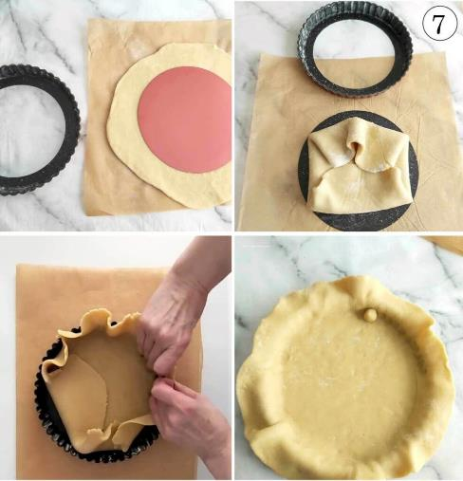
12. Now trim off the excess pastry, by either using a knife or a rolling pin to run over the top of the tin edges. (See Photo 8). Then thin the top of the edges of the pastry casing making it extend a little higher than the level of the tin, by 2 or 3 mm (1/8 inch) – see 2nd pic in photo collage 8. This ensures we have a deep enough casing to hold the lemon curd, that will inevitably shrink a little whilst baking. If the case shrinks back quite a bit, it generally indicates that you worked the dough too much.

‘Dock’ The Pastry Base
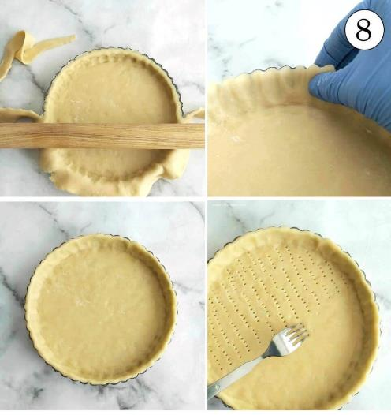
13. Using a fork, pierce lots of holes over the base of the pastry casing. (This let’s steam escape, and helps avoid a ‘soggy bottom’ and is know as ‘docking the pastry’). Now place some cling film/plastic wrap on top of the prepared tin and chill for another 20 – 30 minutes. See Photo 8 above.

13. Using a fork, pierce lots of holes over the base of the pastry casing. (This lets steam escape, and helps avoid a ‘soggy bottom’ and is know as ‘docking the pastry’). Now place some cling film/plastic wrap on top of the prepared tin and chill for another 20 – 30 minutes. See Photo 8 above.

14. Before the chilling time is up, heat up the oven to: 180/160c Fan Oven / 350f /Gas Mark 4.

‘Blind Baking’ The Crust

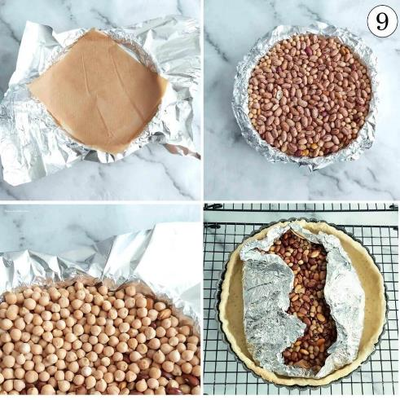
15. Cut some baking foil (aluminium foil) or baking paper/parchment, bigger than the size of the pie case. We will use it to line the pastry case that we will fill with baking beans. (Baking without the pie filling is known as ‘blind baking’ or ‘par baking’ and helps get an evenly cooked bake and can avoid a ‘soggy bottom’ ). If using paper, scrunch the paper up into a ball first and then open it back out (this makes the paper softer with no sharp edges that can jag into the soft pastry dough. You can also place a piece on paper on top of the foil to strengthen it). See Photo 9.
Line the case with the paper or foil and then place ceramic baking beans on top of the lining. (You don’t need to buy baking beans, I use uncooked dried beans and keep them in a jar to use again at a later date, uncooked rice can even be used). See Photo 9. These beans will provide weight to keep the pastry bottom down whilst cooking and not allow it to puff up. Be sure to use enough to fill the base and up all the height of the case to avoid too much shrinking. Try to also have enough paper/foil to cover over the edges of the pastry case too.

Baking The Pastry Case
16. Bake the pastry case for 15 minutes & try to turn the pie half-way through cooking to ensure even baking. (** If baking extra mini pies, blind bake the cases for 8 minutes) .

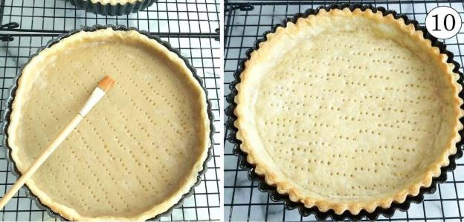
17. Remove the pie from the oven, and very carefully fold the paper/foil into the centre and cover all the beans, so you can remove them all in one go. If any fall into the soft pastry, remove with a fork and smooth the pastry back down. Be careful as it will be hot. (See Photo 8 above).
18. Using the left over egg yolks from the meringue ingredients, whisk one yolk with a fork and apply this as an ‘egg wash’ to all exposed areas of the pastry case. Then pop back in the oven empty (still ‘blind baking’), for another 5 minutes, 3 minutes if making mini ones. See Photo 10.

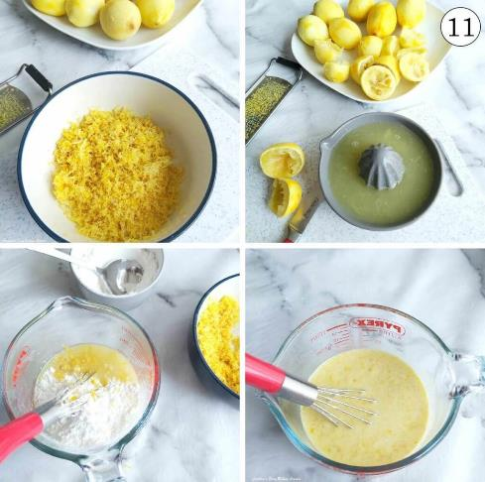
19. Place the pie on a baking tray/sheet to catch any drips of filling later, and let the case cool while you make the filling. You can also leave to fill the next day if wished. Just let cool and then cover in cling film/plastic wrap. Note you can make the lemon curd ahead of time. In which case, leave this part-baked pie case to cool for at least 30 minutes before filling.

TOP TIP – You can use the left over pastry to make mini pies with small pie or tart tins. Roll out the scraps of excess pastry and line the tins as before and chill them too. Otherwise, roll up and wrap well in cling film/plastic wrap and place in a food bag. Label it and date it and store in the freezer. Anytime you have anymore scraps, you can add to it and eventually have enough for a pie!

Making The Lemon Curd Filling

1. Prepare for making the lemon curd, by zesting & juicing all those lemons. (Be sure to zest first to make juicing easier later). Boy it takes a lot of zest!

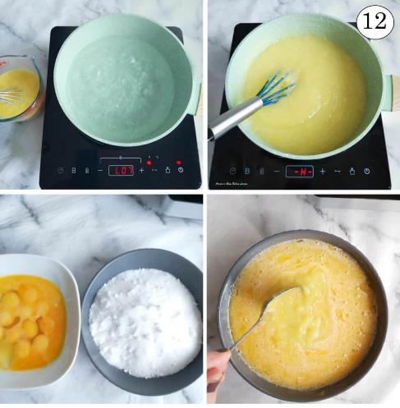
2. In a bowl or large jug, mix the lemon zest, lemon juice and the
corn flour (corn starch) together. See Photo 11.

*Note that if your lemons were a bit smaller than mine, you may have more of a paste consistency at this stage – but that is still fine.

3. Give these ingredients a whisk to combine as best as possible.

4. Measure out 450ml ( 1+ 3/4 cups/ 14 fl oz) of water into a cooking pan and bring to a boil.
5. Add the lemon mixture you made and keep stirring until the whole mixture thickens. See Photo 12.

6. In another bowl mix the caster sugar & egg yolks together until fully combined.

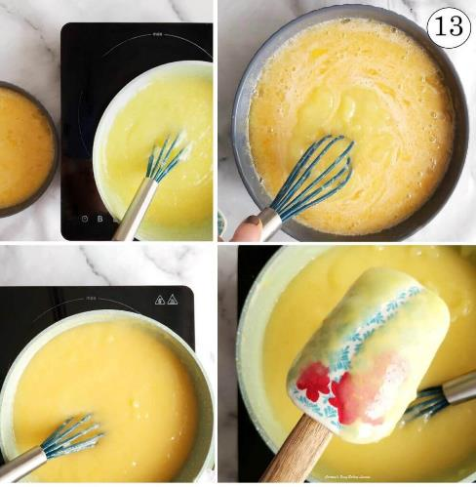
7. Whisk a little of the hot lemon mixture, into the sugar and eggs
– (only a few tbsps worth). Then repeat this process 2 more times.
This is known as ‘tempering’ and basically involves introducing small amounts of heat to a cold mixture such as the eggs, without shocking them or cooking them & making scrambled eggs! Then add this tempered egg mixture from the bowl, into the hot lemon mixture in the cooking pot. (See pics 1 & 2 from Photo 13). Whisk to combine.

8. Reduce the heat to medium and heat it all through until the mixture thickens again. Mix often during this process.

9. Leave off the heat for a few minutes. See Photo 13 where the line drawn through the lemon curd that is on the back of a spatula, is a clear line – indicating it has thickened enough. Note the curd does thicken more once off the heat & after chilling.

TIP– This can also be made a day ahead, just store in a bowl,
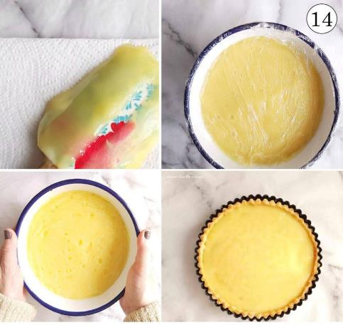
with cling film/plastic wrap loosely covering the surface of the curd and then some more around the entire bowl. (Photo 14 is the curd after chilling a few hours in the fridge).

10. Once the lemon curd is cooled a little, spoon into the pie casing. Depending on the depth of your pie casing, there might be left over curd you can put in a jar & store in the fridge 🙂 See Photo 14.

Making The Meringue Topping

1. Before starting to make the meringue topping, make sure your bowl and beaters are really clean and dry, & further clean the mixing bowl and beaters, by rubbing them with the used lemon halves from before.

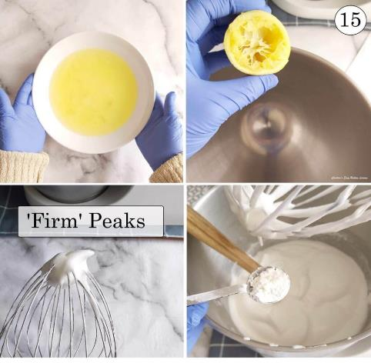
2. Using a hand-held or stand mixer, whisk the egg whites until
firm peaks are formed. See Photo 15 for how those peaks should look. You want it to be firm, but will bend just a little and produce a little curl like in the photo. This is known as ‘firm peaks’. ‘Stiff peaks’ stay stiff and do not bend.

See my short video on tips for beating meringues below.
3. Next add in the sugar, 1 tablespoon or dessert spoon at a time whilst whisking, until stiffer, no longer a foamy texture, but glossy in appearance. This is known as ‘stiff peaks’, with no bend or curl in the meringue. Add in the cornflour (corn starch) and mix through. You can do the famous test of turning the bowl of meringue upside down and over your head, without it moving if you like. Otherwise, see Photo 16 with some different views of the meringue mixture, showing also how the mixture looks in the bowl and not just off the end of the beaters.

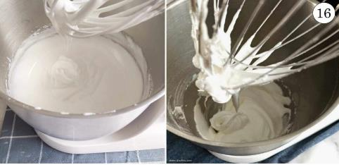
***TOP TIP – if you ever over-beat and the whites go from peaks
to a foamy consistency again, you can recover it, by continuing to mix until you get the peaks you are looking for.

Assembling The Lemon Meringue Pie

1. Have the oven heated to a slightly lower temperature now of 170/150c fan oven / 325f /Gas Mark 3.
2. Using a dessert spoon, place heaped spoonsful of meringue on
the pie, around the outside edges of the pie (trying to cover the area where the lemon curd & crust meet).
This helps seal it in whilst baking). See Photo 17.

3.Work your way into the middle and heap it higher as you get towards the centre. (You can use all the meringue for a ‘mile high meringue’, or keep a little back for topping 2 mini pies as there will be left over pastry dough and lemon curd too). See Photo 17.

4.Using the back of a spoon, rub on the meringue & pull up on it upwards & then pull towards yourself as you reach the top of the meringue. Repeat all around where you would like peaks to form. Alternatively, make a swirling pattern with a peak in the centre. You could also pipe on the meringue.

Bake The Pie

5. If you made extra mini pie cases, fill with left over lemon curd and spoon meringue on top, sealing the edges and swirling the spoon to produce a tall peak in the centre.

6. Bake the pie(s) for 15 minutes (turning once during cooking to ensure even browning of the peaks), until all completely set and the meringue peaks are lightly browned on the edges. Note mini pies will require a shorter baking time, so keep an eye on them (probably 8-10 minutes).

7. Allow to cool before removing from the case or slice still in the tin. This is where loose bottomed pie/tart tins come in handy. Simply place the pie on top of a jar for example, & pull the ring of the tin down. It is easy just to cut the pie on the tin’s loose base (but you wouldn’t get away with that on The Great British Bake off 🙂 ) So once cool, remove with a cake server to a serving plate.

Q&A

“Is The Lemon Curd Set Enough?“
If you are concerned your curd might not be set enough, it can be placed in the fridge overnight (make sure it’s not warm when you do this). But to help with weeping, place some cocktail sticks in the pie (at areas that it won’t matter), and then loosely drape cling film/plastic wrap over the pie and sticks, and close it a bit more secure around the crust of the pie. This is because the fridge can cause condensation and weeping of meringue. Completely covering will cause it to sweat and weep. You can also make your lemon curd ahead of time and chill in a jar overnight to test if set.

DIFFICULTY LEVEL: intermediate, multiple stages/techniques
⭐⭐⭐
Rating: 3 out of 5

https://www.easyonlinebakinglessons.com/lemon-meringue-pie-luscious-and-lemony-loveliness-in-a-pie/

