90 MINUTE BURGER BUNS- Quicker, Bigger Burger Buns
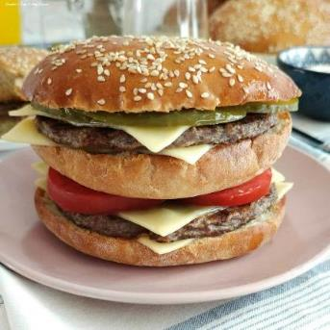
Caroline’s Easy Baking Lessons
Savoury Lesson No.9

A Note On Ingredients
So no special ingredients are required for the dough, just the inclusion of egg whites. Now note the flour is separated into 3 amounts, as they need added in a specific way, and are referred to as [F1], [F2] & [F3]. This method works really well, and once you have done a few times, you really don’t need to refer to the recipe. And it’s the same process for making the dough, in all the Quicker Yeast recipes of mine. So stick with the recipe and you will achieve the same result.
The Yeast – An additional note on the yeast. Normally I use fast acting instant dry yeast, but during the lockdown and shortages, I was only able to get active dry yeast in bulk. So this recipe has been developed and tested using both types of yeast, and with the same amount, with very little difference. If you can only get fresh yeast, you want 28g (1 oz) of this type of yeast. For more conversions of different yeast, see my Yeast Table.
Very Big Burger Buns
Also note the recipe makes 8 large burger buns, about 11 cm (4 1/3 inches) pre-baked and about 12.5cm (5 inches) after the 2nd prove. As seen in the photo, the rolled-out dough is about hand-width. So if your cooked burgers are a bit smaller in diameter, just roll a little smaller. If you want regular sized burger buns, simple divide the dough into 12 equal pieces at step 8 below.

EQUIPMENT
Scales or measuring cups Measuring Spoons
Small Measuring jug Stand Mixer (Or large bowl and spoon)
Small – medium microwave safe bowl if using. Food thermometer (optional)
2 small bowls to separate the egg Pastry brush (or small artist/paint Brush)
3 Baking sheet/trays (or 2 extra large) Tea-Towel
Baking/Parchment paper Rolling Pin
Timer or Phone timer Cooling rack

INGREDIENTS (for 8 large buns)
250g Plain Flour (2 cup, 8 3/4 oz AP)– [F1] 2 tsp Salt
2 tbsp Sugar 2 tsp Onion Powder (optional, or Italian spices)
14g Instant/Fast Acting Yeast (1/2 oz /2 packs)* 400ml Water (5 fl oz, 1 2/3c cup)**
4 tsp Olive Oil (or EVOO) 2 Egg Whites (med-large, US large to extra large)
125g Plain White Flour (1 cup, 4 1/3 oz, AP) – [F2]
250g+ Plain White Flour(2 cup, 8 3/4 oz, White AP) – [F3]

Topping:
Egg wash – 2 Egg yolks + splash of milk Seeds of choice – I used sesame (optional)

**(heated to 49-54c/120-129f) see below OVEN: 400f/200c/180c fan oven/Gas mark 6

Step-By-Step Instructions
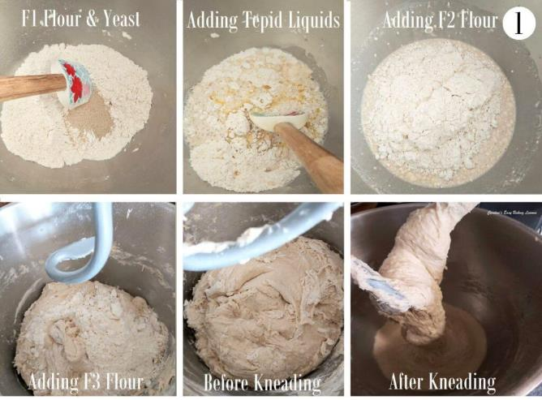
1. Have the 3 amounts of flours weighted or measured out in separate bowls – you can use the stand mixer bowl for the first flour, [F1]. Place the oil and water into a microwave safe bowl or jug and heat for 30 – 45 seconds until just a little warm (120-130f, 49-54c). Alternatively used some hot water and cold water and check the temperature once mixed. It should be just above tepid.
2.Mix the salt into the first flour, [F1] and give it a good mix through. This is because yeast should never come into direct contact with salt or it will reduce the power of the yeast. This way the salt is coated in flour.
3.Add in the yeast, sugar and onion powder (if using) and mix through, one at a time. Once the water and oil is warmed, add this as well as the egg white to this dry mixture. Using the paddle (or ‘k’ hook) on the mixer, mix for 2 minutes. Be sure to time this. See Photo 1 below.
4. Now add in the smaller bowl of flour [F2], and mix for 2 minutes with a timer. The mixing in this recipe is very important so remember to time it.
5.Slowly add in the flour from [F3]. You might not need it all, (or a little more – sometimes I have needed an extra 3/4c or 90g), but you want a dough that starts to come together as a very rough ball around the paddle. So mix for 10 seconds after each addition of flour and wait to see the ‘ball’ of dough. Note that the dough will be a bit sticky. See Photo 1 above.
6.Now put the dough hook onto the stand mixer (use a scraper to get the dough off the paddle), and knead on medium speed for 4 minutes.
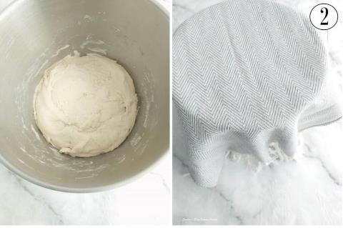
7. Using a rubber or silicone slim spatula, scrape the dough off the bowl from down the sides. Then tilt the bowl and put on its side, so you can see the bottom. Continue scraping the dough out towards the top of the bowl. Now wash and then put oil (or spray oil) onto your dominant hand and ease the dough out and turn it over so that the bottom of the dough is now at the top end of the bowl. Alternatively, just flick the dough over with a silicone spatula. Place the bowl back on the mixer and continue kneading for another 4 minutes. The dough does tend to stick at the bottom when kneading, and this is another reason why we turned it during kneading. Once the total kneading time is up, the dough will be forming a ball and cleaning the sides of the bowl. Have a feel of the dough to know how well kneaded dough feels. (See photo 3 above). Note also how stretchy it is when you lifted the dough hook up. Scrape any dough from the hook and into the bowl. Now place a towel on top of the bowl and leave somewhere warm and draft free for 15 minutes. See Photo 3 below of before and after just 15 minutes proving.
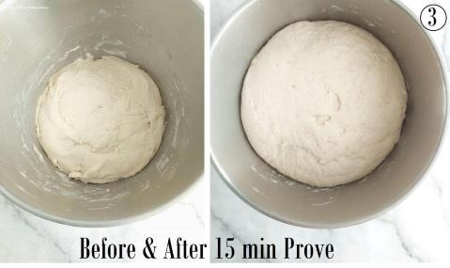
8. Well flour some baking/parchment paper or worktop/counter and your rolling pin. Release the dough from the bowl like before, (without oiled hands this time) and tipping, scrapping out onto the worktop. Turn the dough over and let it get a bit more flour on it. Knead the flour into the dough for a few seconds, adding small amounts of flour if needed for it to be manageable.
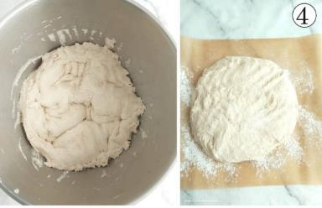
Now divide the dough into 8 pieces. For equal sizes you can weigh or, what I do is form into 2 large disc shapes. Then divide each disc into 4 triangle segments like a pizza. This produces 8 pieces & gives nice big burger buns. These are about 11 cm (4 1/3 inches) pre-baked & a bit bigger once baked. So if you want regular sized burger buns, divide the dough into 12 (make 2 discs of dough and then divide each into 6). See Photo 5 below.

Rolling Balls Of Dough
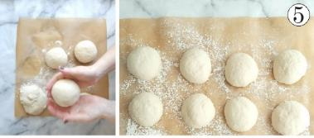
9. Now take each piece of dough and roll into a tight neat ball. (See Photo 5 below). To do this I pull the dough and tuck under itself. This repeated action, not only works the dough a little, but causes surface tension, which in line creates a tighter ball of dough. For more on this, see the video for the burger buns above, on watch the next short video below.

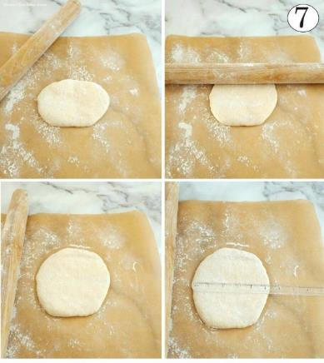
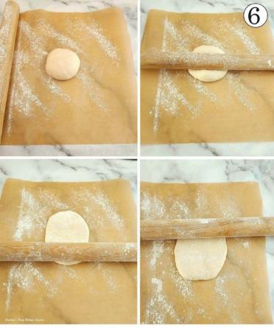
Shaping The Rolls

10. Prepare 2 large baking trays/sheets with some baking/parchment paper. Oil in place if there’s no lip on them or the buns will slide off. Place the rolled balls of dough on top of one of these trays/sheets and lightly flour your working area again. Take one of the balls of dough and with a floured rolling pin, start to roll from the centre of the dough and away from yourself just once & roll this time back the way, towards yourself. Do this 2 more times (See Photo 6 above).
11. Next lift the dough with one hand & use the other to spread the flour to where the dough was. Turn the dough 90 degrees so that is now an oblong, sitting horizontally, see Photo 7 above.
12. Now repeat the same rolling process. You should now have a wide circle of dough. It will be about 11 cm (4 1/3 inches) wide pre-baked and about 12.5cm (5 inches) after the 2nd prove). *If your cooked burgers are usually smaller than this diameter, roll the buns slightly smaller.
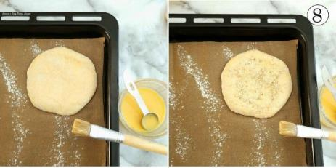
13. Repeat for all balls of dough and place on the 2 or 3 prepared baking sheets/trays, with plenty space in-between. See video above.
14. Now brush some egg wash all over the top and sides of the dough. Sprinkle on some sea-salt or sesame seeds if you wish. (Completely dipping in the seeds is also nice). See Photo 8.

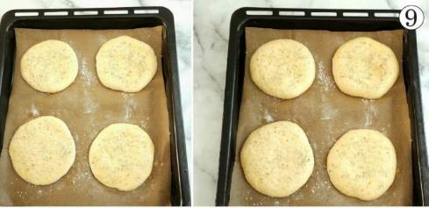
15. Leave, in the same draft free area for 30 – 40 minutes, while they will swell up a little, but not double in size. **Note that if your environment is really warm and sunny, this could take just 20-25 minutes, so keep an eye on them and get the oven on sooner if needed. You don’t want to over-prove or they can sink when baking. See Photo 9 below.
16. Heat up the oven to 220c/200c Fan Oven/425f/Gas Mark 7 before the rising time is up.
17. Place the trays/sheets of rolls into the hot oven and bake for 12 – 16 minutes, until a deep golden colour all over. (See Photo 10). I was used to having an old oven, and un-even baking so I would time my bakes, turning the trays and rotating between the shelves if more than one tray was used. I also often turn the rolls over in the last few mins & apply any egg-wash that is left. You want to tap the top and bottom of the rolls when the top is golden and risen and compare. The bottom is often softer and not a ‘hollow’ sound and so needs a few minutes more of baking, bottom side up.
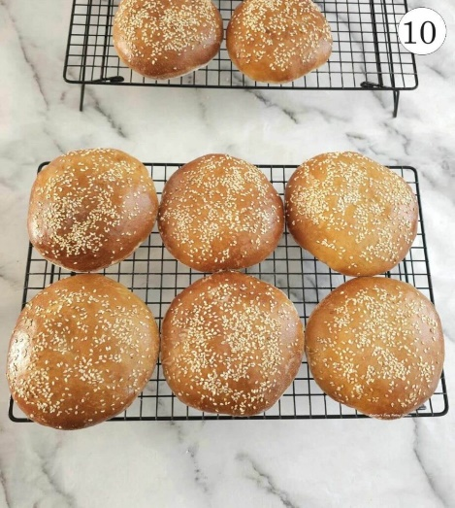
19. Leave on the tray for 5 minutes, on top of a cooling rack, before transferring the rolls/buns, paper and all on to the cooling rack. Leave to cool as much as possible and this will make cutting easier. Slice in half with a large serrated bread nice and enjoy with your favourite burger. See Photo 11 below.
20. Leftovers can be stored in sealed food bag for a few days. Easily be frozen - place a piece of kitchen paper/paper towel inside and this will absorb any moisture when defrosting. You can also make them last a bit longer, by placing the heal/end of a bought loaf of bread in with the buns, this will help preserve them a little longer.

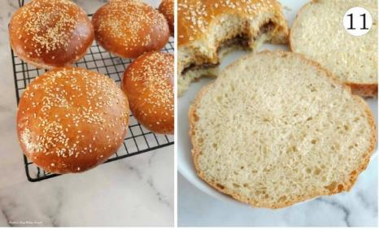

DIFFICULTY LEVEL: easy with guidance
⭐⭐
Rating: 1.5 out of 5.

Savoury Lesson No.9
Caroline’s Easy Baking Lessons
@ https://www.easyonlinebakinglessons.com/90-minute-burger-buns/

