Cranberry Orange Pecan Scottish Shortbread

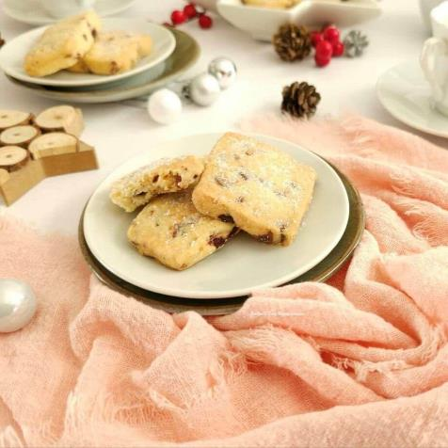
Caroline’s Easy Baking Lessons
Posted on 13/12/2018 by Caro
This Cranberry Orange Pecan Scottish Shortbread recipe, is a variation on my classic Traditional Scottish Shortbread recipe, with some additions that take this biscuit to the next level.

Traditional Scottish Recipe
This recipe is based on traditional Scottish shortbread, and the shortbread we eat here in Scotland. Which makes it perfect for Christmas & Hogmanay celebrations, or food gifting anytime of the year.
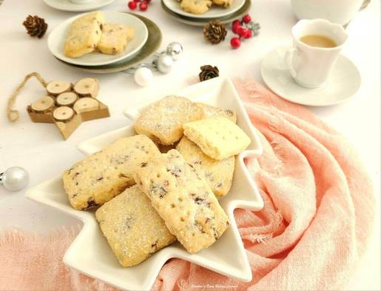

Some Tips For Shortbread
You can of course do half of the batch regular and half with these flavour additions, just remember to half the amounts.

A Note On Ingredients

Caster Sugar
The equivalent of Caster Sugar, is extra/super fine sugar in the states.
Make Your Own Caster Sugar
If you can’t source either of these sugars, you can make your own by grinding regular granulated sugar a little bit or processing them lightly. Do not go as fine as a powder, keep it as small granules. See my photo above of icing/powdered sugar, caster sugar & granulated sugar granule sizes for your reference. Please note when making your own caster sugar, that US granulated is slightly finer a granule size than our UK equivalent. Read more about Differences In UK & US Baking Ingredients
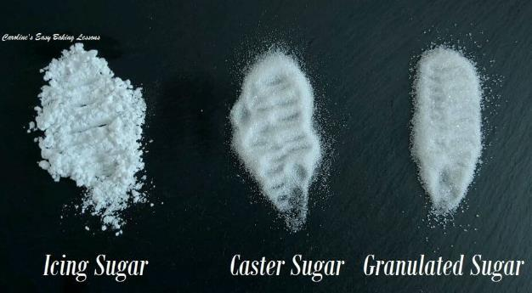
UK icing (powdered) Sugar (L), Caster Sugar (UK, M) & Granulated Sugar (UK, R)

Orange & Nuts

I used a premium orange extract, but you can easily used orange zest and a tsp of orange juice. You can also omit the nuts if there’s any allergies, or use a different nut if you like too 🙂
Alternatives
You can also try some chopped hazelnuts in place of pecans, or chocolate chips in place of the dried cranberries. For cup measurements, the 61g of roughly chopped hazelnuts was about ½ cup and the 50g of chocolate chips a ⅓ cup.
Ingredients
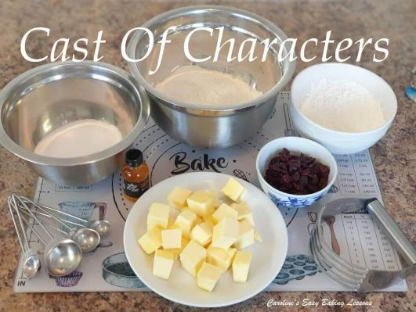
- 225g Butter, cubed & softened
- (1 cup/2 sticks or 8 oz)
- 110g Caster Sugar (* see note)
- (½ cup Extra/super fine sugar, 4 oz)
- 225g Plain Flour
- (1 ¾ cups All Purpose, 8 oz)
- 110g Corn Flour
- (1 cup less 1 tbsp Corn starch, 4 oz)
- Pinch Salt
- 2 tsp Orange Extract (or zest of orange & 1 tsp oj)
- 73g Dried Cranberries (1¼ cup, 2½ oz)
- 52g Pecans, roughly chopped (optional)
- (¾ cup, 1¾ oz)
- Some Granulated Sugar for topping

Equipment
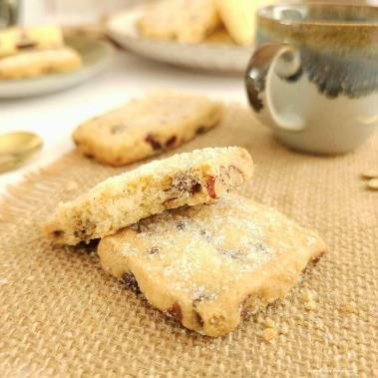
- Scales or Measuring Cups
- Measuring Spoons
- Large spoon
- Stand or Hand Mixer, (or Medium-Large Mixing bowl & spoon)
- Sieve
- Pastry Cutter (optional)
- Baking/parchment Paper
- Baking Tray/sheet x 2
- Palette knife or sharp kitchen spatula
- Timer or Phone Timer
- Cooling Rack
- 2 Large chopping knives
- Chopping Board
- Zester (optional)
- OVEN: 180c/160c Fan Oven/350f/Gas Mark 4

Instructions

Prepare The Dough

1.Weigh or measure out and cube the butter and leave out till softened. I like to cut to about 1cm or 1/3″ size as a smaller surface area will soften faster. If you forget to take out in time, here’s a little video hack for softening in about 12 minutes that I reviewed.

2. Weigh/measure out the sugar into you mixing bowl and add in the softened butter. Combine these two ingredients with a stand/hand mixer until light and fluffy, (known as ‘creaming the butter’). See Photo 1.

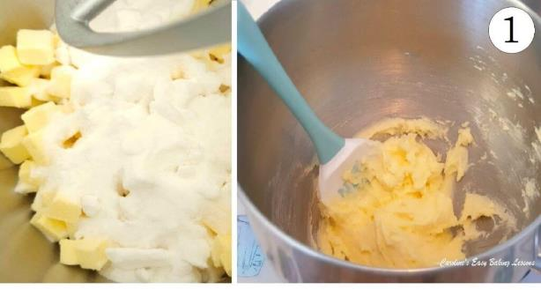
3. Lightly oil the baking trays/sheets before placing baking/parchment paper on top – only need oil if there is no lip or edge on your baking trays/sheets, or else your cookies will fall off!
4. Place the bowl back on the scales with the sieve on top and set to zero (TARE). Weigh in the flour, cornflour (corn starch) & salt through the sieve. Mix well by hand or by machine. See Photo 2.

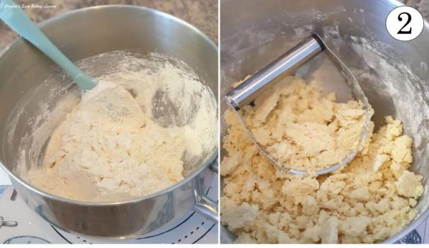
5. Now I like to use a Pastry Cutter/Pastry Blender for this part, it helps you incorporate the flours into the butter/sugar mixture much more easily & is quicker, (especially when your hands hurt sometimes like mine!) With the pastry cutter, you push down on the bottom of the bowl and perform a crushing and turning motion, rotating left and right. Do this to all the mixture until the butter had taken in all the flours. See Photo 2.

Note though that the mixture will not come together into a ball at this stage. It will be very crumbly and that is fine. Otherwise, you wouldn’t have the soft texture after baking. This is also why I don’t knead the dough as such. Try to avoid using a food processor, as it isn’t as gentle on the dough.

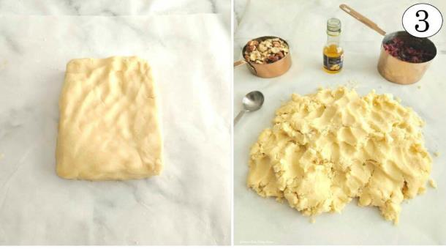
6. Remove the crumbly dough from the mixing bowl and squeeze it together, forming into a rectangular shape by hand, (no rolling out), like in Photo 3. Place on some baking/parchment paper then spread out roughly with your fingertips to open up the dough before adding in half of the orange extract (1 tsp).
See Photo 4 below where I dotted the extract over the top of the dough.

*Tip – add some orange zest too for even more flavour, or in place of the extract.

7. Next fold the ends of the dough over, into the centre of the dough, covering where you added the extract. Turn the dough 90 degrees and repeat the folding.

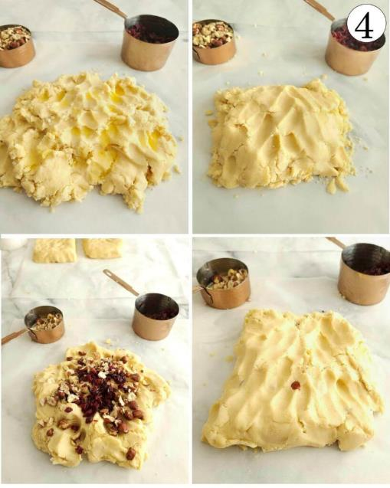
8. Add in half of the dried cranberries and chopped nuts on top of the dough, before folding the dough again, like before. See Photo 4. Repeat with the remaining cranberries, nuts and extract, folding and working the extra ingredients into the dough, as gently as possible. See Photo 5 below.
9. Once all the ingredients are worked into the dough, gently bring it together into a rough square or rectangular shape. The dough will be nice and soft now but will still need to be chilled to relax the gluten that has just be worked. (See Photo 5 above).
10. Place in the fridge for 10 minutes for the dough to also firm up and make rolling easier. Not forming into a disc shape, will also mean less rolling out as you will get more shapes from it.
*Tip – you can leave the shortbread dough in the fridge overnight if need be. Just wrap well in cling film/plastic wrap.

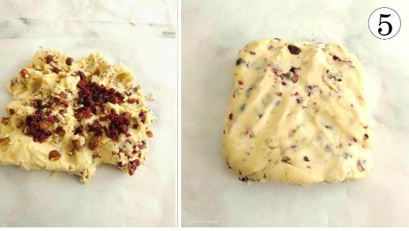
Cutting The Shortbread

Using A Cutter

1. To use a cookie cutter to cut out the biscuits, roll out your shortbread dough between 2 sheets of baking/parchment paper (these can be re-used). Roll out to a rectangular shape, to a thickness of about 1-1½ cm ( ⅓– ⅔“). Dip a rectangular cookie cutter (see sizing in equipment section), into a small bowl with a little flour, before pressing down on the rolled-out dough, to cut out as many biscuits as possible. See Photo 6.

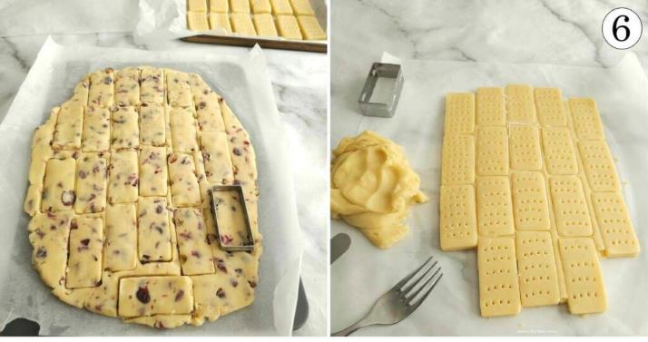
2. Leave transferring the biscuits till all cut out, and simply pull back the excess dough. ‘Dock’ the surface of the biscuits with a fork to help release air when baking and reduce speeding, before carefully transferring the biscuits to the prepared baking tray/cookie sheet with a palette knife. (Leave at least 1½ cm (⅔“) gap in-between the biscuits.
You can also cut out different shapes with a cutter, like my recipe tester Mrs D often does. (See Photo collage below with regular Scottish shortbread in petticoat tails).
Freehand Shaping
Traditionally, Scottish shortbread can be make without a cookie cutter and freehand, in either biscuit ‘fingers’ or petticoat Tail triangles, (see Photo 7).
For the Petticoat Tails, form about ⅓ of the shortbread dough into a flat disk, 1-1½ cm ( ⅓– ⅔“) deep, and about 10cm (4″) in diameter. Divide into 6 triangles, ‘dock’ the surface with a fork, and form a crimp at the edges, by squeezing the biscuit dough between your thumb and index finger, like in Photo 7.
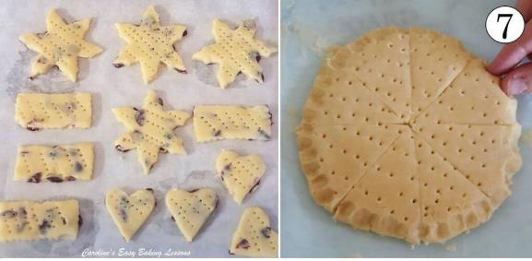
For shortbread fingers, form the dough into a rough rectangle by hand & without a rolling pin, with a depth of 1-1½ cm (⅓– ⅔“). Then use a knife to trim the edges straight and cut fingers about 1½ cm (⅔“) by 6¼ cm (2½” ).
*Cut slightly thinner than you want as they will puff up a little on baking. Roll up the scraps of dough and form more biscuit fingers or other shapes. With cranberry & nut inclusions, cutting can be a bit more difficult & you might have to go over some of the cuts. See Photo 8 below of the classic Scottish shortbread recipe cut into fingers.

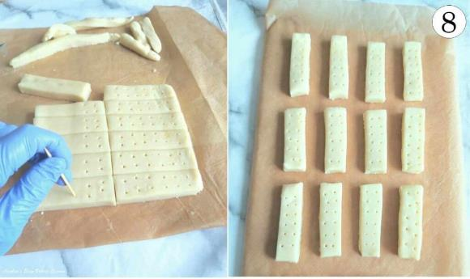
*Tip For Neat Biscuits – after cutting the biscuit fingers, use 2 knives to straighten the sides to make cleaner, sharper edges & sides. Turn the shortbread fingers over, place on the cookie tray, chill for 30 minutes, then turn them over and continue chilling for another 30 minutes before the baking time.

Chill The Biscuits

1.After all biscuits are on the cookie trays, chill the shortbread in the fridge for 1 hour. Be sure not to skip this part as it is essential for the soft texture and for less spreading. *Tip – You can also leave the cut out of shortbread dough in the fridge overnight. Just cover in cling film/plastic wrap and bake straight from the fridge.

2. Heat the oven to 180c/160c Fan Oven/350f/Gas Mark 4, to coincide with the ending of the 1 hour chill time.

Bake The Shortbread
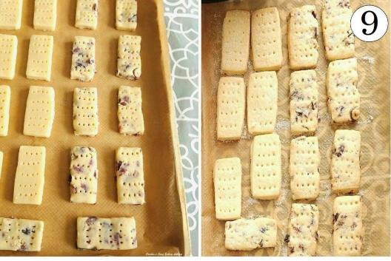
1. Place the 2 of the cookie trays/sheets in the oven and bake for 14 – 18 minutes. (If you have a 3rd tray, keep in the fridge). You may need a little longer baking time, but you want to take them out when the edges are just starting to turn a very pale golden colour. The rest of the shortbread should be quite pale, like sugar cookies. You can turn and rotate the trays during baking to ensure an even bake if needed, after 8 minutes.

To test if ready to come out, attempt to push the biscuits to see if they will move when very gently pushed. Be aware though that they will still be soft, and so should be left on the baking trays for 5-10mins. As soon as removing from the oven however, you want to sprinkle plenty of granulated sugar on top of the biscuits.

Cooling The Shortbread
1. After the 10 minutes of cooling & setting on the baking tray, transfer the baked shortbread (very carefully) to a cooling rack by lifting the baking/parchment paper. Slide the paper and biscuits onto the cooling rack. The biscuits are very delicate and so this I find to be the best way to move them and reduce breakages.
2. Leave the biscuits to cool down completely on the cooling rack.

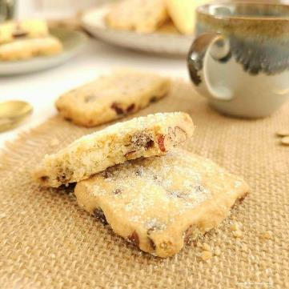
Serving & Storage
1. Enjoy the cranberry orange pecan shortbread once cooled, with a cup of tea or coffee (or Whisky if you prefer).
2. Once cooled, store Scottish shortbread in an airtight tin or container for at least 7 days. I find storing cakes & biscuits in a metal cookie or cake tin to help keep them fresh longer. I once shipped homemade shortbread from Scotland to America, well wrapped inside a tight-fitting cake tin. Delivery took 2 weeks, but the shortbread was still good!

DIFFICULTY LEVEL: easy, beginner
⭐
Difficulty Rating: 1 out of 5

Online recipe: https://www.easyonlinebakinglessons.com/cranberry-orange-pecan-scottish-shortbread/
More recipes & tutorials at: https://www.easyonlinebakinglessons.com/

